Circle time discussion cards

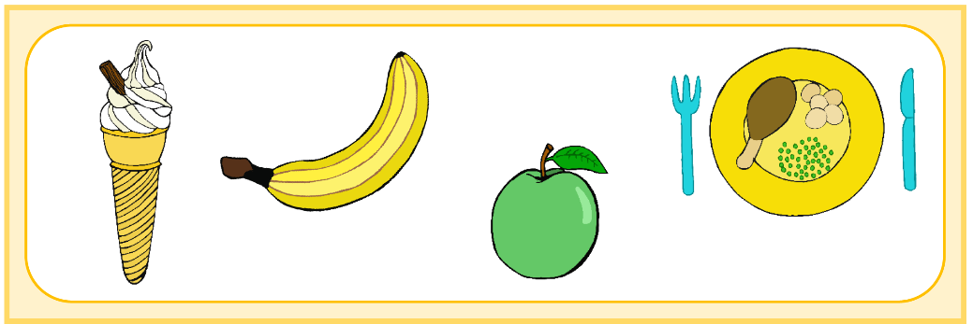

* Cut around complete double card.
* Fold along middle and stick/laminate.
* In a group, ask a child to choose a card for the first discussion. The pictures on the rear of the card serve to aid their choice.
* Read the main question at the top of the card.
* If needed/required use the second, smaller question to develop the discussion and the children’s thinking.

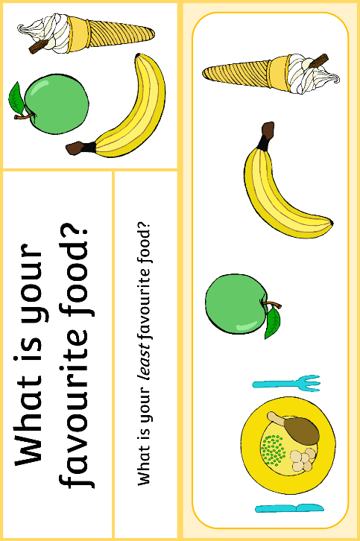

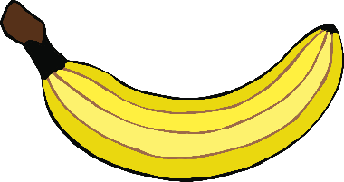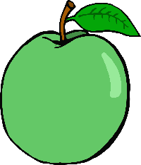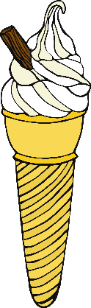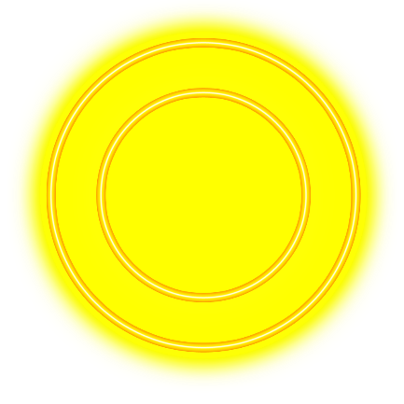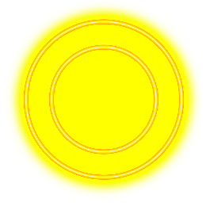

What is your favourite colour?

Can you think of something that is _______? (insert their favourite colour)

What is your favourite food?

What is your *least* favourite food?

© 2019 Little Owls Resources

© 2019 Little Owls Resources

What makes you happy?

What makes you sad?

Who is someone who loves you?

How do you know?

© 2019 Little Owls Resources

© 2019 Little Owls Resources

What is your favourite book?

What is the best bit?

What is your favourite TV show?

Why do you like it?

© 2019 Little Owls Resources

© 2019 Little Owls Resources

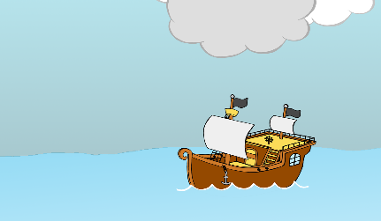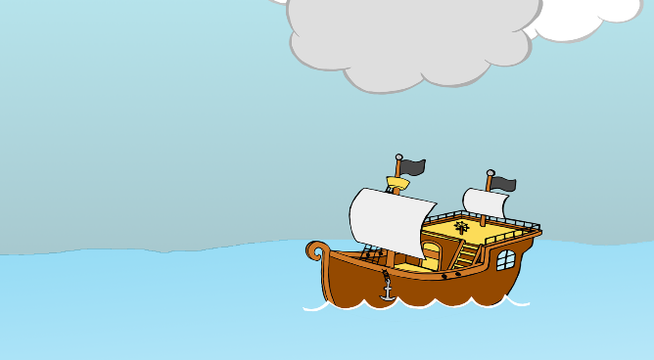

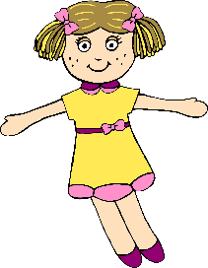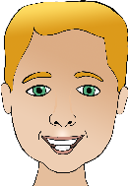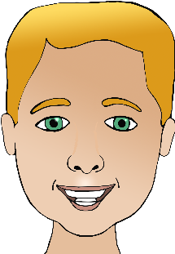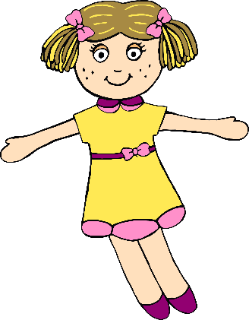

© 2019 Little Owls Resources

© 2019 Little Owls Resources

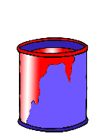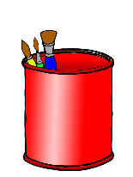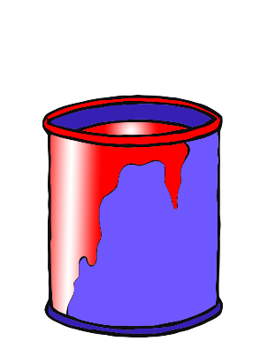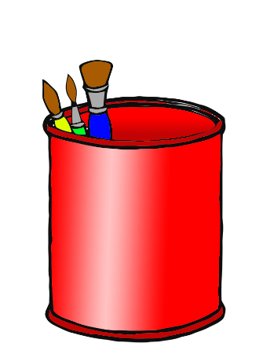

What is the best part about _______?

(insert their current educational setting)

What don’t you like about _______? (insert their current educational setting)

What are you looking forward to doing at _______?

(insert their upcoming educational setting)

Is there anything that worries you about _______? (insert their upcoming educational setting)