© 2019 Little Owls Resources

© 2019 Little Owls Resources

© 2019 Little Owls Resources

**If you could be a dinosaur…**

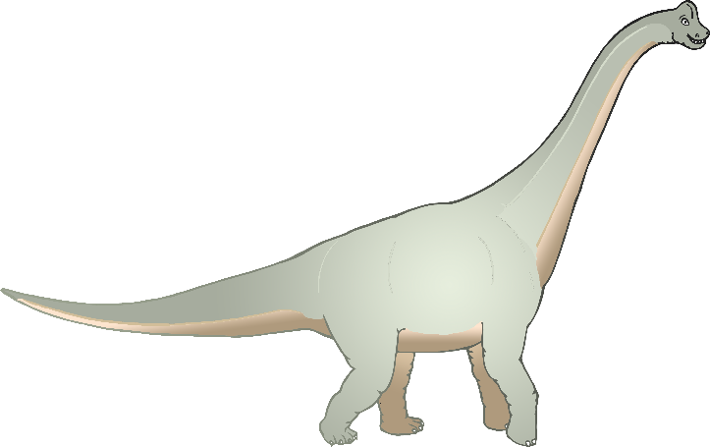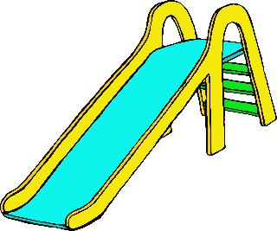

Would you choose to be a small, light, fast dinosaur?

Or

Would you choose to be a big, heavy, slow dinosaur?

**Why?**

**What minibeast would you like to be?**

What sounds can you hear?

**Imagine you are at the park…**



© 2019 Little Owls Resources

© 2019 Little Owls Resources

© 2019 Little Owls Resources

**Look at this Gift…**

What do you think is inside?

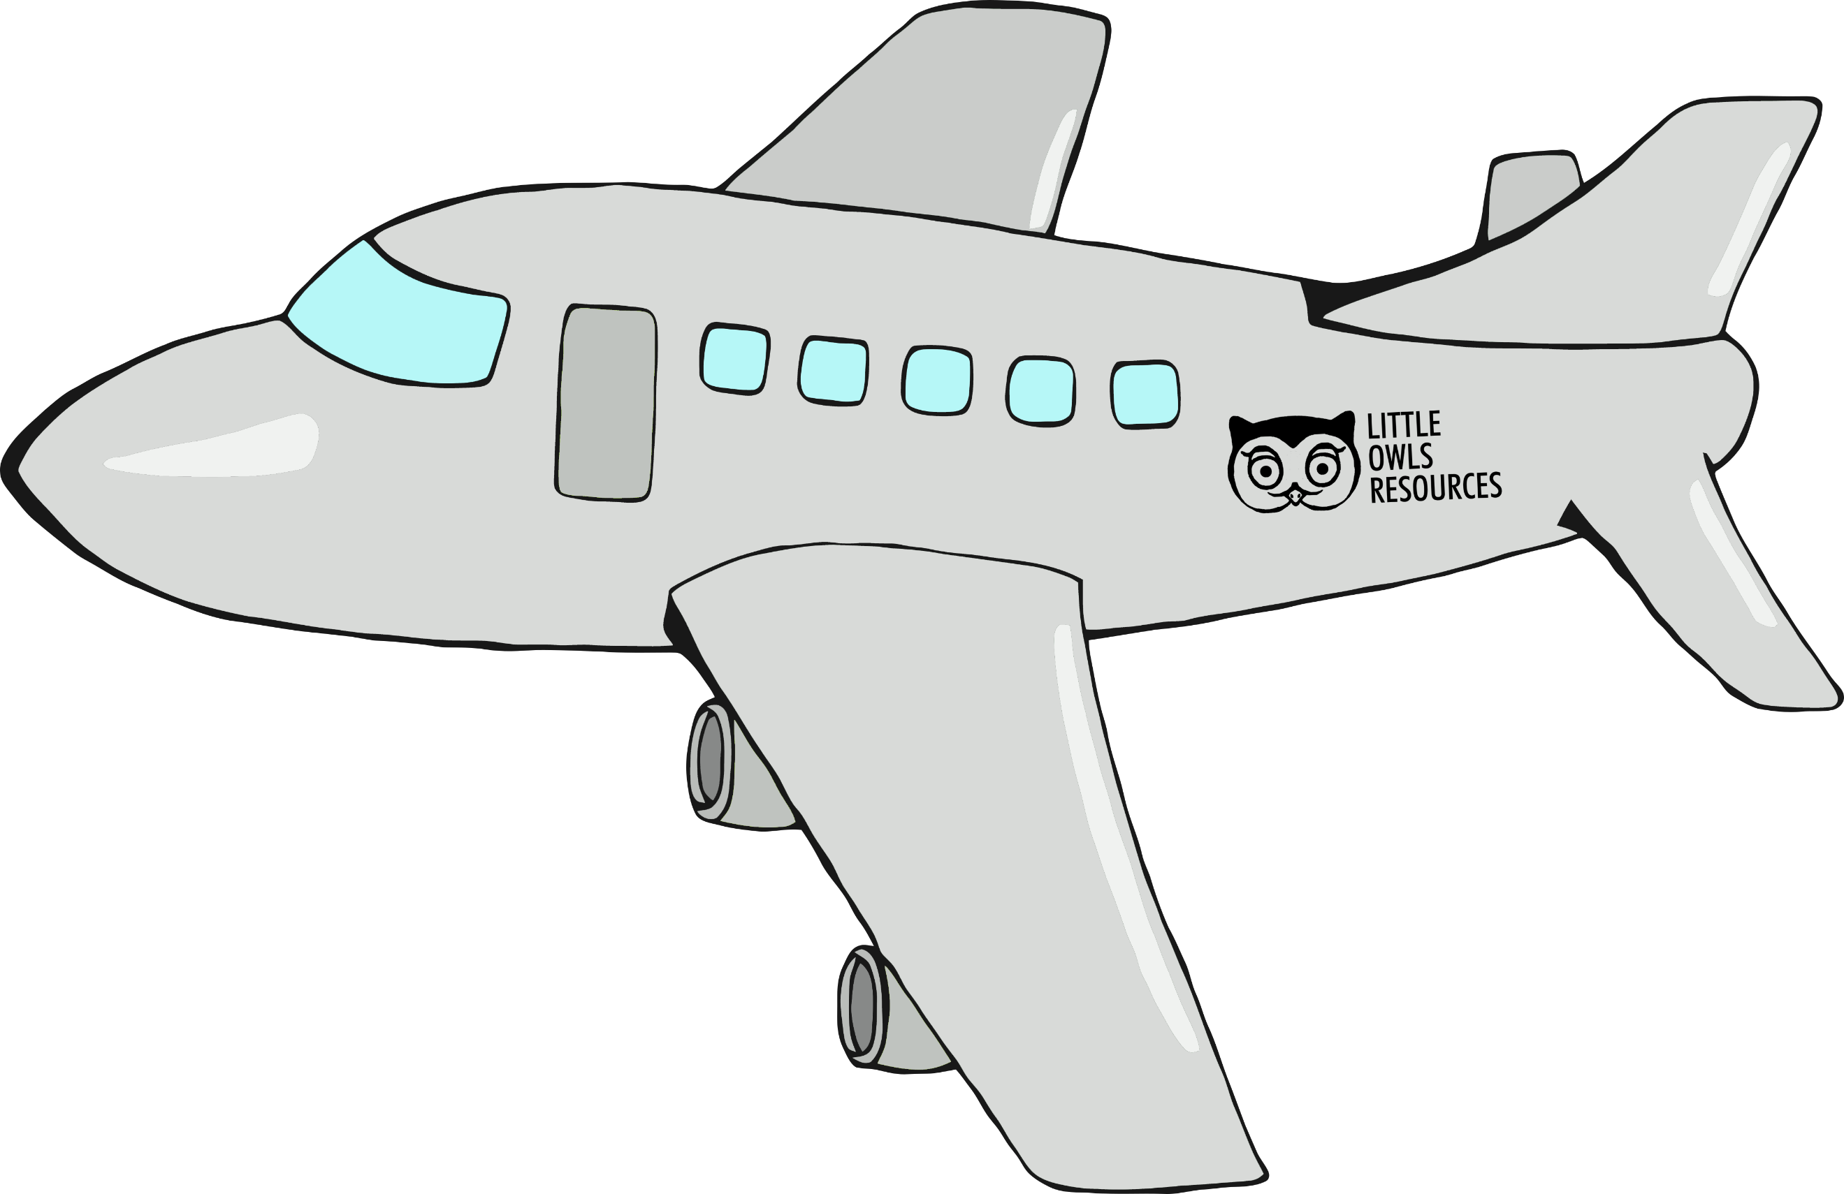

**If you could choose a holiday…**

Would you choose a **hot** holiday where you can play on the beach and build sandcastles?

Or

Would you choose a **cold** holiday where you play in the snow and build snowmen?

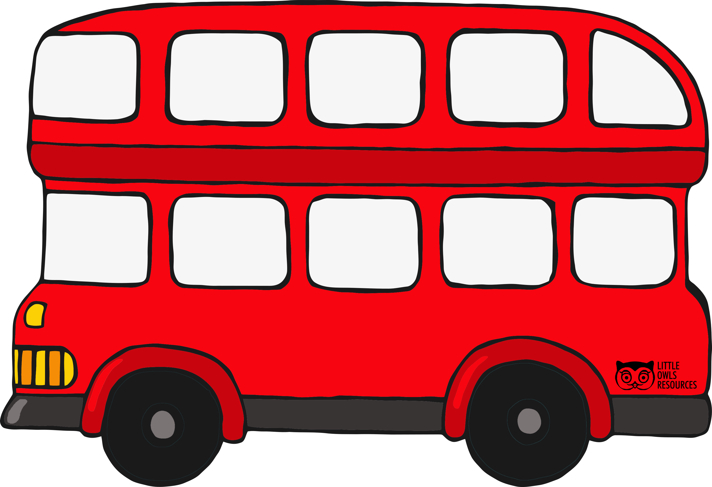

**You are buying a ticket on the bus…**

Where are you going?

© 2019 Little Owls Resources

© 2019 Little Owls Resources

© 2019 Little Owls Resources

**Would you like to live in the city or the country?...**

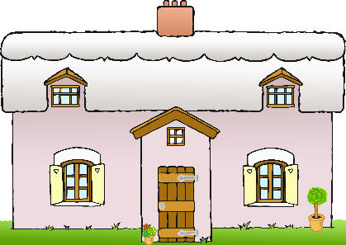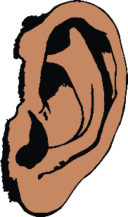

**Invisibility!**

**Super Strength!**

**Flight!**

**Which superpower do you wish you had?**

Why?

**Imagine you are at the supermarket…**

What sounds can you hear?

**You are on a space mission…**



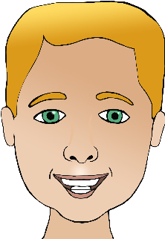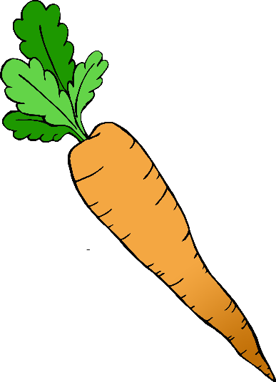

© 2019 Little Owls Resources

© 2019 Little Owls Resources

© 2019 Little Owls Resources

**What makes you happy?**

**What is your favourite food?**

Where does the rocket take you?

What do you see?



© 2019 Little Owls Resources

© 2019 Little Owls Resources

© 2019 Little Owls Resources

**It is a really hot day…**



What clothes will you wear?

**What are some healthy foods?**

**Who is someone you love?**



**What animal would you like to be?**

**Why?**

What clothes will you wear?

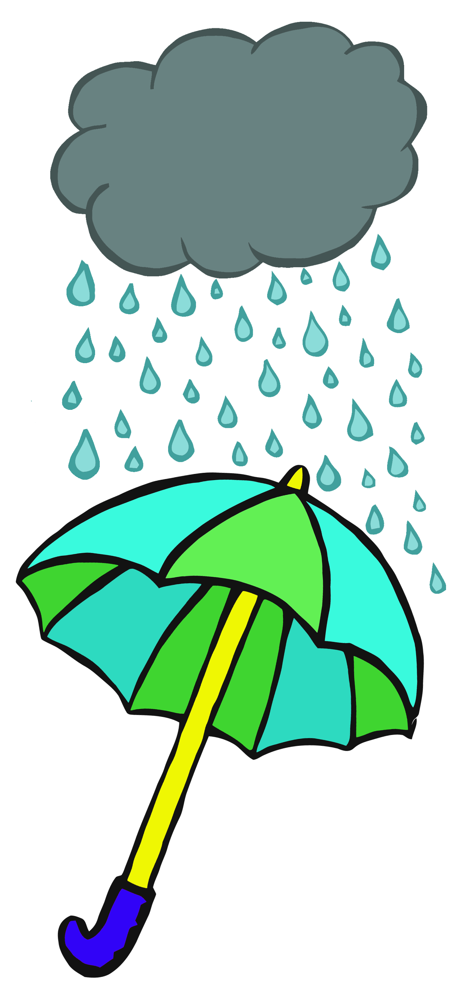

**It is a very rainy day…**

© 2019 Little Owls Resources

© 2019 Little Owls Resources

© 2019 Little Owls Resources

**?**

**What fun things do you like to do?**