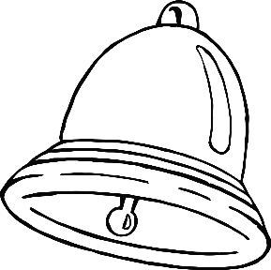

**My**

**Activity Booklet!**

**Christmas**

© 2021 Little Owls Resources

Name:

© 2021 Little Owls Resources

What’s inside?

Draw what you hope is inside this present.

Finish the pictures

Draw the other half of these pictures.

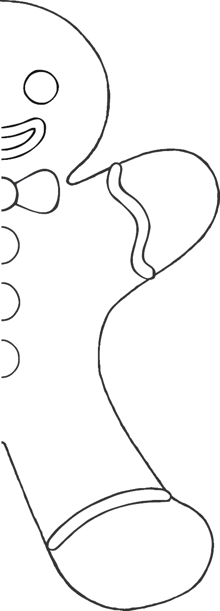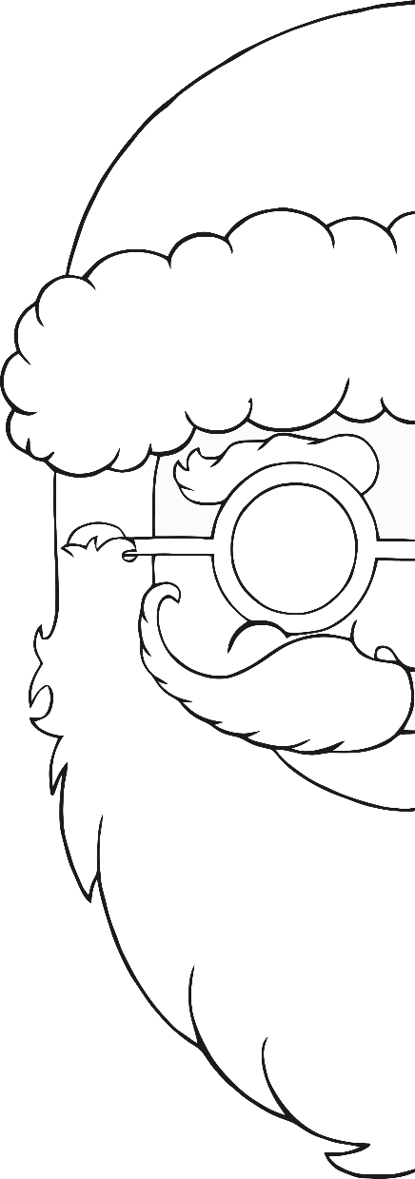

© 2021 Little Owls Resources

Draw a line from each picture to the correct sound.

Match

the sound

t

s

p

h

e

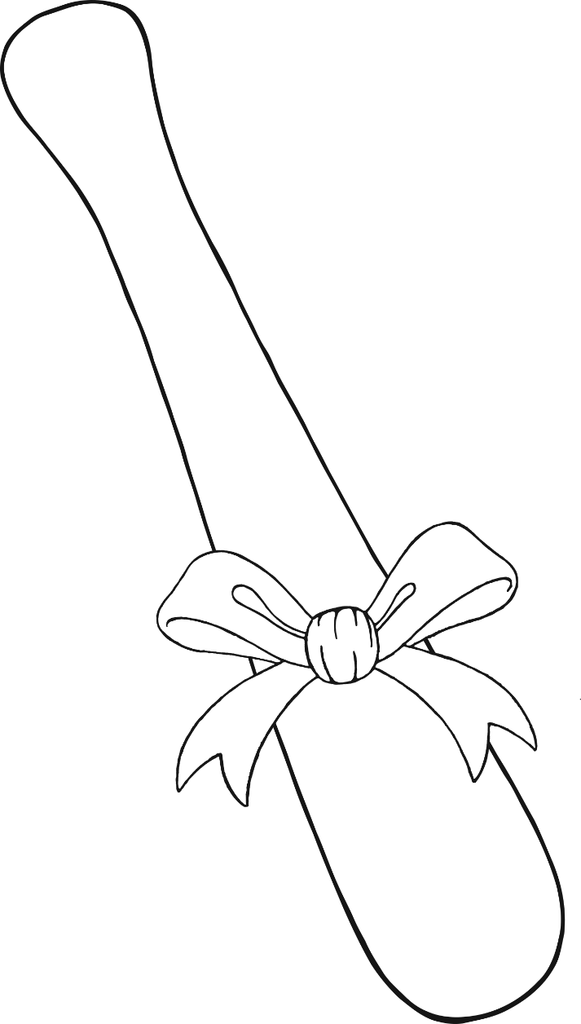

**3**

**7**

**4**

**10**

**8**

**1**

**6**

**9**

**5**

**2**

**0**

Colour

in order

Find and colour the decorations in the right order starting with 0.

© 2021 Little Owls Resources

Mindfulness

colouring

Enjoy colouring these pictures.

© 2021 Little Owls Resources