|  |  |  |  |
| --- | --- | --- | --- |
| 1 | one |  | yī  (yee) |
| 2 | two |  | èr  (uhr) |
| 3 | three |  | sān  (sahn) |
| 4 | four |  | sì  (suh) |
| 5 | five |  | wǔ  (woo) |
| 6 | six |  | liù  (lyo) |
| 7 | seven |  | qī  (chee) |
| 8 | eight |  | bā  (bah) |
| 9 | nine |  | jiǔ  (jyo) |
| 10 | ten |  | shí  (shi) |

© 2019 Little Owls Resources

1

one



yī

(yee)

2

two



èr

(uhr)

© 2019 Little Owls Resources

© 2019 Little Owls Resources

3

three



sān

(sahn)

4

four

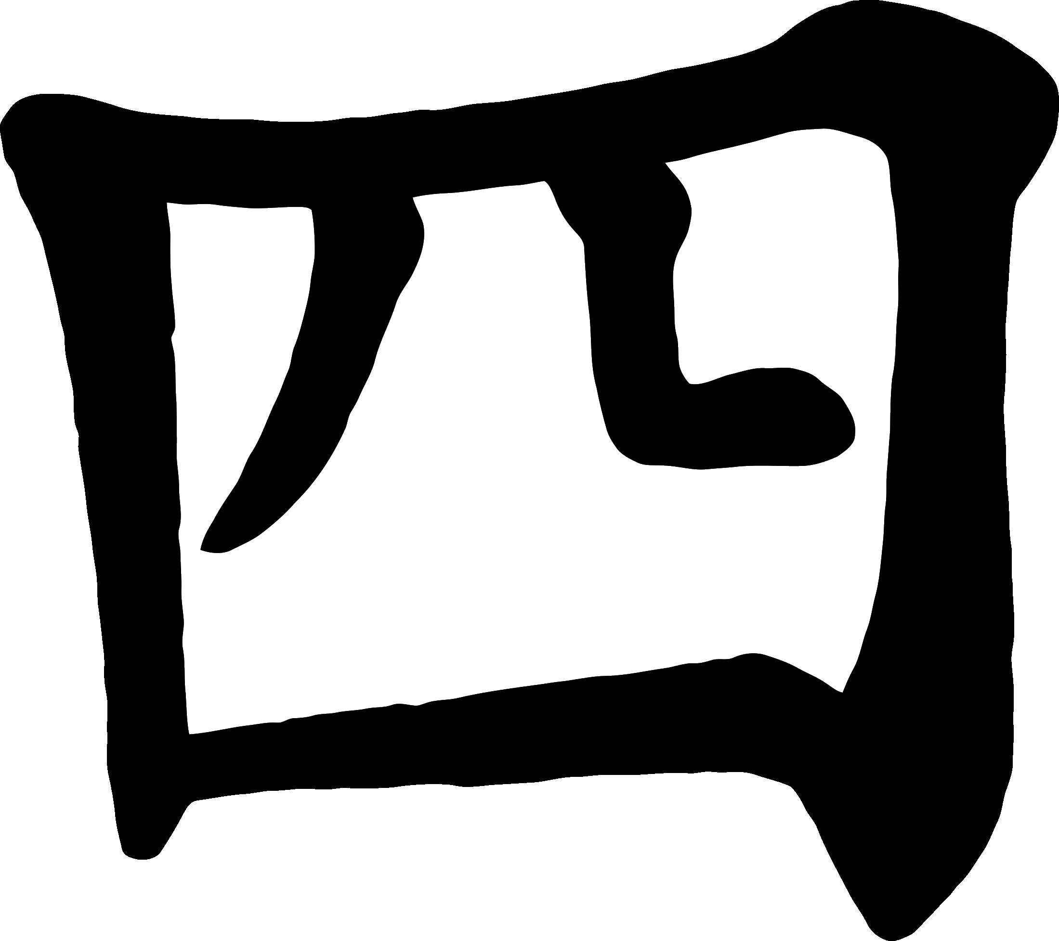

sì

(suh)

© 2019 Little Owls Resources

© 2019 Little Owls Resources

5

five

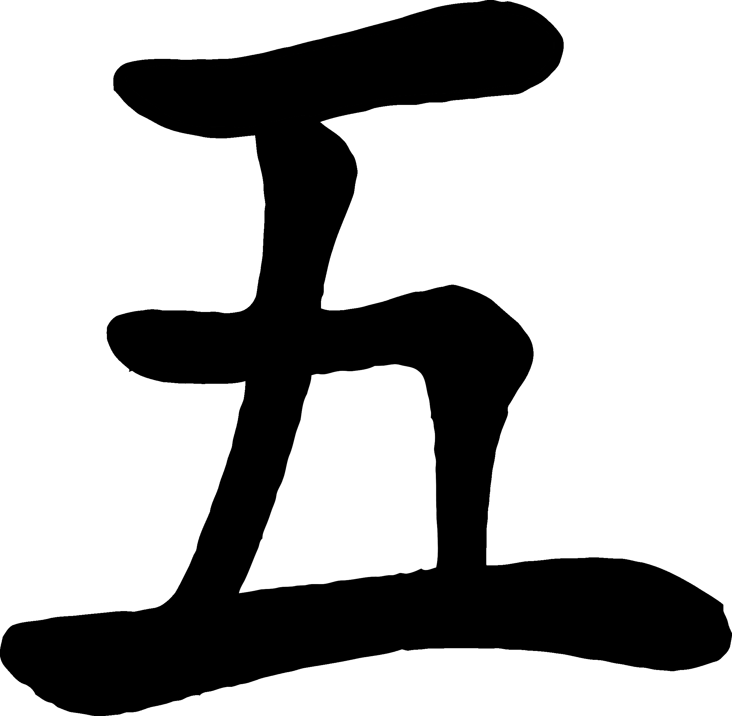

wǔ

(woo)

6

six

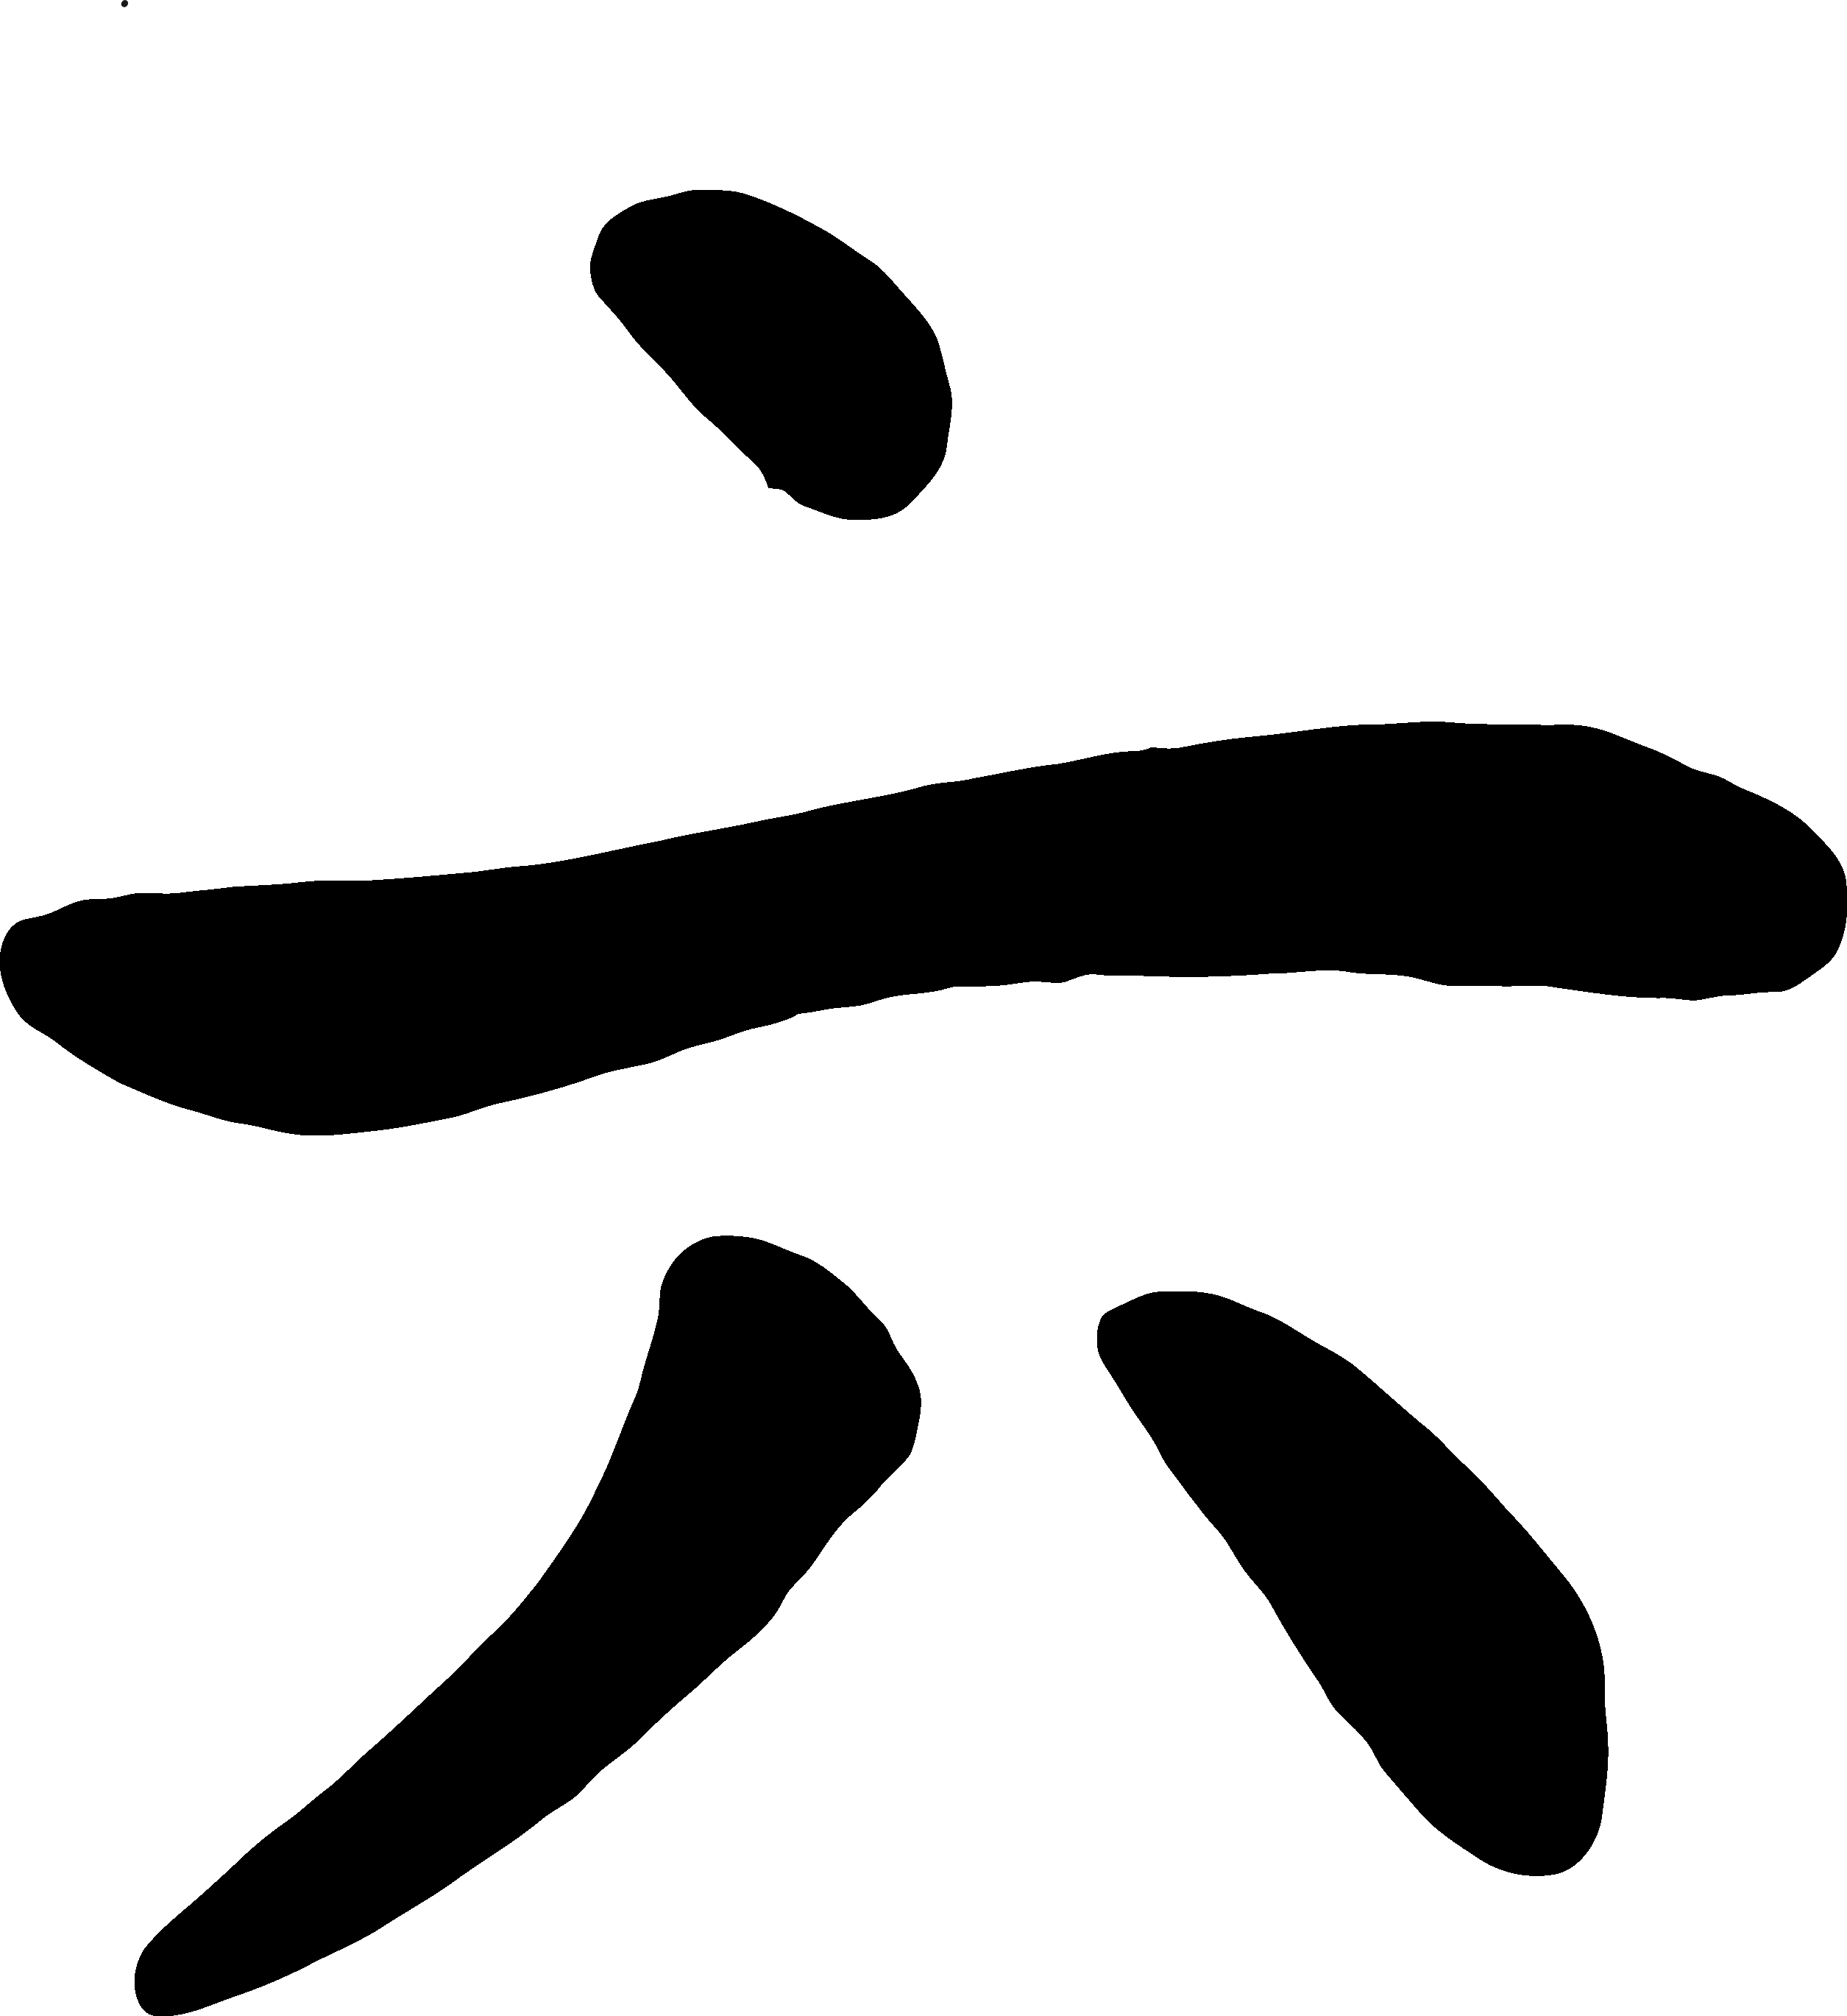

liù

(lyo)

© 2019 Little Owls Resources

© 2019 Little Owls Resources

7

seven

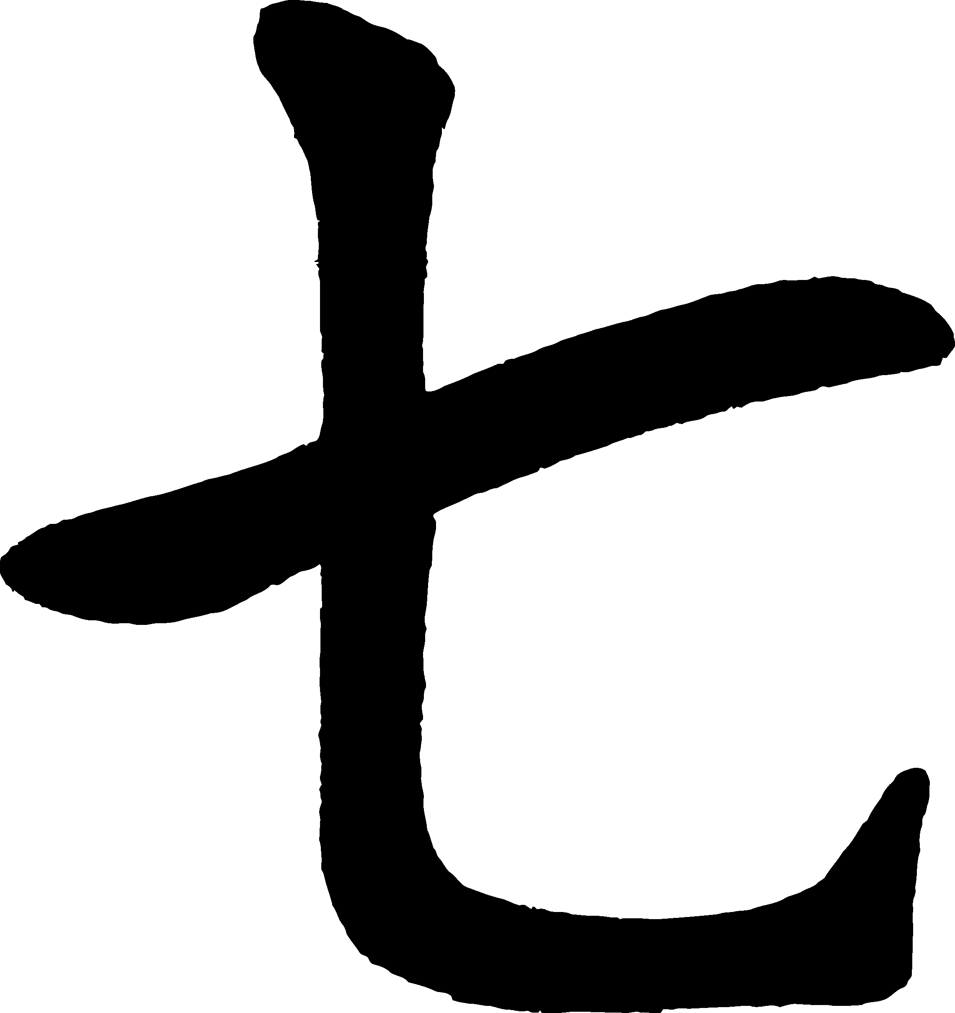

qī

(chee)

8

eight

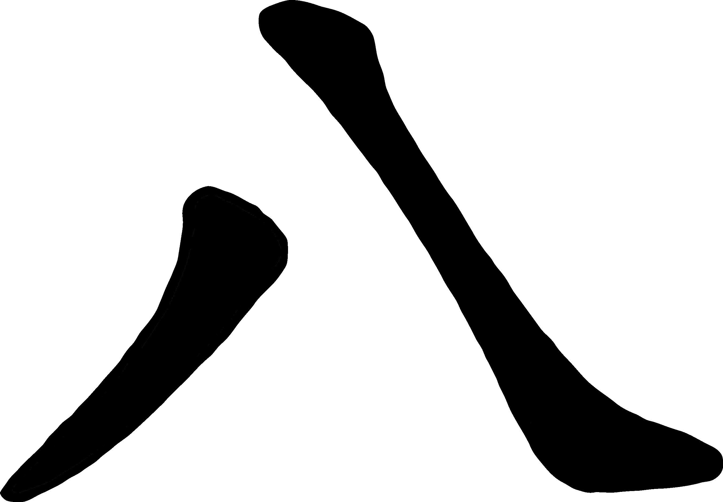

bā

(bah)

© 2019 Little Owls Resources

© 2019 Little Owls Resources

9

nine

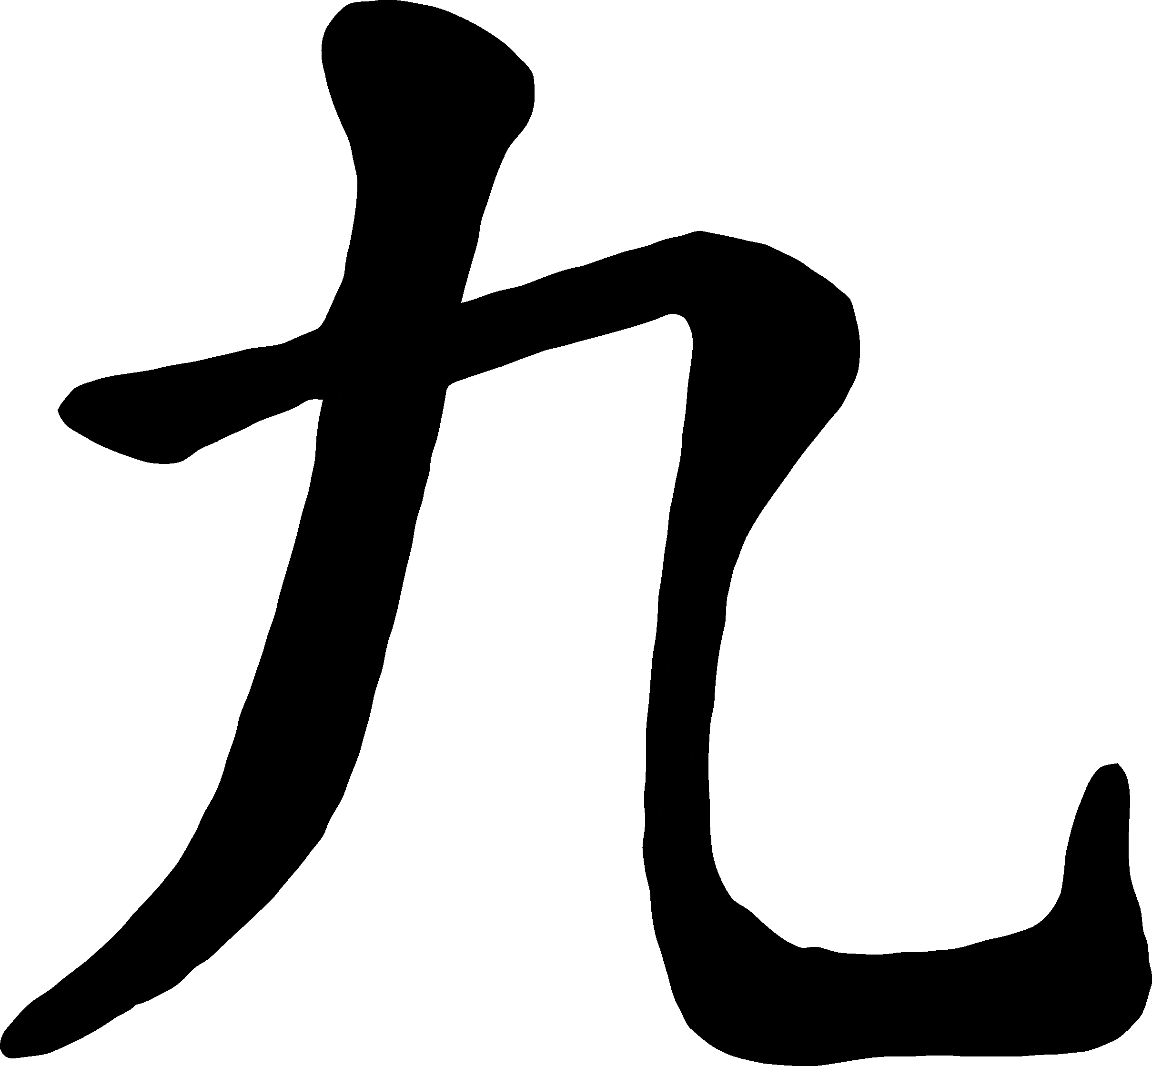

jiǔ

(jyo)

10

ten

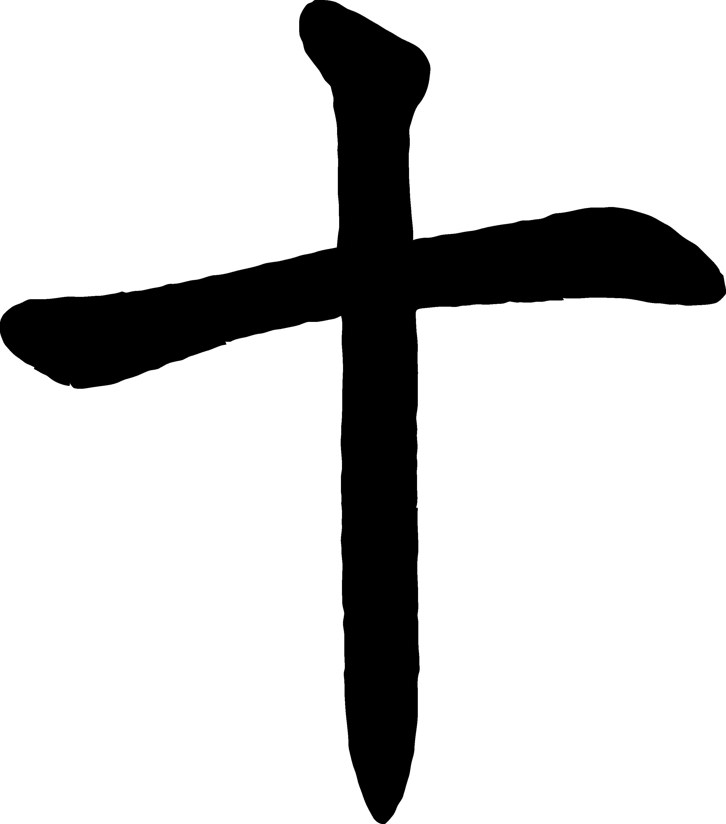

shí

(shi)

© 2019 Little Owls Resources

© 2019 Little Owls Resources