**The Great Race**

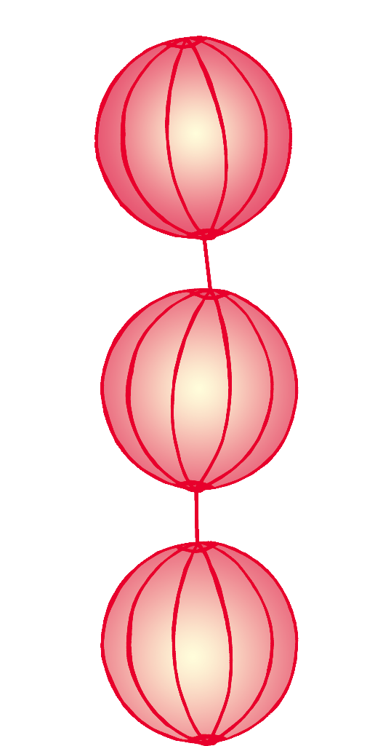

© 2019 Little Owls Resources

1

first

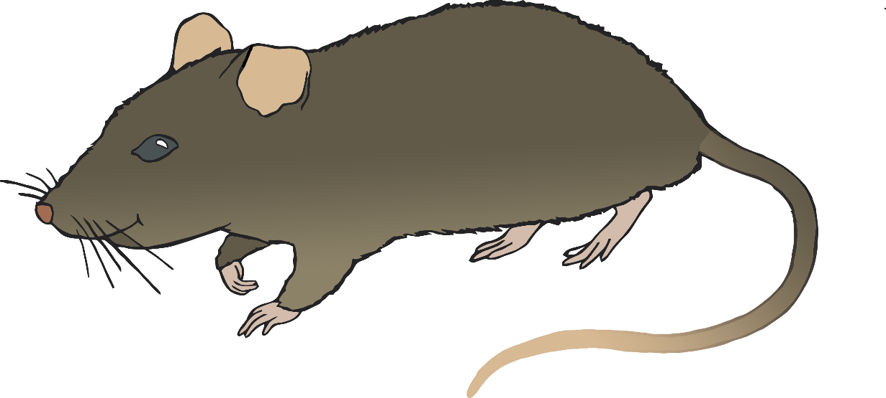

© 2019 Little Owls Resources

2

second

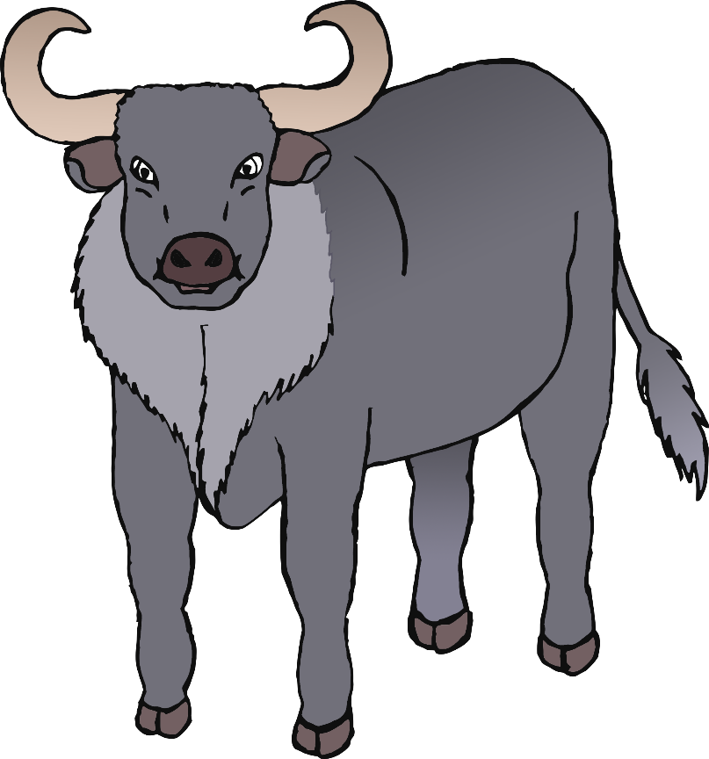

© 2019 Little Owls Resources

3

third

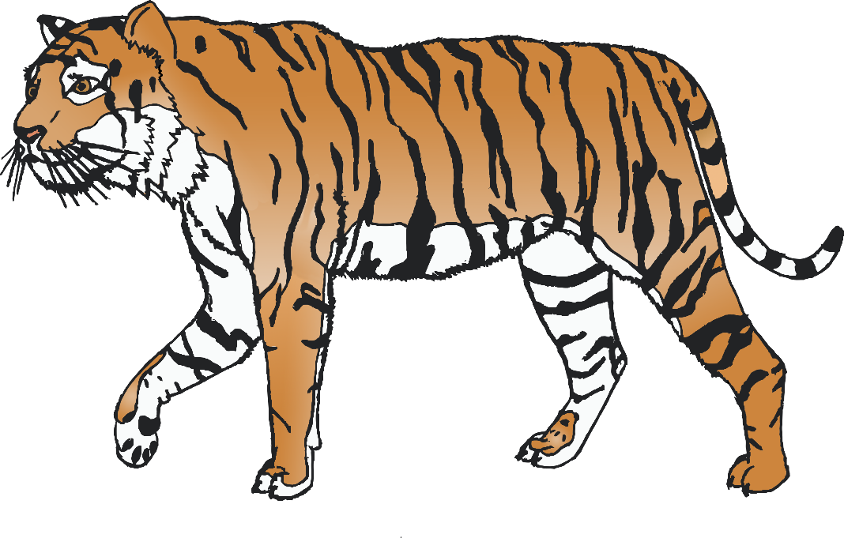

© 2019 Little Owls Resources

**4**

**fourth**

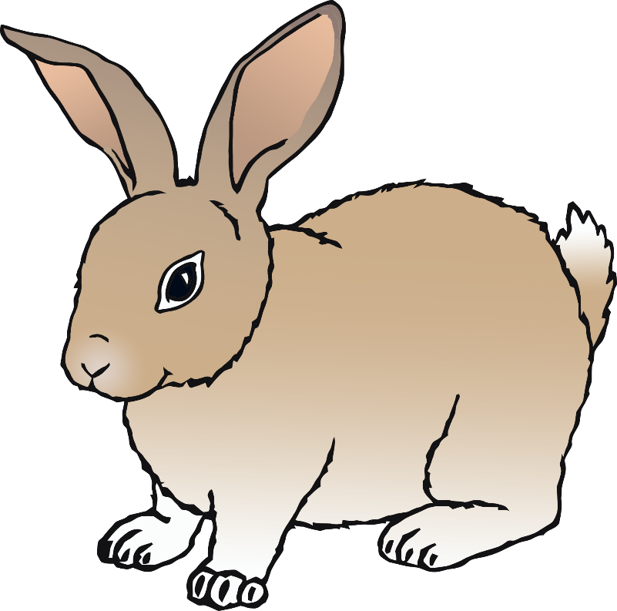

© 2019 Little Owls Resources

5

fifth

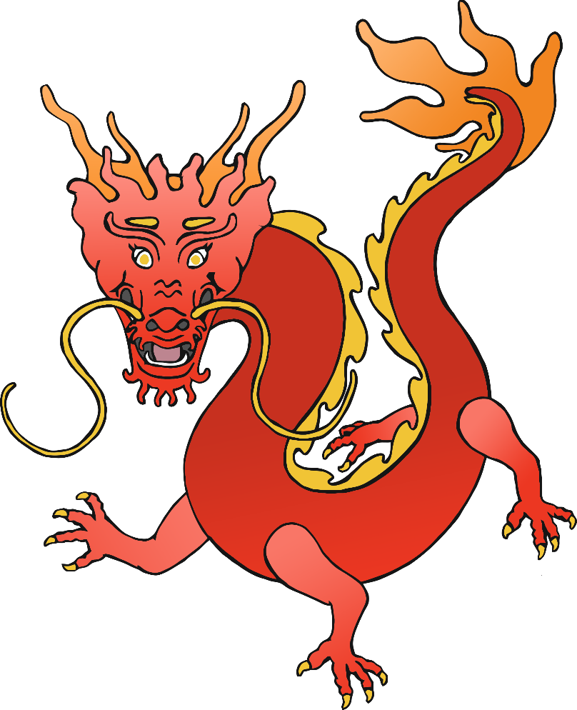

© 2019 Little Owls Resources

6

sixth

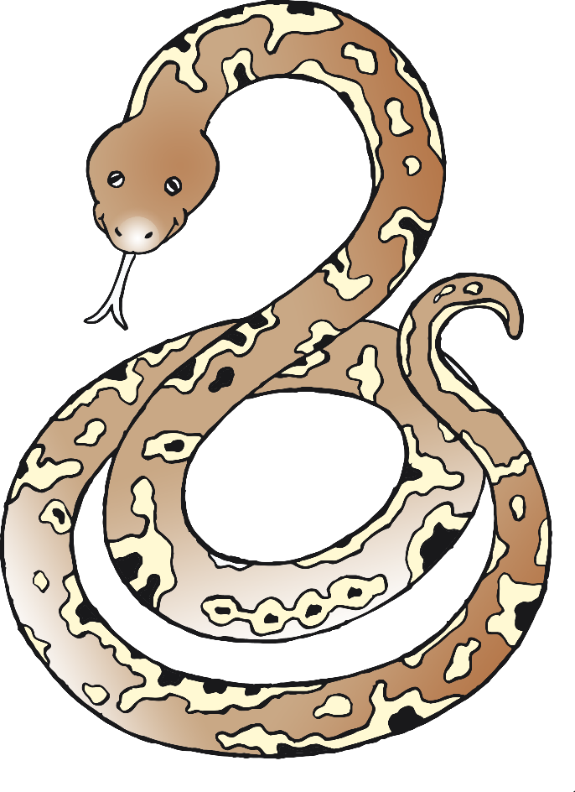

© 2019 Little Owls Resources

7

seventh

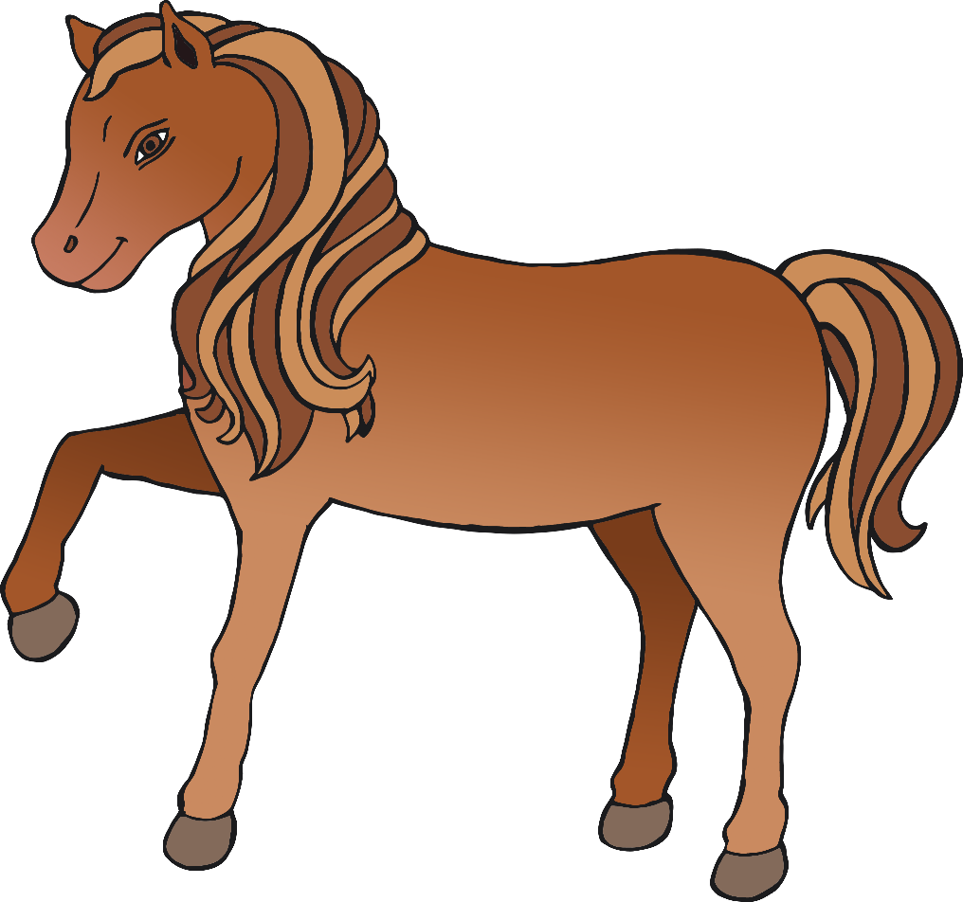

© 2019 Little Owls Resources

8

eighth

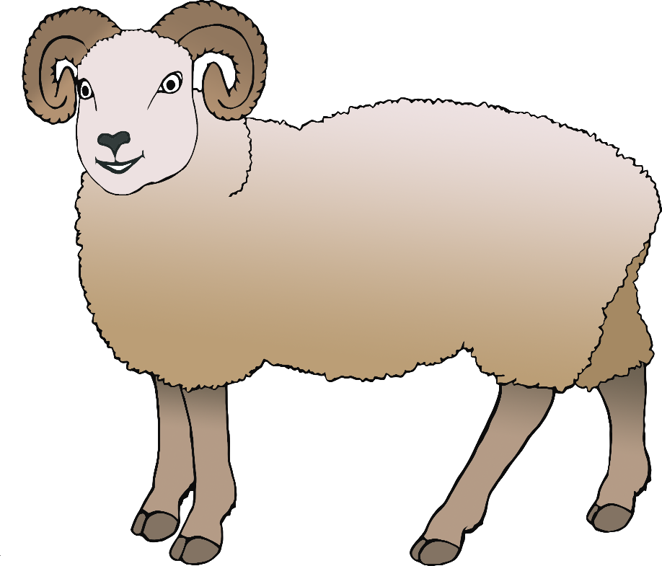

© 2019 Little Owls Resources

9

ninth

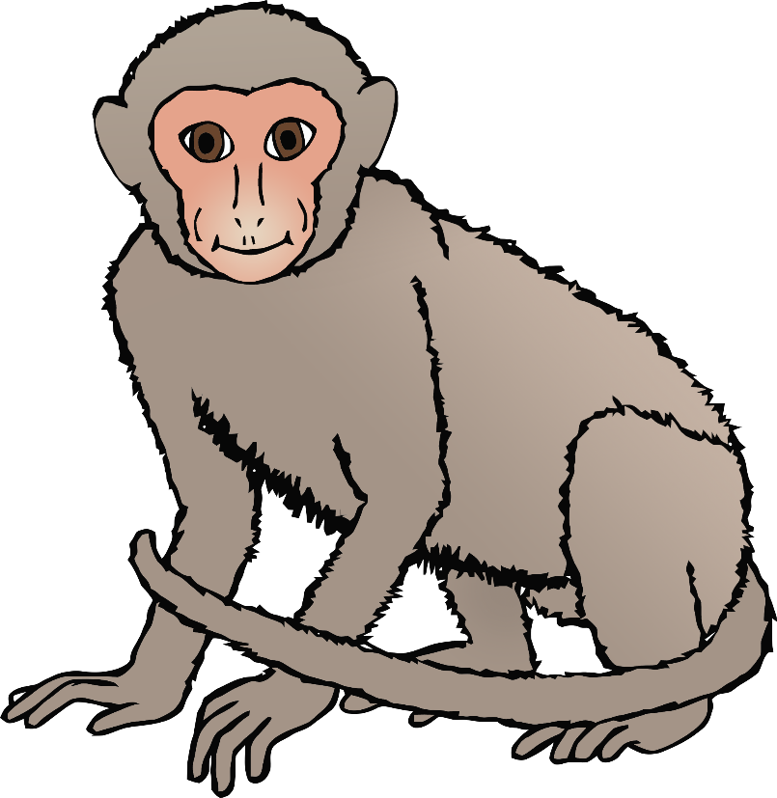

© 2019 Little Owls Resources

10

tenth

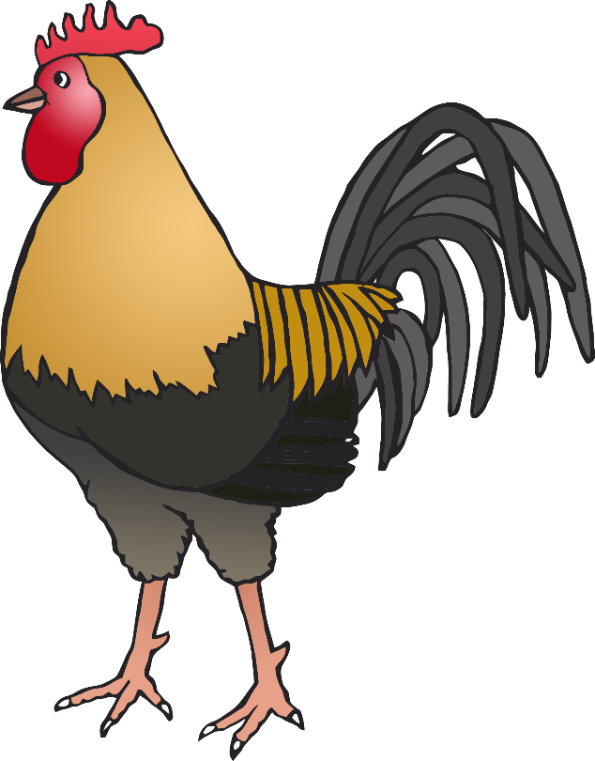

© 2019 Little Owls Resources

11

eleventh

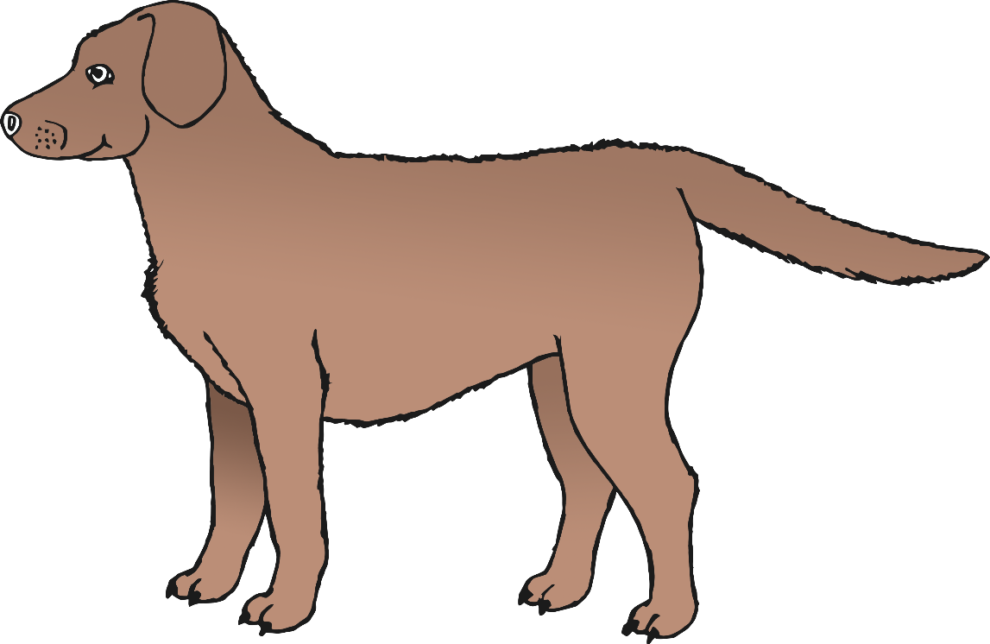

© 2019 Little Owls Resources

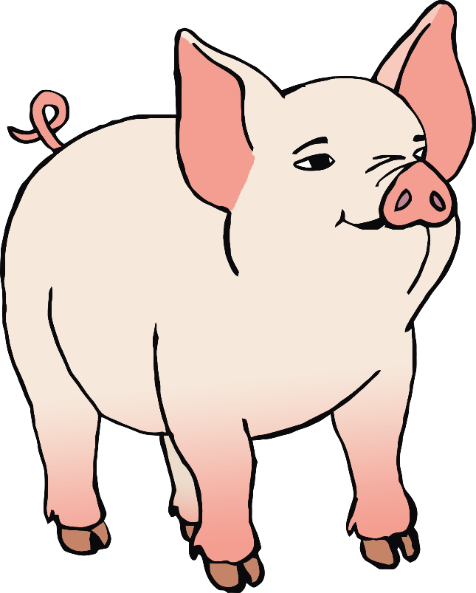

12

© 2019 Little Owls Resources

twelfth



© 2019 Little Owls Resources