tiger

rat

ox

Wolf

© 2021 Little Owls Resources

© 2021 Little Owls Resources

© 2021 Little Owls Resources

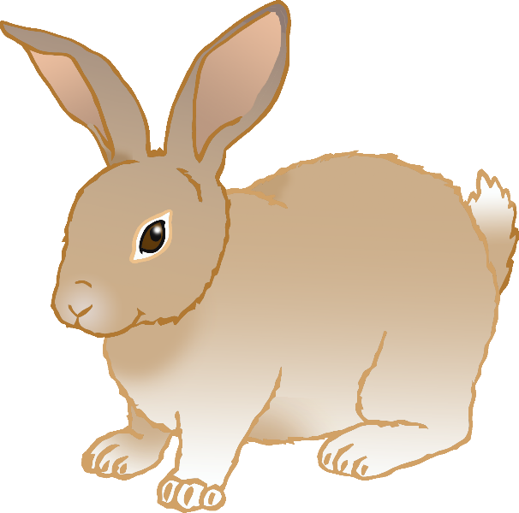

dragon

rabbit

snake

© 2021 Little Owls Resources

© 2021 Little Owls Resources

© 2021 Little Owls Resources

ram

© 2021 Little Owls Resources

© 2021 Little Owls Resources

© 2021 Little Owls Resources

monkey

horse

© 2021 Little Owls Resources

pig

rooster

dog

© 2021 Little Owls Resources

© 2021 Little Owls Resources