© 2021 Little Owls Resources

lantern

spoon

rice

**Chinese New Year Word Mat**

noodles

spring rolls

chopsticks

prawn crackers

sweetcorn soup

red envelope

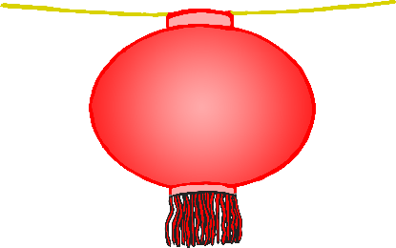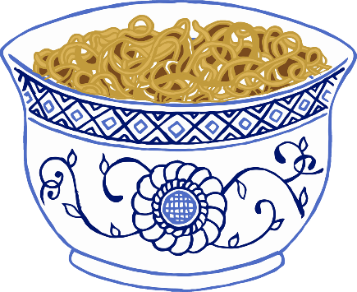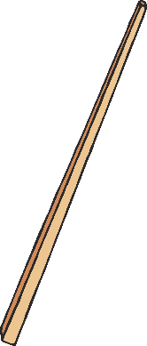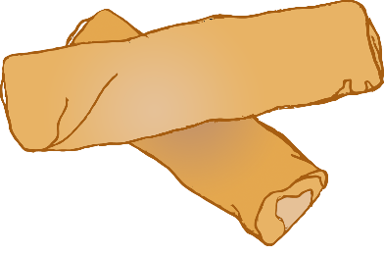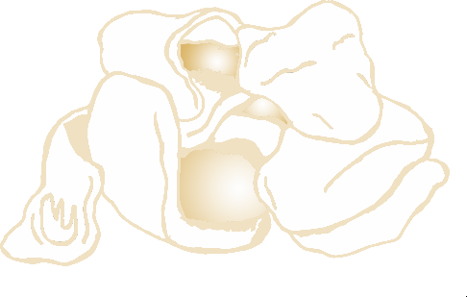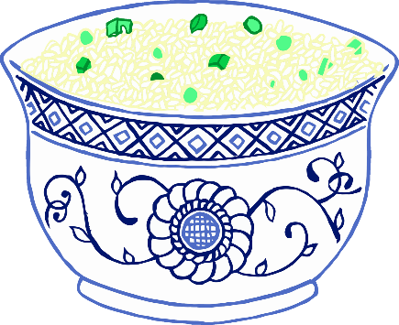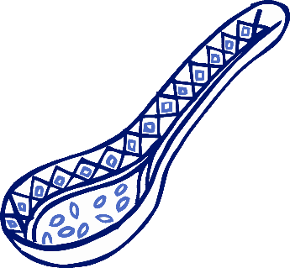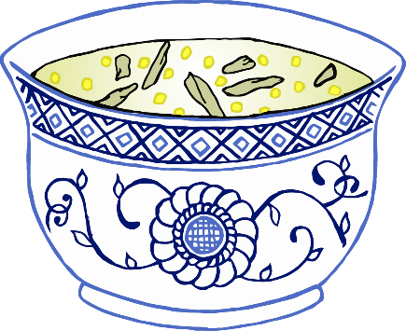

© 2021 Little Owls Resources

lantern

spoon

rice

**Lunar New Year Word Mat**

noodles

spring rolls

chopsticks

prawn crackers

sweetcorn soup

red envelope

