chopsticks

spoon

lantern

© 2021 Little Owls Resources

© 2021 Little Owls Resources

© 2021 Little Owls Resources

spring rolls

noodles

© 2021 Little Owls Resources

© 2021 Little Owls Resources

© 2021 Little Owls Resources

rice

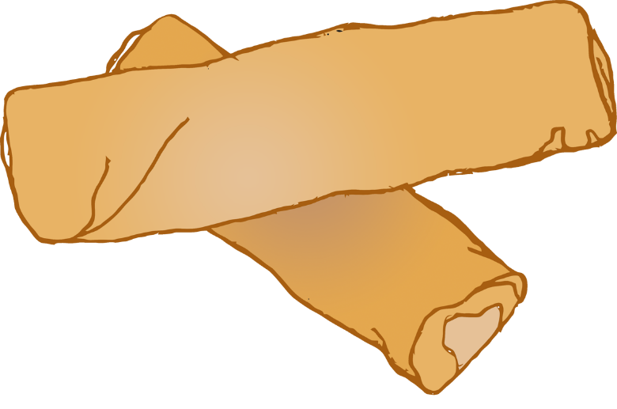

© 2021 Little Owls Resources

red envelope

prawn crackers

sweetcorn soup

© 2021 Little Owls Resources

© 2021 Little Owls Resources