Chinese / Lunar New Year cards

© 2022 Little Owls Resources

Design activity

Chinese New Year cards p2-11

Lunar New Year cards p12-21

© 2022 Little Owls Resources

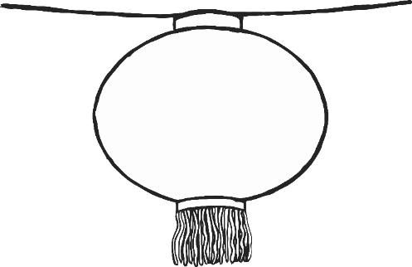

Happy Chinese New Year!



Happy Chinese New Year!

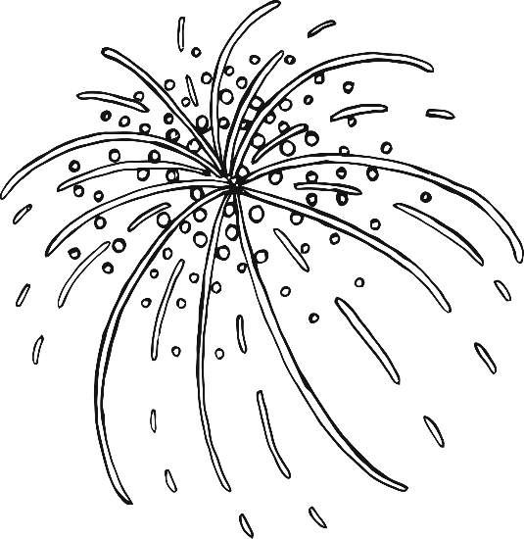



Year of the Dragon

© 2022 Little Owls Resources

Happy Chinese New Year!

© 2022 Little Owls Resources

2024

The Year of the Dragon

© 2022 Little Owls Resources

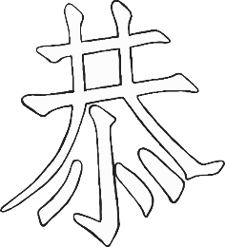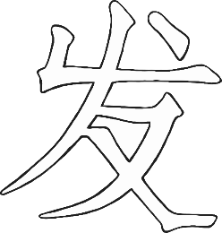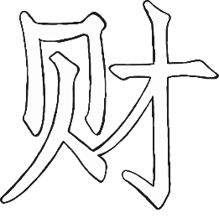

Happy New Year!

© 2022 Little Owls Resources

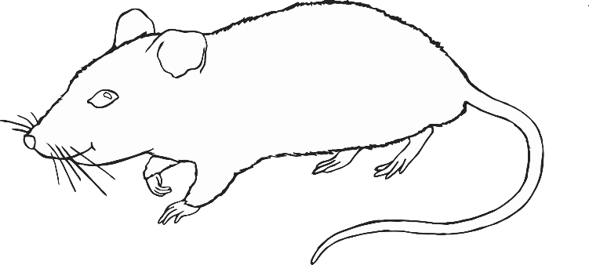

© 2022 Little Owls Resources

Happy New Year!



Happy

New

Year!

© 2022 Little Owls Resources

Happy

New

Year!

© 2022 Little Owls Resources

© 2022 Little Owls Resources

Happy

Chinese

New

Year!

© 2022 Little Owls Resources

Happy Chinese

New Year!

© 2022 Little Owls Resources



Happy Lunar New Year!



Happy Lunar New Year!



Year of the Dragon

© 2022 Little Owls Resources

Happy Lunar New Year!

© 2022 Little Owls Resources

2023

The Year of the Dragon

© 2022 Little Owls Resources

Happy Lunar New Year!

© 2022 Little Owls Resources

Happy Lunar New Year!

© 2022 Little Owls Resources

Happy

LUNAR

New

Year!

© 2022 Little Owls Resources

Happy

New

Year!

© 2022 Little Owls Resources

© 2022 Little Owls Resources

Happy

Lunar

New

Year!

© 2022 Little Owls Resources

Happy Lunar

New Year!