Chinese / Lunar New Year cards

Chinese New Year cards p2-11

Lunar New Year cards p12-21

Design activity

© 2022 Little Owls Resources

© 2022 Little Owls Resources

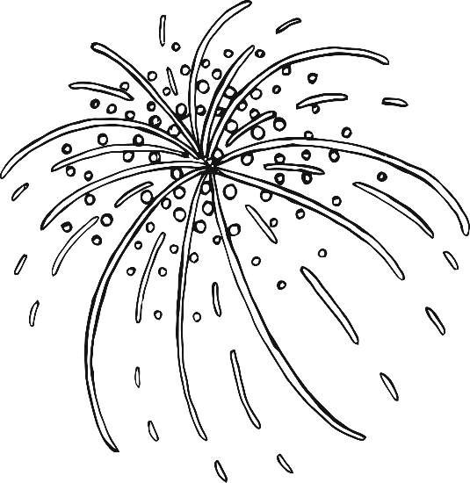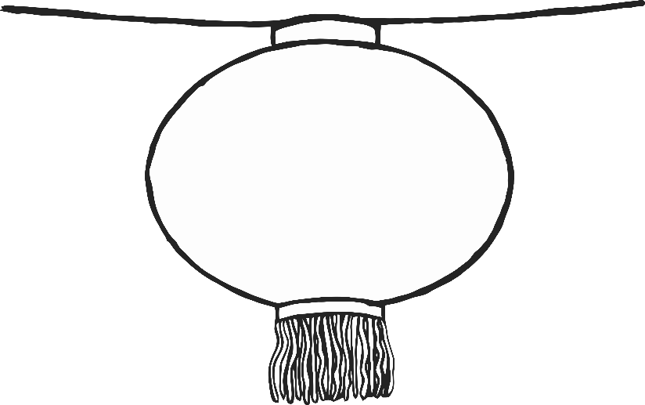

Happy

Chinese

New Year!

© 2022 Little Owls Resources

Happy Chinese New Year!

Year of the Dragon

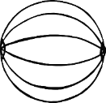

© 2022 Little Owls Resources

Happy Chinese New Year!

© 2022 Little Owls Resources

2024

The Year of the Dragon

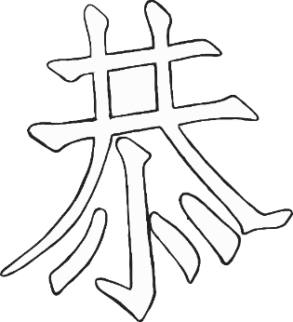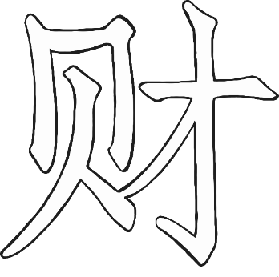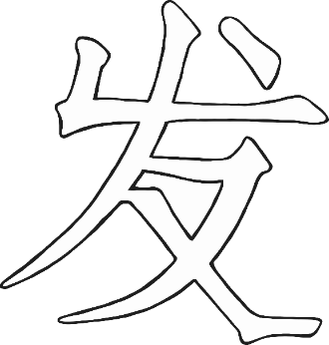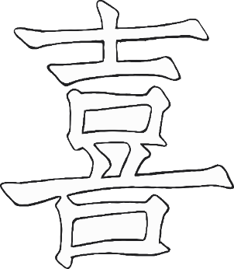

Happy New Year!

© 2022 Little Owls Resources

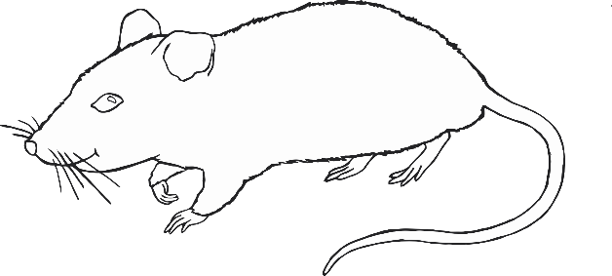

Happy New Year!

© 2022 Little Owls Resources



Happy New Year!

© 2022 Little Owls Resources

Happy

New

Year!

© 2022 Little Owls Resources

Happy

Chinese

New

Year!

© 2022 Little Owls Resources

Happy Chinese New Year!

© 2022 Little Owls Resources

© 2022 Little Owls Resources



Happy

Lunar

New Year!

© 2022 Little Owls Resources

Happy Lunar New Year!

Year of the Dragon



© 2022 Little Owls Resources

Happy Lunar New Year!

© 2022 Little Owls Resources

2024

The Year of the Dragon

Happy Lunar New Year!

© 2022 Little Owls Resources

Happy Lunar New Year!

© 2022 Little Owls Resources

Happy LUNAR New Year!

© 2022 Little Owls Resources

Happy

New

Year!

© 2022 Little Owls Resources

Happy

Lunar

New

Year!

© 2022 Little Owls Resources

Happy Lunar New Year!

© 2022 Little Owls Resources