Chinese / Lunar Activity Challenge cards

© 2022 Little Owls Resources

Chinese New Year p2-7

Lunar New Year p8-13

**Chinese New Year**

Scuttle slowly…then fast! Stop!

**Sniff! Sniff!**

**1st Place**

© 2019 Little Owls Resources

Rat

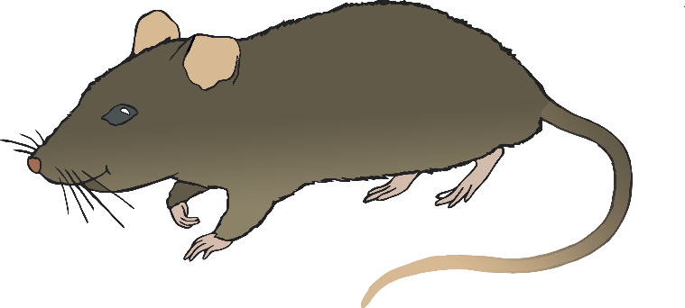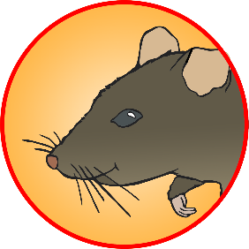

**Chinese New Year**

Strong heavy steps. Pull your heavy load…

**Step! Step!**

**2nd Place**

© 2019 Little Owls Resources

Ox

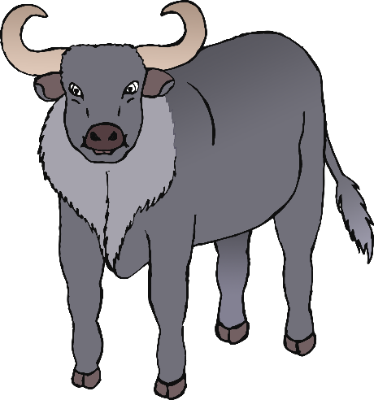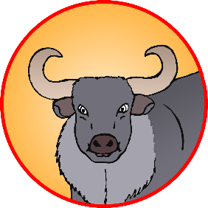

**Chinese New Year**

**3rd Place**

© 2019 Little Owls Resources

Tiger

**Chinese New Year**

**4th Place**

© 2019 Little Owls Resources

Rabbit

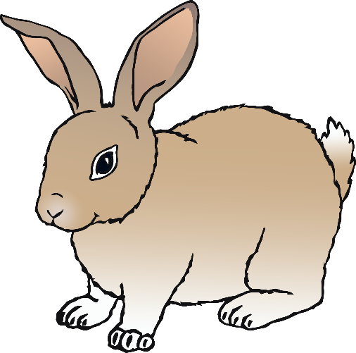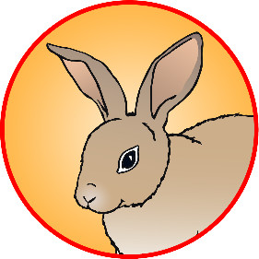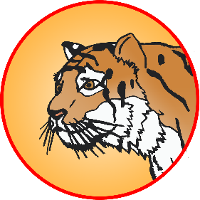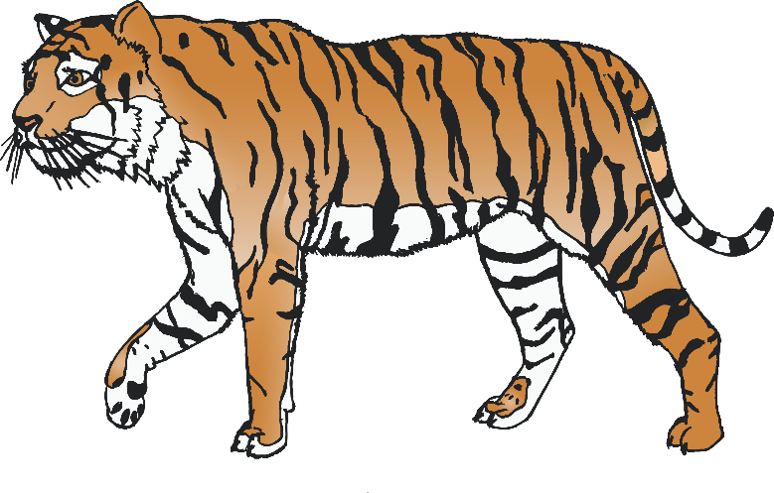

Keep very still…then…

Pounce!

Crouch down and make small hops

Hop! Hop!

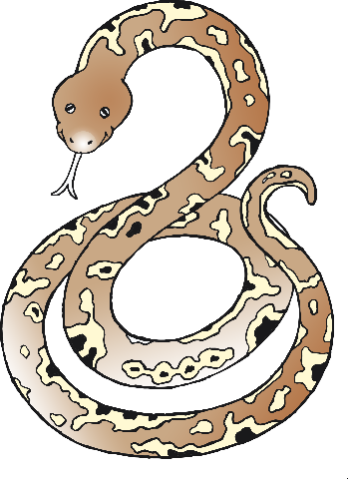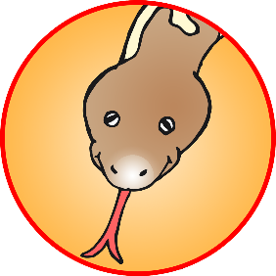

**Chinese New Year**

**5th Place**

© 2019 Little Owls Resources

Dragon

**Chinese New Year**

**6th Place**

© 2019 Little Owls Resources

Snake

Prowl and growl…then…

Jump! Jump!

Slither and slide along the floor…

Slither! Slide!

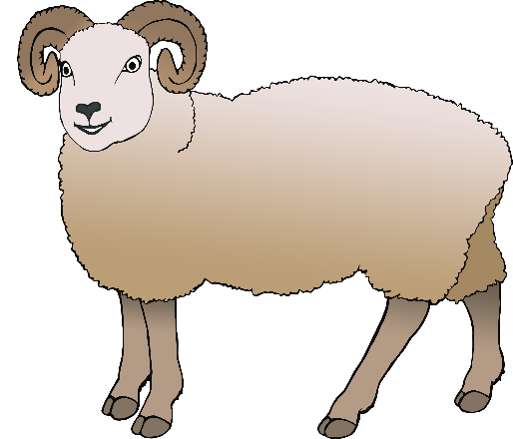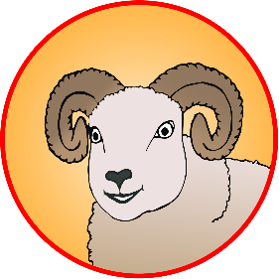

**Chinese New Year**

**7th Place**

© 2019 Little Owls Resources

Horse

**Chinese New Year**

**8th Place**

© 2019 Little Owls Resources

Ram

Trot along with bouncy steps and high knees.

Trot! Trot!

Bend down to eat some grass…then look up and around as you chew…

**Munch! Munch!**

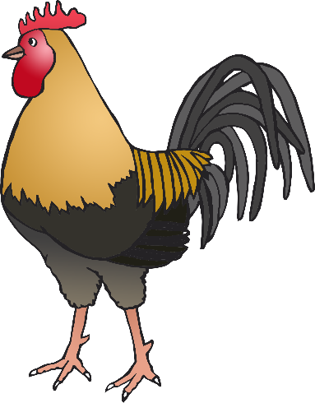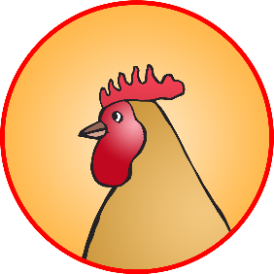

**Chinese New Year**

**9th Place**

© 2019 Little Owls Resources

Monkey

**Chinese New Year**

**10th Place**

© 2019 Little Owls Resources

Rooster

Pretend to climb up through the trees… leap from branch to branch…

Jump! Leap!

Stand straight and tall and walk stiffly… then pretend to peck the floor to eat.

Peck! Peck!

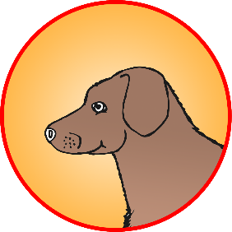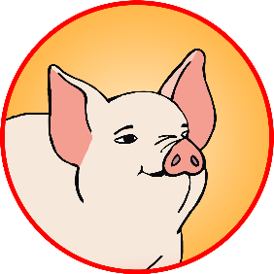

**Chinese New Year**

**11th Place**

© 2019 Little Owls Resources

Dog

**Chinese New Year**

**12th Place**

© 2019 Little Owls Resources

Pig

Run and jump and run and jump!

Run! Jump!

Crawl around and snort as you search for food!

Snort! Snort!

**Lunar New Year**

Scuttle slowly…then fast! Stop!

**Sniff! Sniff!**

**1st Place**

© 2019 Little Owls Resources

Rat



**Lunar New Year**

Strong heavy steps. Pull your heavy load…

**Step! Step!**

**2nd Place**

© 2019 Little Owls Resources

Ox



**Lunar New Year**

**3rd Place**

© 2019 Little Owls Resources

Tiger

**Lunar New Year**

**4th Place**

© 2019 Little Owls Resources

Rabbit



Keep very still…then…

Pounce!

Crouch down and make small hops

Hop! Hop!

**Lunar New Year**

**5th Place**

© 2019 Little Owls Resources

Dragon

**Lunar New Year**

**6th Place**

© 2019 Little Owls Resources

Snake

Prowl and growl…then…

Jump! Jump!

Slither and slide along the floor…

Slither! Slide!

**Lunar New Year**

**7th Place**

© 2019 Little Owls Resources

Horse

**Lunar New Year**

**8th Place**

© 2019 Little Owls Resources

Ram

Trot along with bouncy steps and high knees.

Trot! Trot!

Bend down to eat some grass…then look up and around as you chew…

**Munch! Munch!**

**Lunar New Year**

**9th Place**

© 2019 Little Owls Resources

Monkey

**Lunar New Year**

**10th Place**

© 2019 Little Owls Resources

Rooster

Pretend to climb up through the trees… leap from branch to branch…

Jump! Leap!

Stand straight and tall and walk stiffly… then pretend to peck the floor to eat.

Peck! Peck!

**Lunar New Year**

**11th Place**

© 2019 Little Owls Resources

Dog

**Lunar New Year**

**12th Place**

© 2019 Little Owls Resources

Pig

Run and jump and run and jump!

Run! Jump!

Crawl around and snort as you search for food!

Snort! Snort!