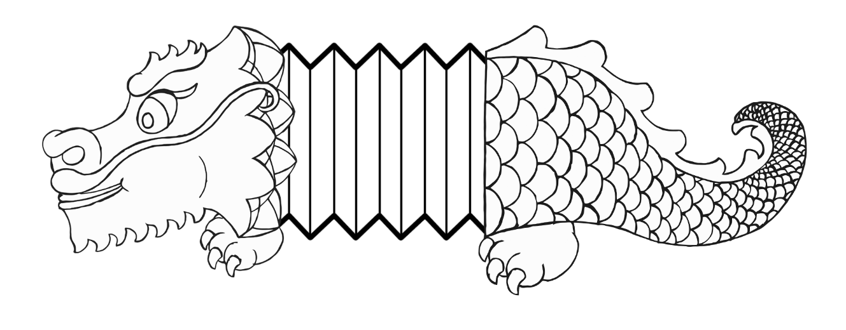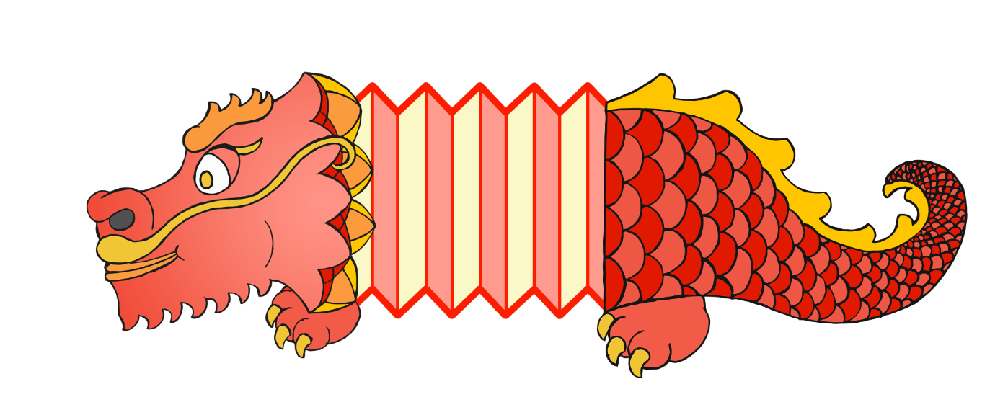

Chinese Dragon Puppet



|  |  |  |  |  |  |  |  |  |  |  |  |  |
| --- | --- | --- | --- | --- | --- | --- | --- | --- | --- | --- | --- | --- |
|  |  |  |  |  |  |  |  |  |  |  |  |  |

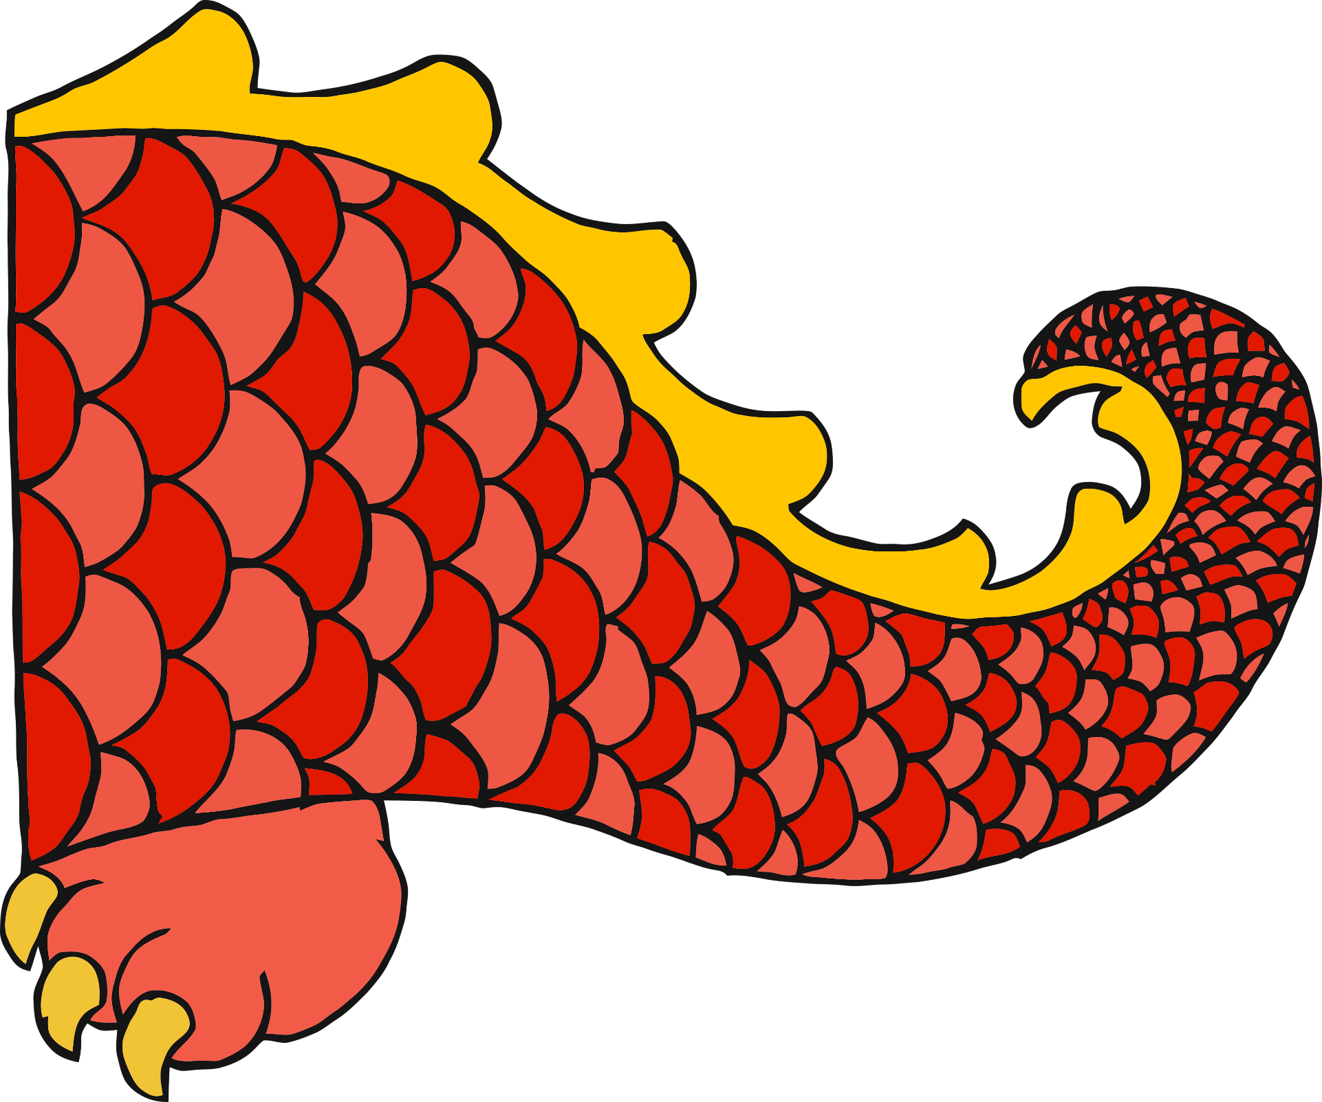

© 2019 Little Owls Resources



                          
                          
                          

