**Chimpanzee**

The pages of this pack give some general information about chimpanzees and some fun and engaging activities to foster and develop children’s interest in them.

**This pack includes:**

* Fact posters x3 (Could be used as stimuli for a lesson input)
* Number slice activity (1-10) (Can be pre-cut for a pure number ordering activity or left to be cut by child to add scissor practice)
* Number slice activity - colouring version (1-10) (As above but to be coloured before cutting)
* Description sheet (Can be used as an independent writing activity or with an adult scribing the ideas of a younger child)
* A4 poster
* A4 poster - colouring version
* ‘Body Parts’ x3 (fully labelled, initial sounds only, blank)
* Draw and write sheets x3 (blank sheet, wide lines and narrow lines)
* 1x 4-piece puzzle
* Multimats x2 (for Colouring/Art & Craft/Loose Parts/Playdough)

© 2021 Little Owls Resources

This pack includes:

The pages of this pack give some general information about the role of a paramedic and some fun and engaging activities to foster and develop children’s interest in this role in society.

© 2021 Little Owls Resources

**Chimpanzee Facts**

Wild chimpanzees can live for

years.

**40**

Chimpanzees eat **plants**, **fruit**, **seeds**, **insects** and sometimes **meat**.

Chimpanzees are the closest animal relative to humans!

Humans have hunted and killed many chimpanzees.

Humans have destroyed lots of places that chimpanzees used to live.

This means there is a very high risk that they may become extinct.



**Chimpanzees are** Endangered.

© 2021 Little Owls Resources

**How big is a Chimpanzee?**



© 2021 Little Owls Resources

100cm / 1m

1

2

3

4

5

6

7

8

9

10

© 2021 Little Owls Resources

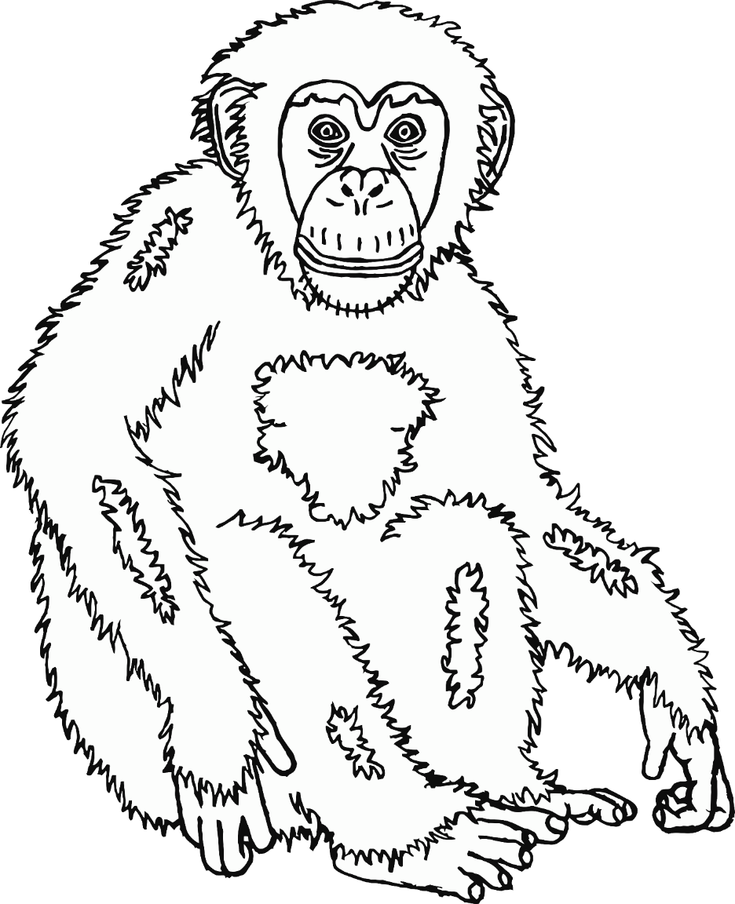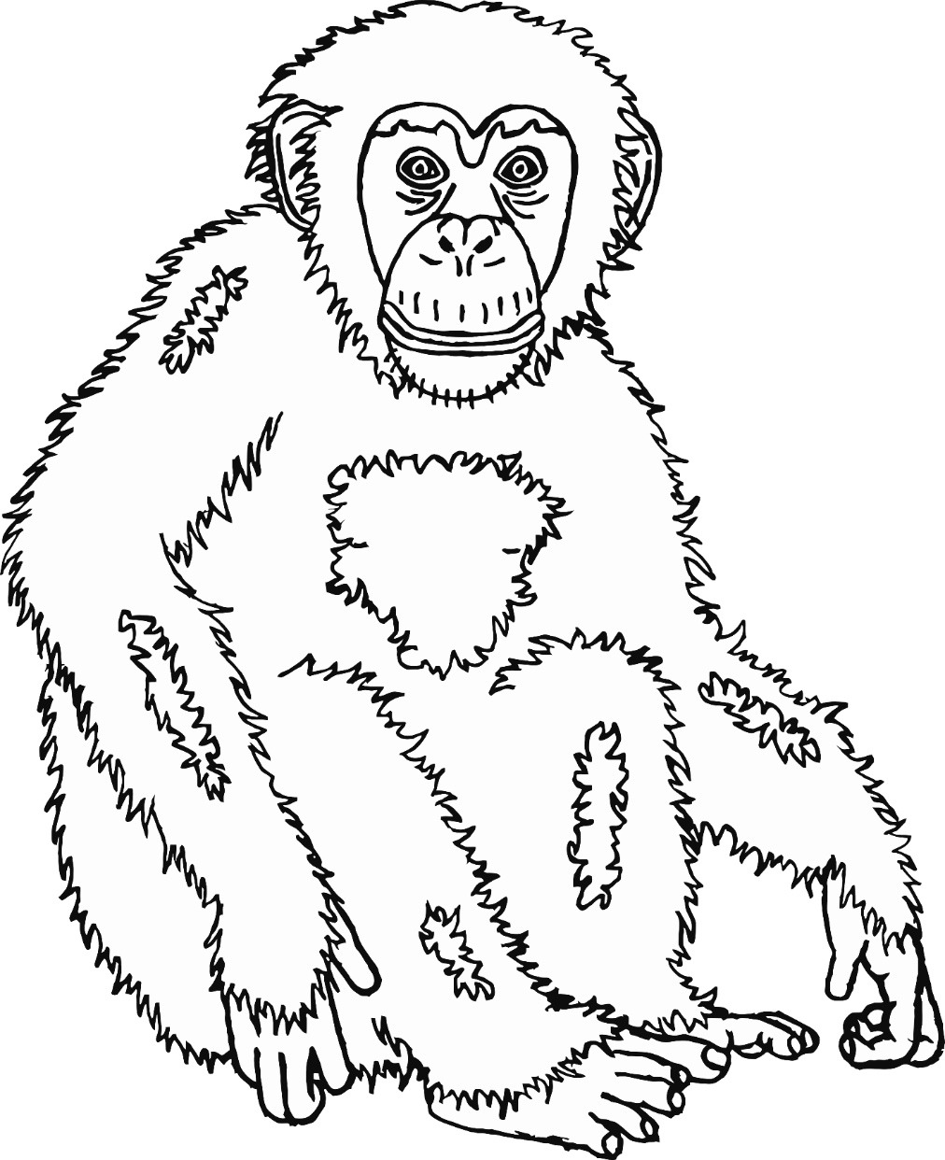

© 2021 Little Owls Resources

1

2

3

4

5

6

7

8

9

10

© 2021 Little Owls Resources

**What words would you use to describe a chimpanzee?**

**Chimpanzee**

© 2021 Little Owls Resources

**Chimpanzee**

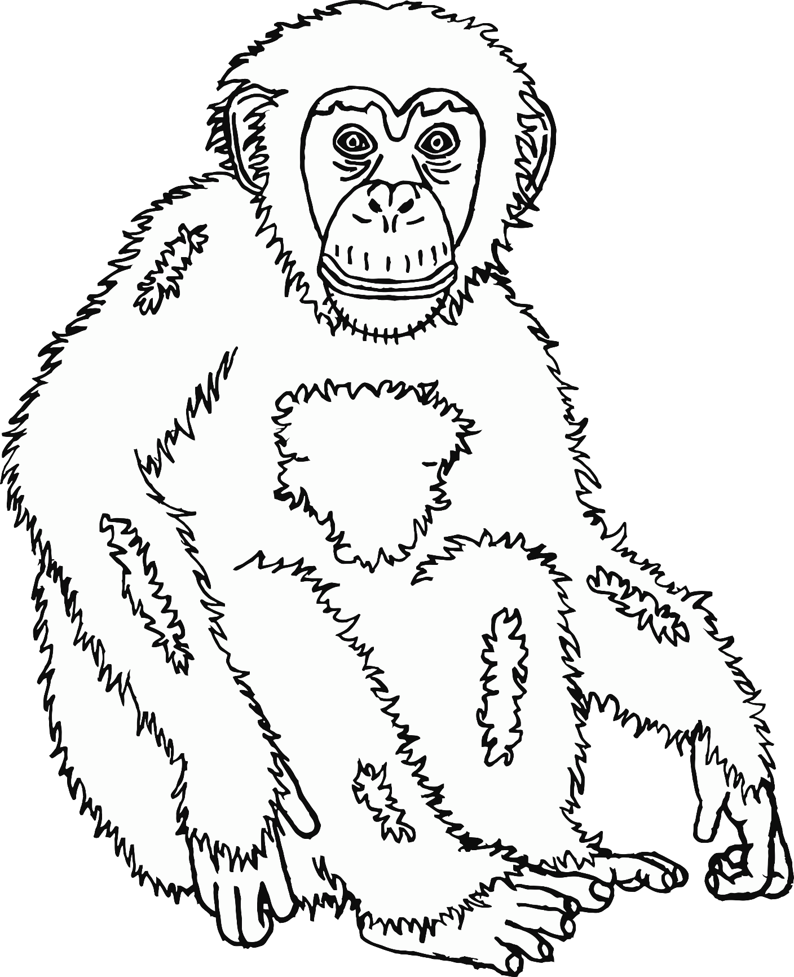

© 2021 Little Owls Resources

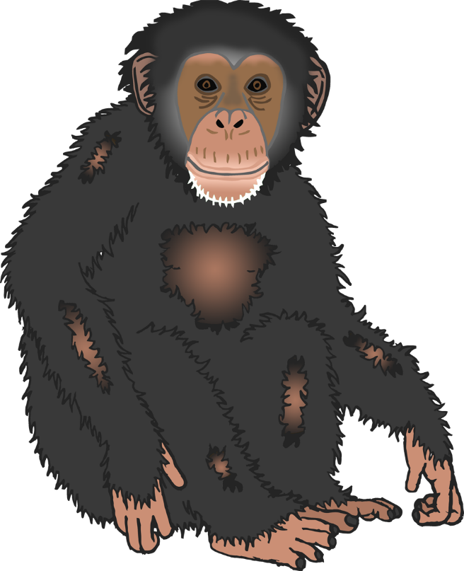

**Chimpanzee body parts**

© 2021 Little Owls Resources

ear

mouth

hand

foot

arm

eye



**Chimpanzee body parts**

© 2021 Little Owls Resources

e

m

h

f

a

e



**Chimpanzee body parts**

© 2021 Little Owls Resources

© 2021 Little Owls Resources

**Draw a Chimpanzee!**

© 2021 Little Owls Resources

**Draw and write about a Chimpanzee!**

____________________________________________________

© 2021 Little Owls Resources

**Draw and write about a Chimpanzee!**

______________________________________________________________________________________________________

**Chimpanzee**

© 2021 Little Owls Resources

© 2021 Little Owls Resources

**Chimpanzee Multimat – Chimpanzee**



© 2021 Little Owls Resources

**Chimpanzee Multimat – Chimpanzees**

