Chicken

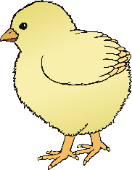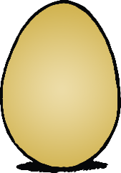

**Chicken Life Cycle**

© 2020 Little Owls Resources

Egg

Chick

© 2020 Little Owls Resources

**Chicken Life Cycle**

Egg

Chicken

Chick