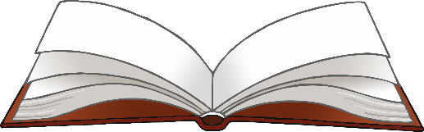

**Character Talk**

Write what they would say.

Draw a character.

© 2023 Little Owls Resources



Draw a character.

Write what they would say.

© 2023 Little Owls Resources

**Character Talk**