Character Sheet

Name:

Age:

What do they like to eat?

What do they like to drink?

What do they do for fun?

Special ability:

Character Sheet

Name:

Age:

What do they like to eat?

What do they like to drink?

What do they do for fun?

Special ability:

Character Sheet

Name:

Age:

What do they like to eat?

What do they like to drink?

What do they do for fun?

Special ability:

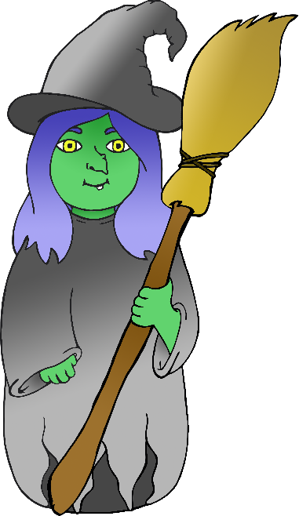

Character Sheet

Name:

Age:

What do they like to eat?

What do they like to drink?

What do they do for fun?

Special ability:

Character Sheet

Name:

Age:

What do they like to eat?

What do they like to drink?

What do they do for fun?

Special ability:

Character Sheet

Name:

Age:

What do they like to eat?

What do they like to drink?

What do they do for fun?

Special ability:

Character Sheet

Name:

Age:

What do they like to eat?

What do they like to drink?

What do they do for fun?

Special ability:

Character Sheet

Name:

Age:

What do they like to eat?

What do they like to drink?

What do they do for fun?

Special ability: