What will you put in the cauldron?

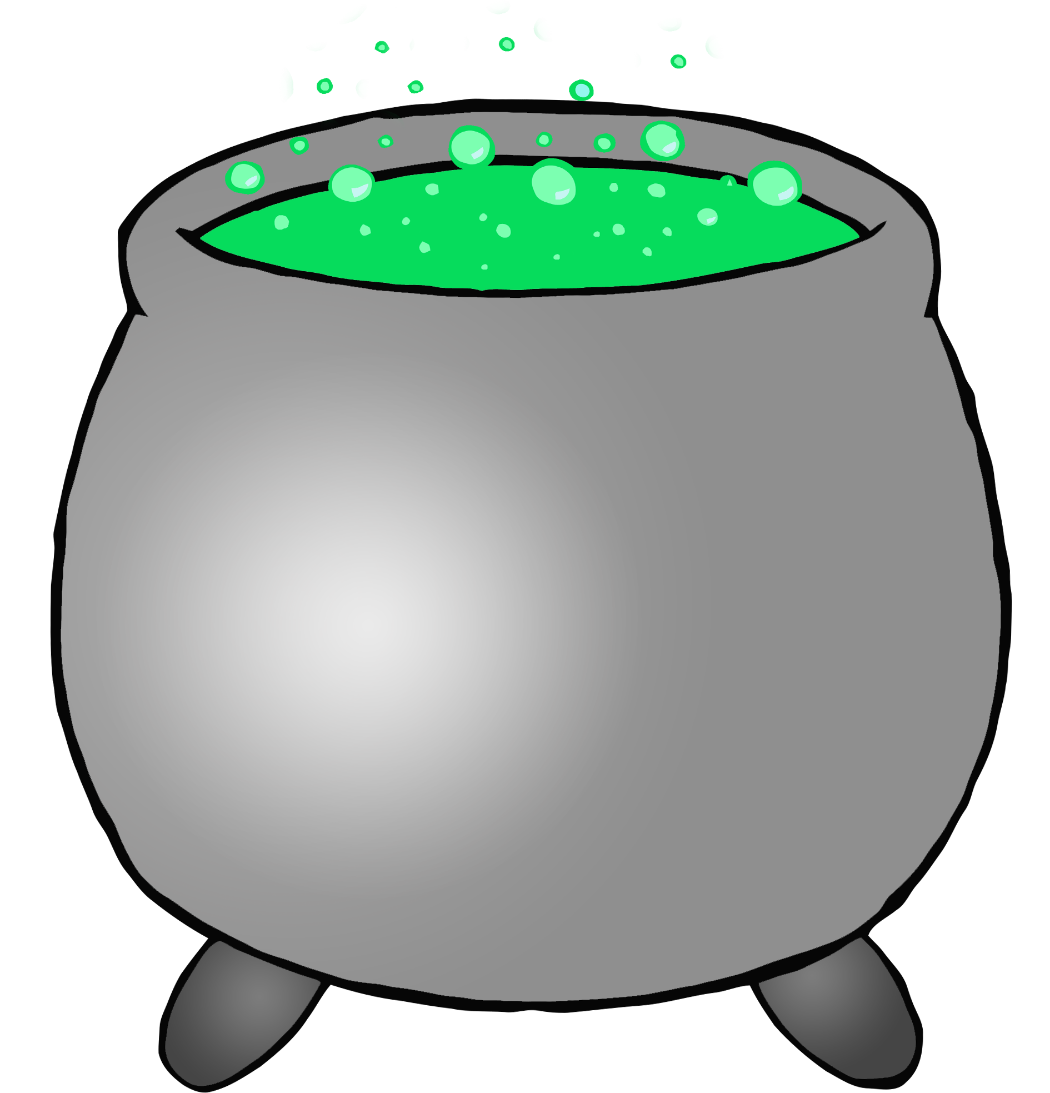

© 2019 Little Owls Resources

______________________________________________________________________________



What will you put in the cauldron?

© 2019 Little Owls Resources