**Catch it.**

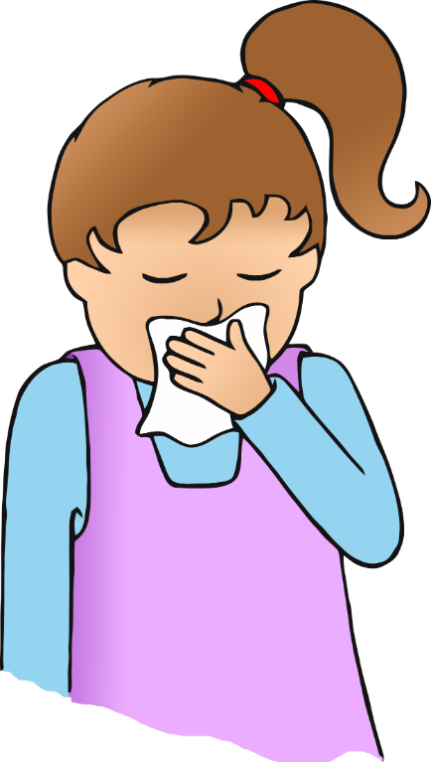

**Bin it.**

**Kill it.**

© 2020 Little Owls Resources

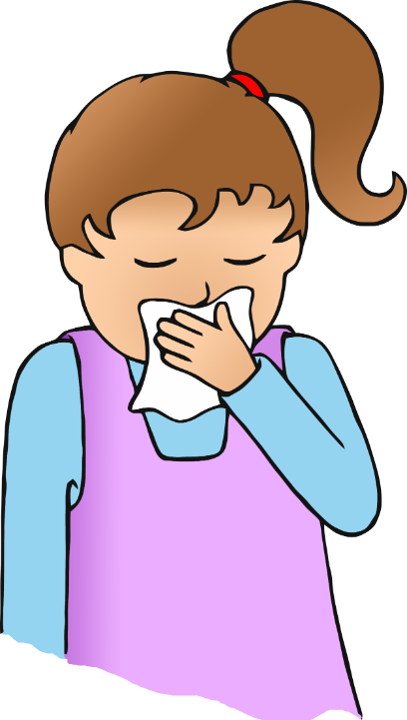

© 2020 Little Owls Resources

**CATCH IT.**

**KILL IT.**

**BIN IT.**