**What does a cat need?**

© 2021 Little Owls Resources

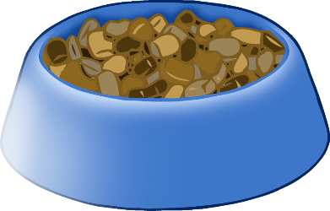

Scratching Post

Chew toys for fun

Healthy food and water

Brush for keeping clean