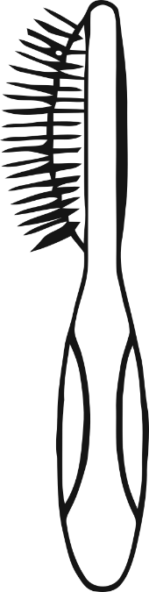

**What does a cat need?**

© 2021 Little Owls Resources

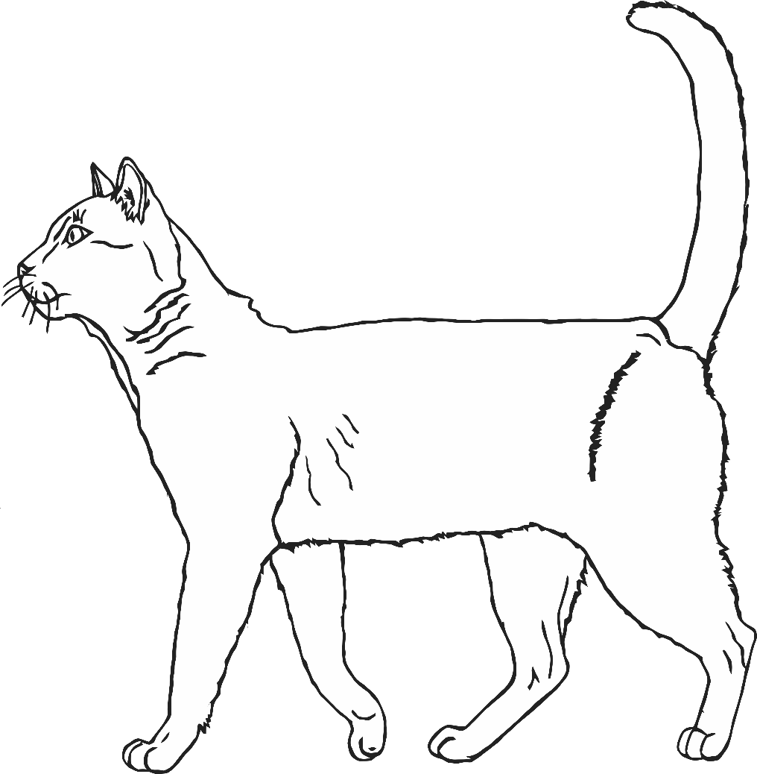

**Chew toys for fun**

**Scratching Post**

**Healthy food and water**

**Brush for keeping clean**