Cat Needs Game

Game for four players.

Each player has a coloured cat mat. Takes turns to turn a card. If it is an item of the correct colour place it on your mat.

The first player to get all five items of the right colour is the winner!

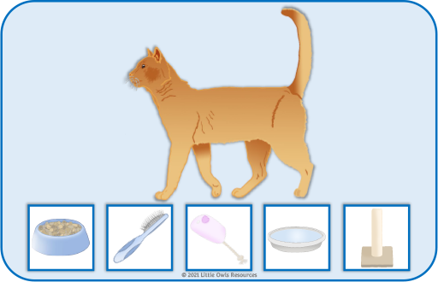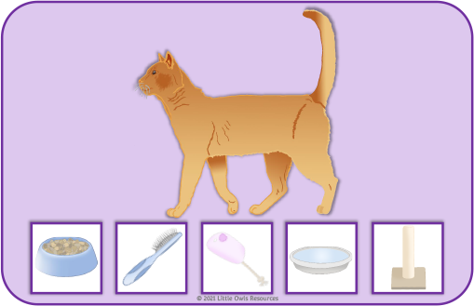

© 2021 Little Owls Resources

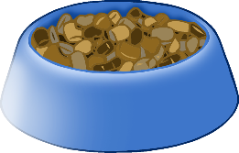

© 2021 Little Owls Resources

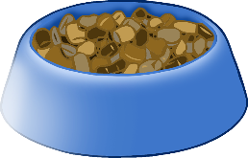

© 2021 Little Owls Resources

© 2021 Little Owls Resources

© 2021 Little Owls Resources

