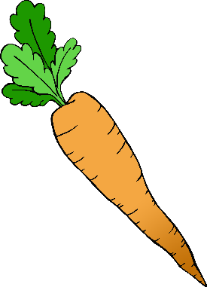

Make **1** carrot.

Can you make some carrots using playdough?

© 2020 Little Owls Resources



Make **2** carrots.

© 2020 Little Owls Resources

Can you make some carrots using playdough?



Make **3** carrots.

Can you make some carrots using playdough?

© 2020 Little Owls Resources

© 2020 Little Owls Resources



Make **4** carrots.

© 2020 Little Owls Resources

Can you make some carrots using playdough?



Make **5** carrots.

Can you make some carrots using playdough?

© 2020 Little Owls Resources



Make **6** carrots.

Can you make some carrots using playdough?

© 2020 Little Owls Resources



Make **7** carrots.

Can you make some carrots using playdough?

© 2020 Little Owls Resources



Make **8** carrots.

Can you make some carrots using playdough?

© 2020 Little Owls Resources



Make **9** carrots.

Can you make some carrots using playdough?

© 2020 Little Owls Resources



Make **10** carrots.

© 2020 Little Owls Resources

Can you make some carrots using playdough?