People Who Help Us

Caretaker

* Information Posters
* Information Posters (Colouring)
* Drawing/Writing Sheets
* Draw items Sheet
* Draw items Sheet (Colouring)
* Item Poster
* Item Poster (Colouring)
* Multimats for Art & Craft/Loose Parts/Playdough
* 5x 2-Piece individual items puzzles
* 1x 4-Piece all items puzzle

This pack includes:

The pages of this pack give some general information about the role of a caretaker and some fun and engaging activities to foster and develop children’s interest in this role in society.

© 2023 Little Owls Resources

© 2023 Little Owls Resources

Caretaker

I’m a **caretaker.**

I work at a school. I fix things that get broken or are not working properly.

It is my job to make sure the school grounds are safe and ready for the children and teachers to enjoy their day!

I have a big set of tools ready for anything that might need fixing!

Caretaker

I am in charge of locking and unlocking the school with my keys.

I use a broom to sweep up anything that might be dangerous.

If there is a dangerous spillage, I am ready with my mop!

© 2023 Little Owls Resources

.

Caretaker

© 2023 Little Owls Resources

I’m a **caretaker.**

I work at a school. I fix things that get broken or are not working properly.

It is my job to make sure the school grounds are safe and ready for the children and teachers to enjoy their day!

I have a big set of tools ready for anything that might need fixing!

Caretaker

I am in charge of locking and unlocking the school with my keys.

I use a broom to sweep up anything that might be dangerous.

If there is a dangerous spillage, I am ready with my mop!

© 2023 Little Owls Resources

© 2023 Little Owls Resources

**Draw a Caretaker!**

© 2023 Little Owls Resources

**Draw and write about a**

**Caretaker!**

_________________________________________________________

© 2023 Little Owls Resources

**Caretaker!**

**Draw and write about a**

________________________________________________________________________________________________________________________________________________

**Can you draw the items a caretaker needs?**

© 2023 Little Owls Resources

**Can you draw the items a caretaker needs?**

© 2023 Little Owls Resources

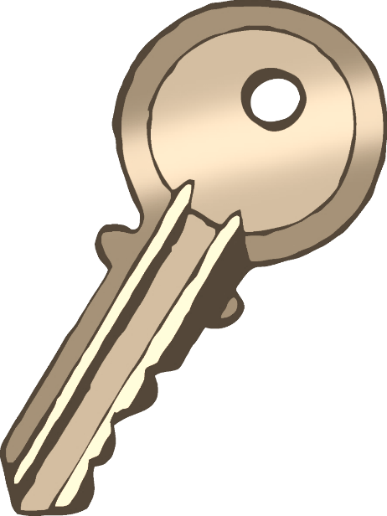

Caretaker

broom

© 2023 Little Owls Resources

mop

toolbox

keys

Caretaker

**broom**

**keys**

toolbox

© 2023 Little Owls Resources

mop

Caretaker Multimat – toolbox

© 2023 Little Owls Resources

Caretaker Multimat – broom and mop

© 2023 Little Owls Resources

Caretaker Multimat – keys

© 2023 Little Owls Resources

Caretaker Multimat – tools

© 2023 Little Owls Resources

© 2023 Little Owls Resources

© 2023 Little Owls Resources

© 2023 Little Owls Resources

© 2023 Little Owls Resources

© 2023 Little Owls Resources

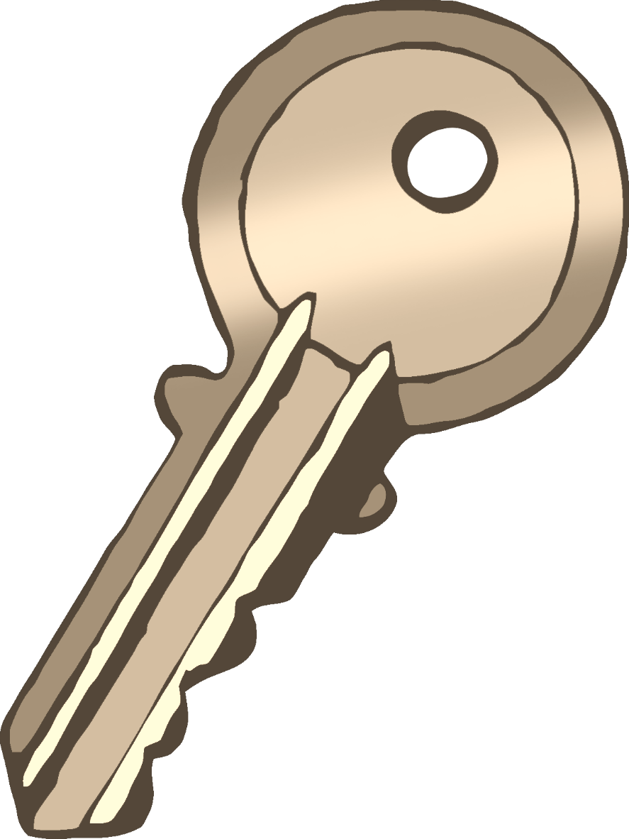

© 2023 Little Owls Resources

\

Caretaker

© 2023 Little Owls Resources

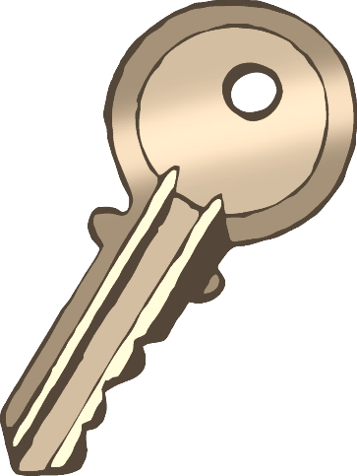

broom

keys

mop

tools