Water Play

Capacity Challenge – A5 Cards

The cards can be used as part of a small display near the water area or as a direct challenge to be used by the children when playing in the water tray.

© 2021 Little Owls Resources

Make the container…

Make the container…

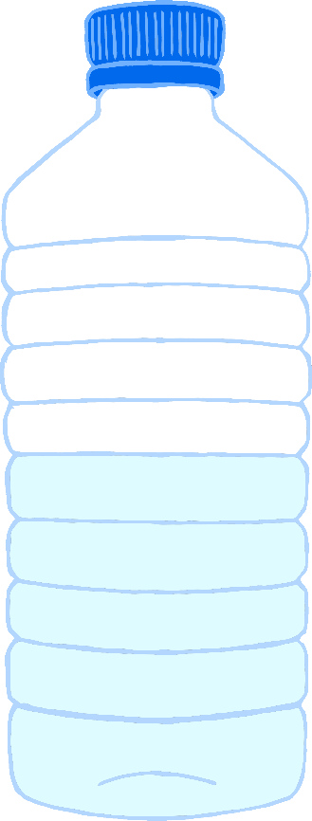

© 2021 Little Owls Resources

© 2021 Little Owls Resources

half-full

empty

Make the container…

Make the container…

© 2021 Little Owls Resources

© 2021 Little Owls Resources

nearly empty

half-empty

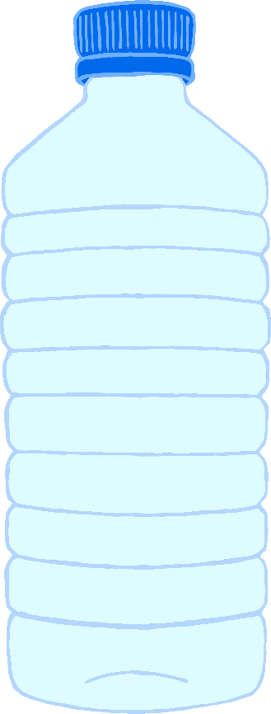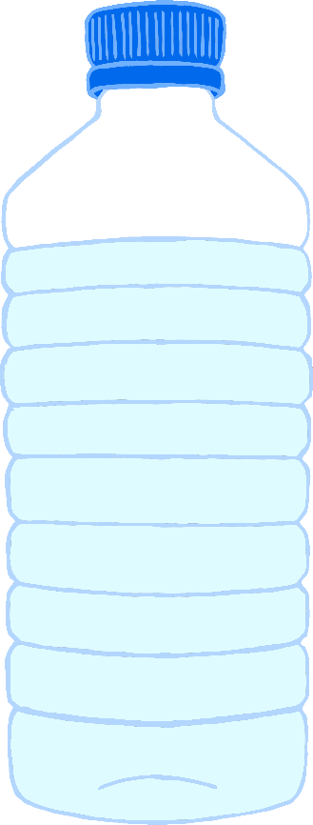

Make the container…

Make the container…

full

nearly full

© 2021 Little Owls Resources

© 2021 Little Owls Resources