Name:

**ch**

**booklet**

**ch**

**ch**

**ch**

**ch**

**My**

© 2020 Little Owls Resources

Circle the pictures that use the ch sound.

Name:

**Colour** the pictures that use the ch sound.

Name:

Name:

Circle the ch sound.

ch

t

i

ch

ch

p

d

ch

oo

z

t

Practise writing ch.

Name:

**ch ch ch**

**ch ch ch**

ch ch ch

ch ch ch

ch ch ch

___ ___ ___

Name:

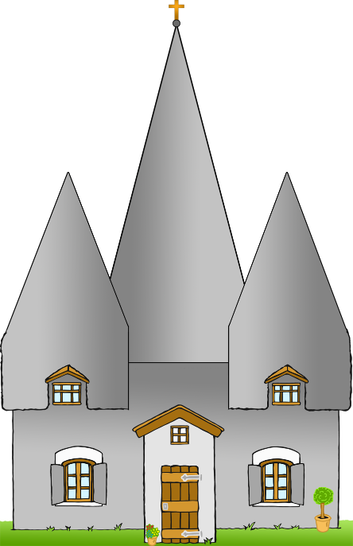

ur

i ck en

i n

Write ch and then read the word.

Name:

church

chicken

chin

Read the words and **colour** the pictures.

Name:

Match the word with the picture.

1

chicken

1

dog

1

box

1

church

1

egg

1

chin

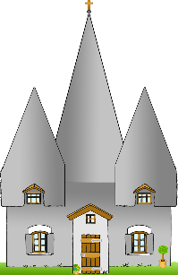

Name:

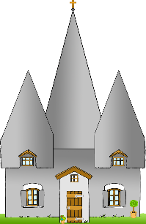

00000

**✔**

Write the words for the pictures. Tick the ch words.

Name:

Write the words for the pictures. Tick the ch words.

1

1

1

1

1

1

**✔**

Name:

Read all the words. Tick the ones that are real.

**✔**

1

1

chat

1

1

toch

1

1

check

1

1

chen

1

1

chab

1

1

rich

1

1

chuz

1

1

such

1

1

chill

1

1

choop

Name:

Read the words and draw pictures for them.

1

chop

1

chip