Butterfly

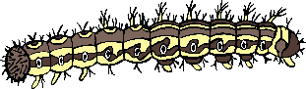

© 2020 Little Owls Resources

Caterpillar

**Butterfly Life Cycle**

Chrysalis

Egg

© 2020 Little Owls Resources

**Butterfly Life Cycle**

Butterfly

Egg

Caterpillar

Chrysalis