**Bus**

**Stop**

© 2022 Little Owls Resources

Touch your **BUS PASS** on the *contactless* pad.

© 2022 Little Owls Resources

**)**

**)**

**)**

**)**

**)**

**)**

**)**

**)**

**)**

**)**

**)**

**)**

**BUS PASS**

**)**

**)**

**)**

**)**

© 2022 Little Owls Resources

**BUS PASS**

© 2022 Little Owls Resources

**BUS PASS**

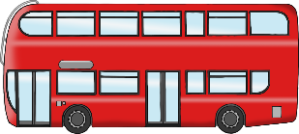

**BUS PASS**



**)**

**)**

**)**

**)**

© 2022 Little Owls Resources

**)**

**)**

**)**

**)**

© 2022 Little Owls Resources

**BUS PASS**

**BUS PASS**



**)**

**)**

**)**

**)**

**)**

**)**

**)**

**)**

**)**

**)**

**)**

**)**

© 2022 Little Owls Resources

© 2022 Little Owls Resources

**BUS PASS**

**BUS PASS**

**BUS PASS**

**BUS PASS**

© 2022 Little Owls Resources

Next bus in minutes.

**6**

**7**

**8**

**9**

**10**

**5**

**4**

**3**

**2**

**1**

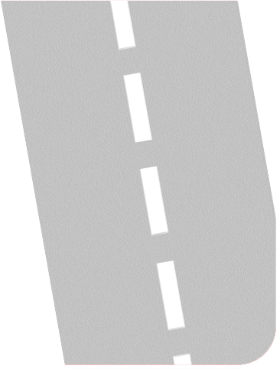

**Driver**

© 2022 Little Owls Resources



**Driver**

© 2022 Little Owls Resources



**Driver**

© 2022 Little Owls Resources



**Driver**

© 2022 Little Owls Resources



**Driver**

© 2022 Little Owls Resources



**Driver**

© 2022 Little Owls Resources

**Bus Ticket**

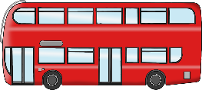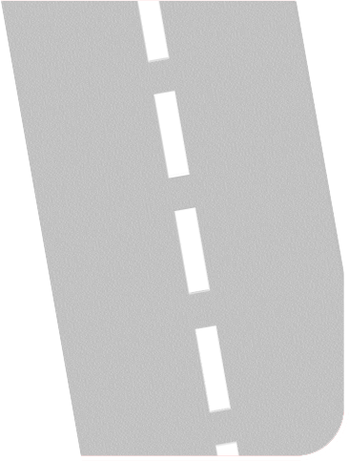

Name:……………………………………………............................……………….

Destination:………………………………………………………………………….

Cost:……………….…………….....………………...........................................

© 2022 Little Owls Resources

**Bus Ticket**



Name:……………………………………………............................……………….

Destination:………………………………………………………………………….

Cost:……………….…………….....………………...........................................

© 2022 Little Owls Resources

**Bus Ticket**



© 2022 Little Owls Resources

**Bus Ticket**



© 2022 Little Owls Resources

**Bus Ticket**



Name:……………………………………………............................……………….

Destination:………………………………………………………………………….

Cost:……………….…………….....………………...........................................

© 2022 Little Owls Resources

**Bus Ticket**



Name:……………………………………………............................……………….

Destination:………………………………………………………………………….

Cost:……………….…………….....………………...........................................

© 2022 Little Owls Resources

**Bus Ticket**



© 2022 Little Owls Resources

**Bus Ticket**



© 2022 Little Owls Resources

**Bus Ticket**



Name:……………………………………………............................……………….

Destination:………………………………………………………………………….

Cost:……………….…………….....………………...........................................

© 2022 Little Owls Resources

**Bus Ticket**



Name:……………………………………………............................……………….

Destination:………………………………………………………………………….

Cost:……………….…………….....………………...........................................

© 2022 Little Owls Resources

**Bus Ticket**



© 2022 Little Owls Resources

**Bus Ticket**



© 2022 Little Owls Resources

**Bus Ticket**



Name:……………………………………………............................……………….

Destination:………………………………………………………………………….

Cost:……………….…………….....………………...........................................

© 2022 Little Owls Resources

**Bus Ticket**



Name:……………………………………………............................……………….

Destination:………………………………………………………………………….

Cost:……………….…………….....………………...........................................

© 2022 Little Owls Resources

**Bus Ticket**



© 2022 Little Owls Resources

**Bus Ticket**



© 2022 Little Owls Resources

Bus Stop

**BUS**

**STOP**



© 2022 Little Owls Resources

Ring the bell when you need to get off the bus.

Please wait until the bus has stopped before standing up.

Thank-you!

© 2022 Little Owls Resources

Ticket Prices

© 2022 Little Owls Resources

**Draw your bus journey**

© 2022 Little Owls Resources

© 2022 Little Owls Resources

________________________________________________________________________________________________________________________________________________________________________________________________

© 2022 Little Owls Resources

© 2022 Little Owls Resources

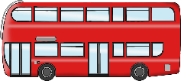

**Bus Timetable**

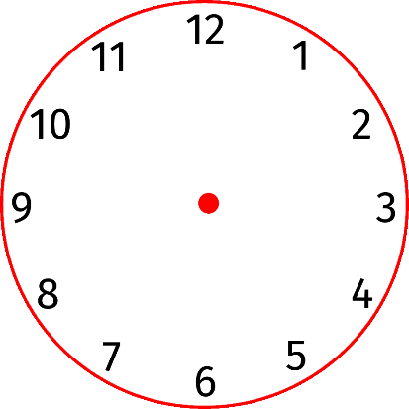

2nd

1st

4th

3rd

© 2022 Little Owls Resources



**Bus Timetable**



© 2022 Little Owls Resources

**Bus Route 1**

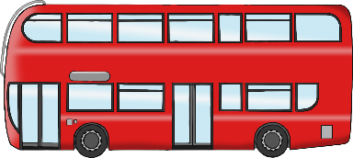

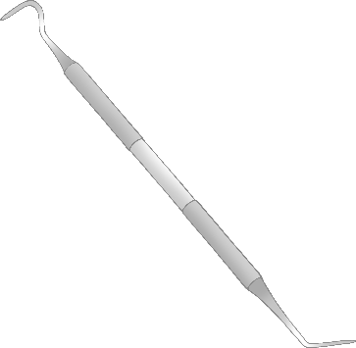

Zoo

Museum

Dentist

Toy Shop

© 2022 Little Owls Resources

**Bus Route 2**

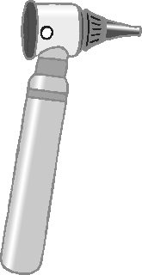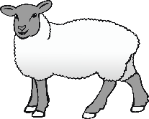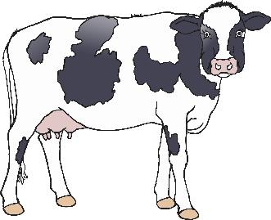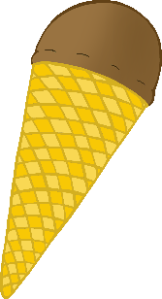

Library

Farm

Doctor

Ice-Cream Shop

© 2022 Little Owls Resources

Bus Route - **Red**



© 2022 Little Owls Resources

Bus Route - **Blue**

© 2022 Little Owls Resources

Bus Route - **Green**

© 2022 Little Owls Resources

Bus Route - **Purple**