The pages of this pack give some general information about bumblebees and some fun and engaging activities to foster and develop children’s interest in them.

**Bumblebee**

**This pack includes:**

* Fact posters x3 (Could be used as stimuli for a lesson input)
* Number slice activity (1-10) (Can be pre-cut for a pure number ordering activity or left to be cut by child to add scissor practice)
* Number slice activity - colouring version (1-10) (As above but to be coloured before cutting)
* Description sheet (Can be used as an independent writing activity or with an adult scribing the ideas of a younger child)
* A4 poster
* A4 poster - colouring version
* ‘Body Parts’ x3 (fully labelled, initial sounds only, blank)
* Draw and write sheets x3 (blank sheet, wide lines and narrow lines)
* 1x 4-piece puzzle
* Multimats x3 (for Colouring/Art & Craft/Loose Parts/Playdough)

© 2021 Little Owls Resources

This pack includes:

The pages of this pack give some general information about the role of a paramedic and some fun and engaging activities to foster and develop children’s interest in this role in society.

© 2021 Little Owls Resources

**Bumblebee Facts**

Bumblebees live for

days.

**28**

Bumblebees eat **nectar from flowers**.

Bumblebees perform a **VITAL** role spreading pollen from flower to flower.

Humans have destroyed lots of places in which bumblebees make their homes.

Climate change is also affecting where bumblebees live.

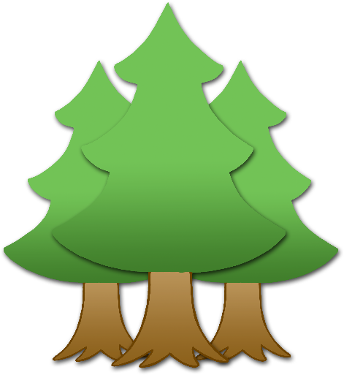

**Many Bumblebee species are at risk of extinction.**

© 2021 Little Owls Resources

**How big is a Bumblebee?**

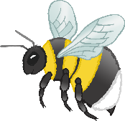

10 – 18mm

© 2021 Little Owls Resources

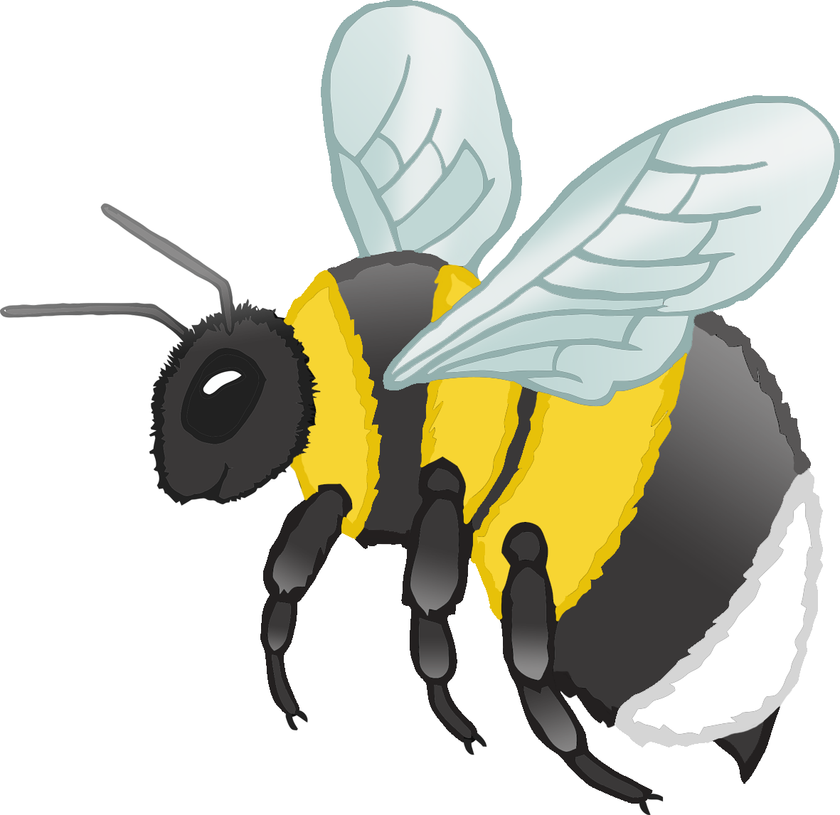

1

2

3

4

5

6

7

8

9

10



© 2021 Little Owls Resources

© 2021 Little Owls Resources

1

2

3

4

5

6

7

8

9

10

© 2021 Little Owls Resources

**What words would you use to describe a bumblebee?**

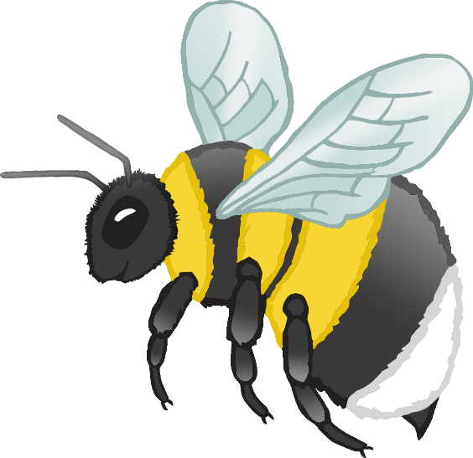

**Bumblebee**



© 2021 Little Owls Resources

**Bumblebee**

© 2021 Little Owls Resources

**Bumblebee body parts**



© 2021 Little Owls Resources



**Bumblebee body parts**

© 2021 Little Owls Resources

e

l

a

**w**

s

**Bumblebee body parts**

© 2021 Little Owls Resources

leg

eye

antenna

**w**ing

stinger



© 2021 Little Owls Resources

**Draw a Bumblebee!**

© 2021 Little Owls Resources

**Draw and write about a Bumblebee!**

____________________________________________________

© 2021 Little Owls Resources

**Draw and write about a Bumblebee!**

______________________________________________________________________________________________________

**Bumblebee**



© 2021 Little Owls Resources

© 2021 Little Owls Resources

**Bumblebee Multimat - Bumblebee**

© 2021 Little Owls Resources

**Bumblebee Multimat - Bumblebees**

© 2021 Little Owls Resources

**Bumblebee Multimat – Bumblebees and Flower**

