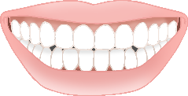

Brush your teeth!

© 2021 Little Owls Resources

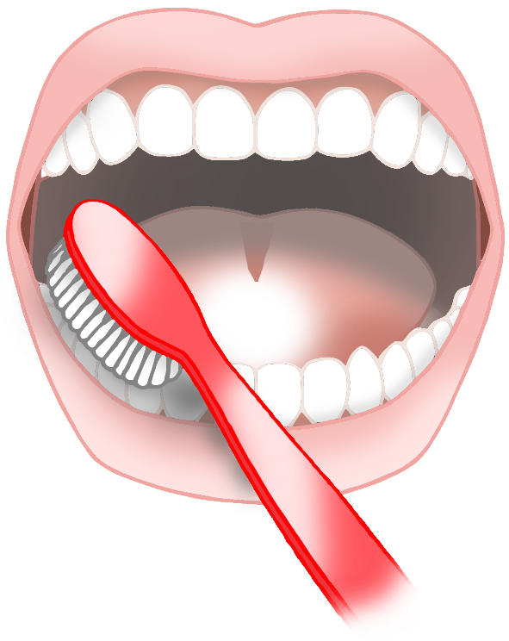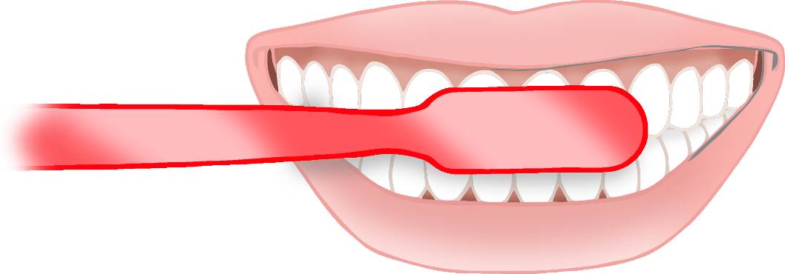

Brush your bottom teeth.

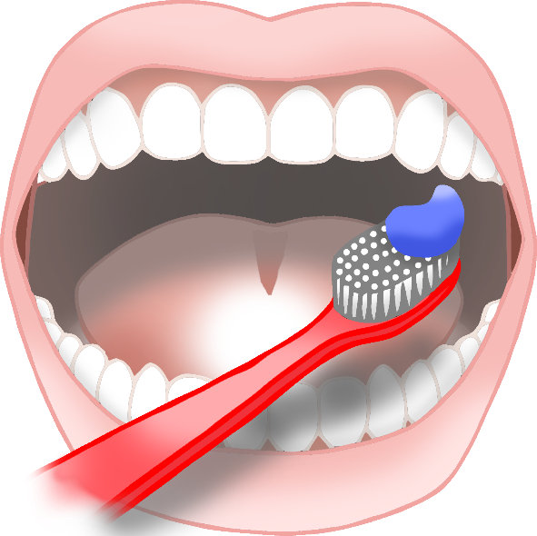

Brush your top teeth.

Brush the front of your teeth.



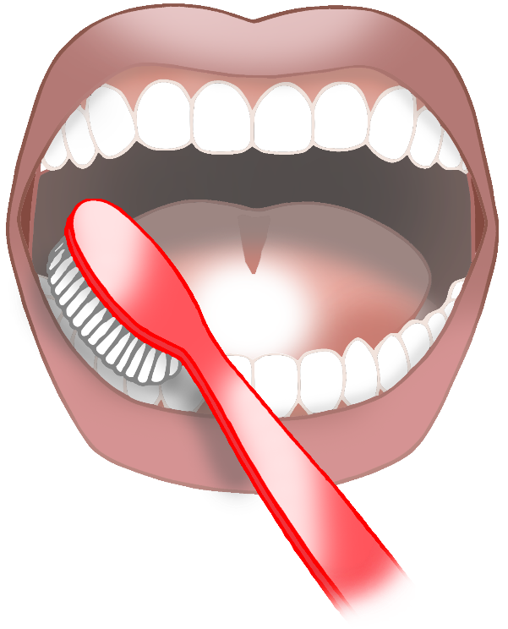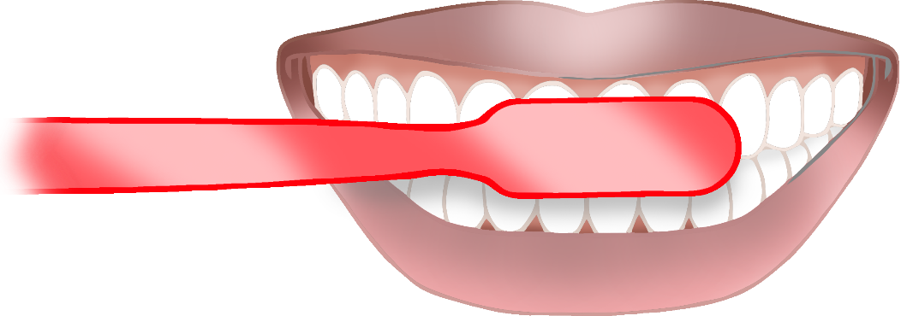

Brush your teeth!

© 2021 Little Owls Resources

Brush your bottom teeth.

Brush your top teeth.

Brush the front of your teeth.