**Brush your teeth!**

© 2021 Little Owls Resources

**Brush your bottom teeth.**

**Brush the front of your teeth.**

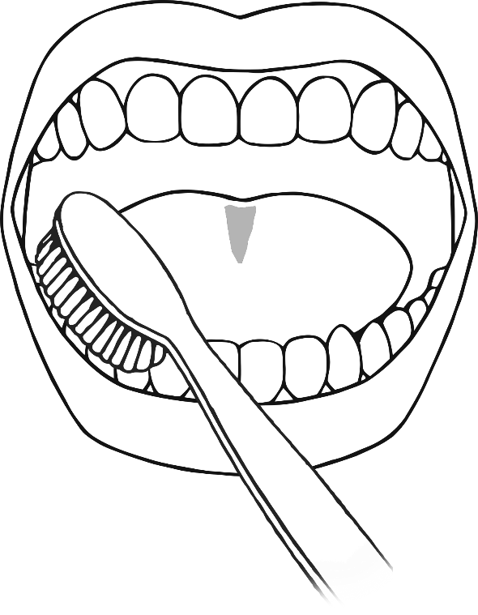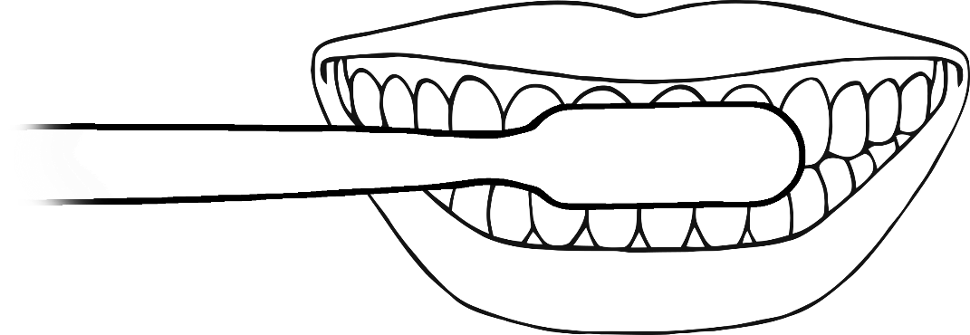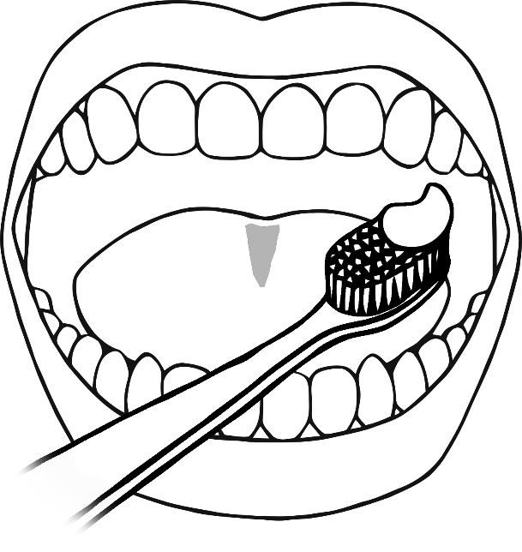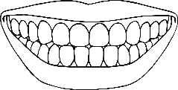

**Brush your top teeth.**