Brush your teeth two times each day…

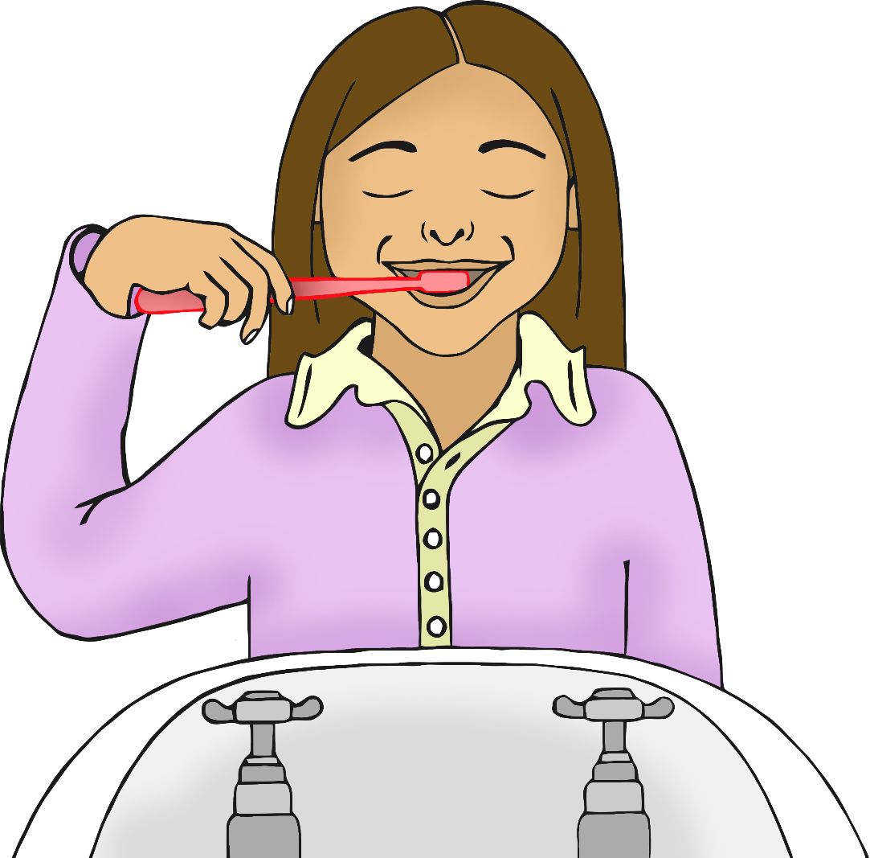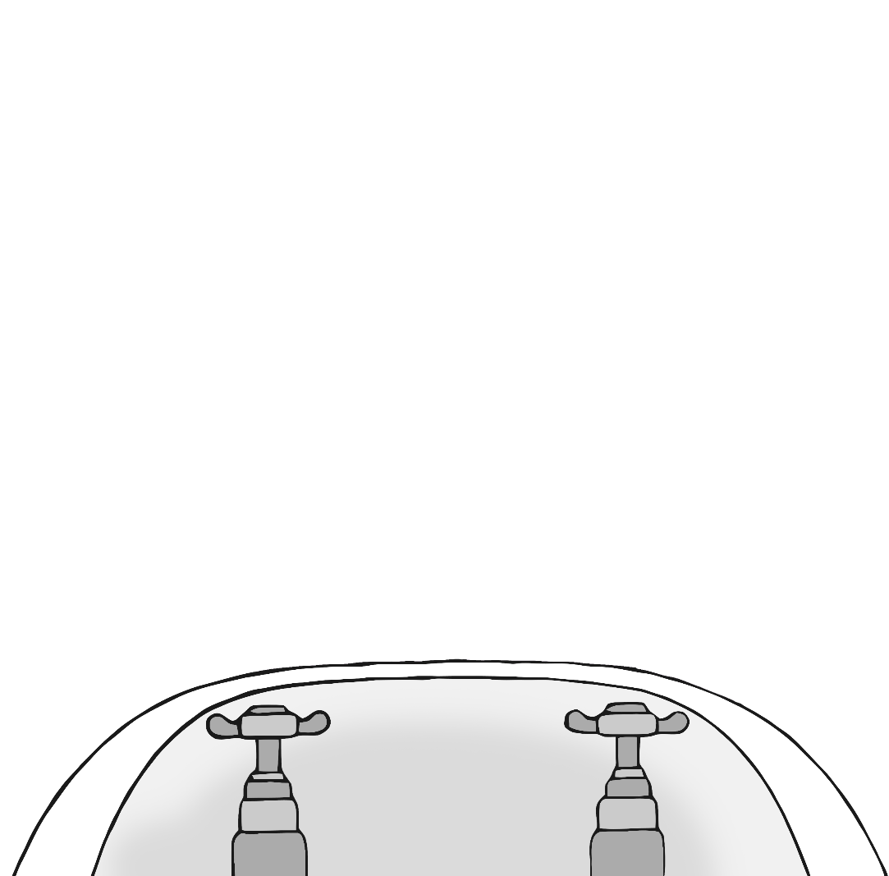

**Night**

**Morning**

© 2021 Little Owls Resources