**British flag hats**

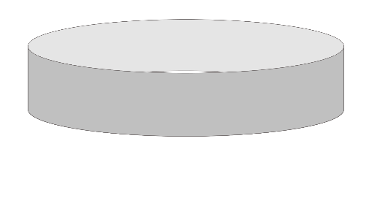

Wear the flag hat!

Cut out the flag and colour if desired. Then stick to the paper loop.

**3**

**2**

**1**

Prepare a loop of paper to fit the child’s head.

© 2022 Little Owls Resources

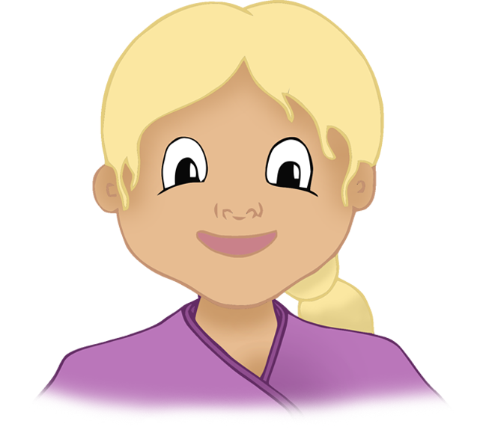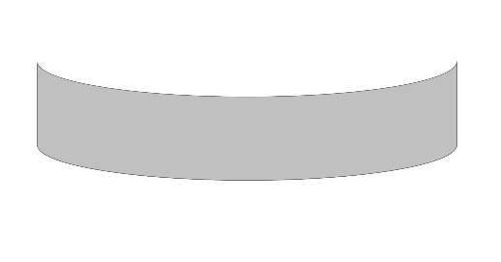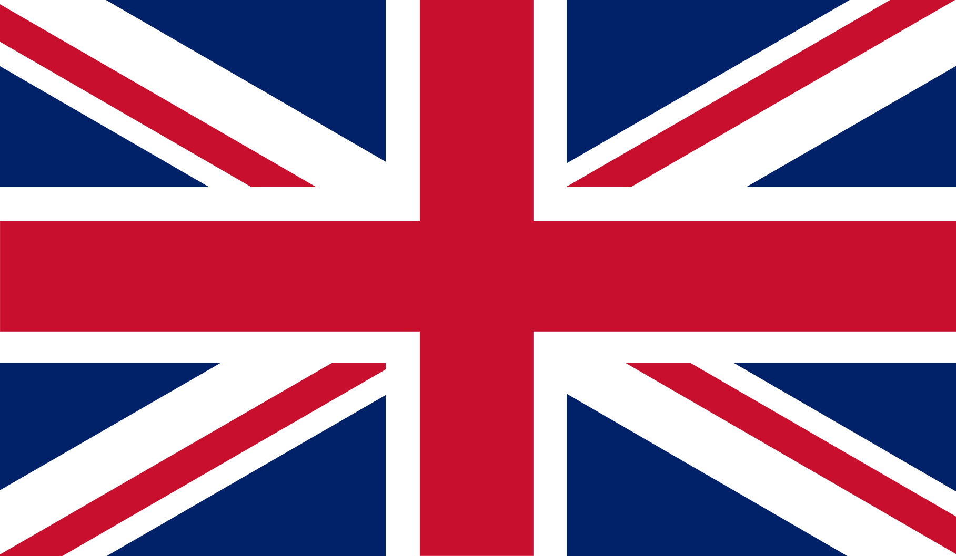

© 2022 Little Owls Resources

© 2022 Little Owls Resources