© 2022 Little Owls Resources

**Fingerpaint British Flag**

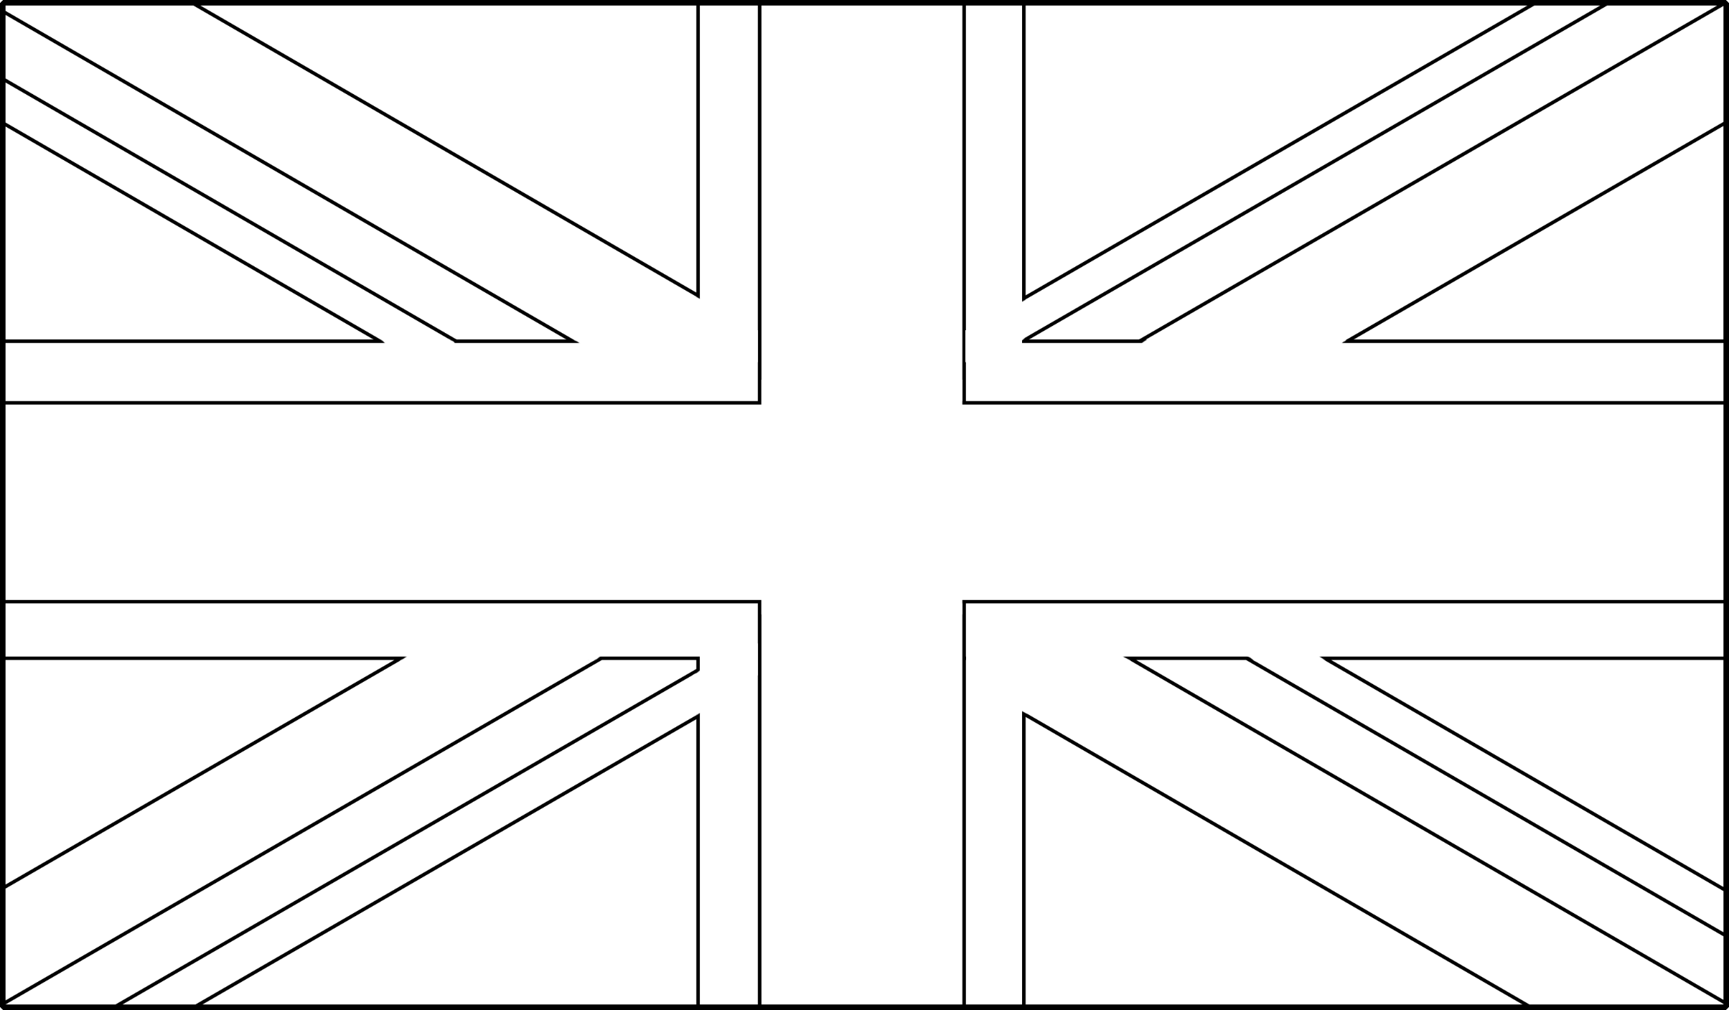

© 2022 Little Owls Resources

**Fingerpaint British Flag for the Jubilee**

