© 2021 Little Owls Resources

I was born in the…

**Year of the Rat**

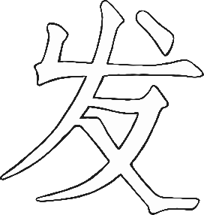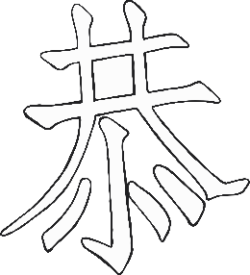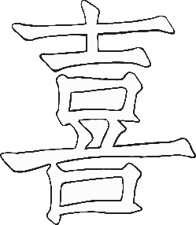

© 2021 Little Owls Resources

I was born in the…

**Year of the Ox**



© 2021 Little Owls Resources

I was born in the…

**Year of the Tiger**



© 2021 Little Owls Resources

I was born in the…

**Year of the Rabbit**



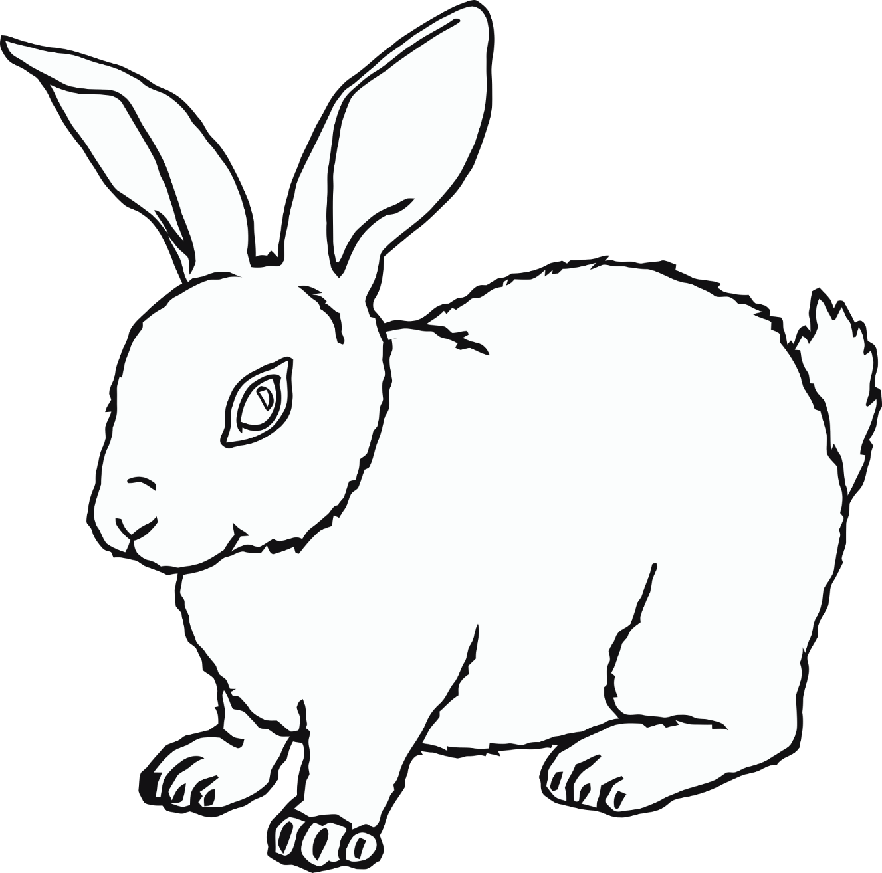

© 2021 Little Owls Resources

I was born in the…

**Year of the Dragon**



© 2021 Little Owls Resources

I was born in the…

**Year of the Snake**



© 2021 Little Owls Resources

I was born in the…

**Year of the Horse**



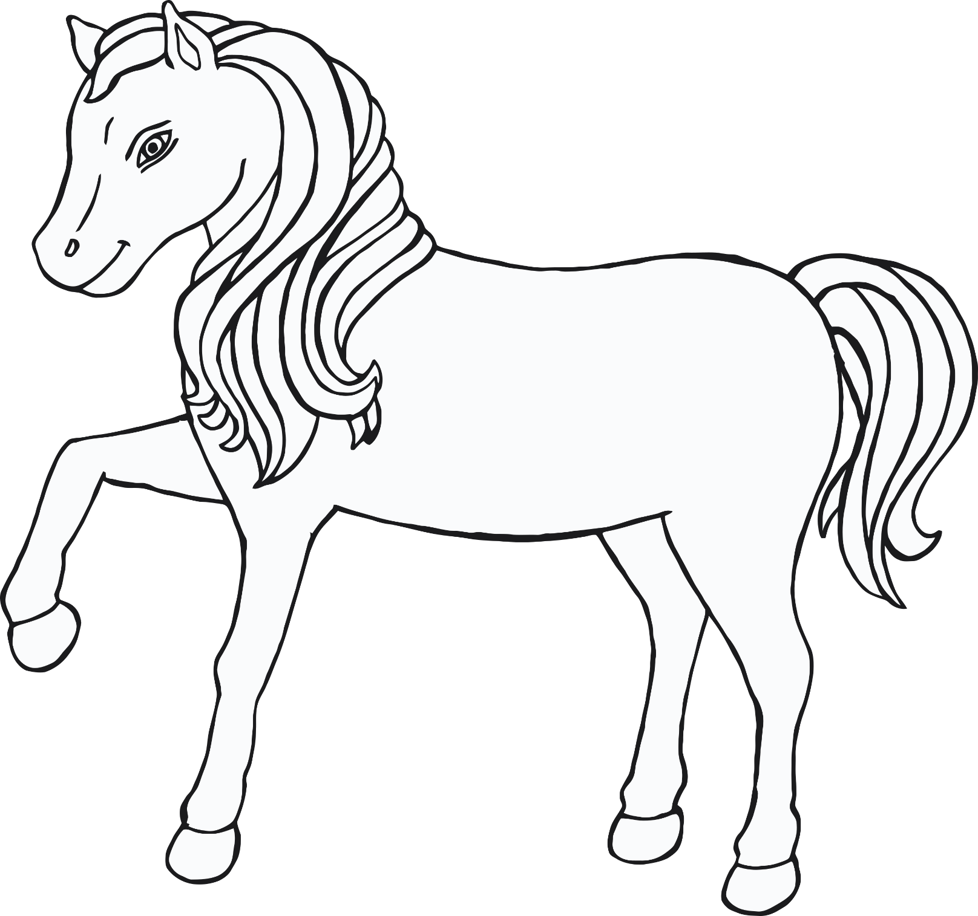

© 2021 Little Owls Resources

I was born in the…

**Year of the Ram**



© 2021 Little Owls Resources

I was born in the…

**Year of the Monkey**



© 2021 Little Owls Resources

I was born in the…

**Year of the Rooster**



© 2021 Little Owls Resources

I was born in the…

**Year of the Dog**



© 2021 Little Owls Resources

I was born in the…

**Year of the Pig**

