**World Book Day**

**Name:**



**World Book Day Bookmark**

Design – Cut – Fold - Laminate

© 2020 Little Owls Resources

**World Book Day**

**Name:**



**World Book Day Bookmark**

Design – Cut – Fold - Laminate

© 2020 Little Owls Resources

**Name:**



**World Book Day Bookmark**

Design – Cut – Fold - Laminate

© 2020 Little Owls Resources

**World Book Day**

**My Favorite Book!**

**Name:**



**World Book Day Bookmark**

Design – Cut – Fold - Laminate

© 2020 Little Owls Resources

**My Favorite Book!**

**Name:**



**World Book Day Bookmark**

Design – Cut – Fold - Laminate

© 2020 Little Owls Resources

**Name:**



**World Book Day Bookmark**

Design – Cut – Fold - Laminate

© 2020 Little Owls Resources

**Name:**



**World Book Day Bookmark**

Design – Cut – Fold - Laminate

© 2020 Little Owls Resources

**Name:**



**World Book Day Bookmark**

Design – Cut – Fold - Laminate

© 2020 Little Owls Resources

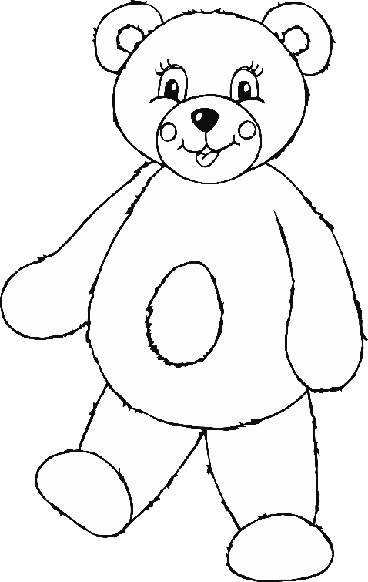

**Name:**



**World Book Day Bookmark**

Design – Cut – Fold - Laminate

© 2020 Little Owls Resources

**Name:**



**World Book Day Bookmark**

Design – Cut – Fold - Laminate

© 2020 Little Owls Resources

