**Design and Cut a** **World Book Day Bookmark!**

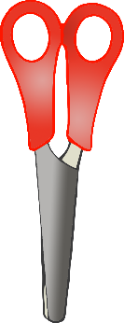

**World Book Day**

**World Book Day**

© 2020 Little Owls Resources

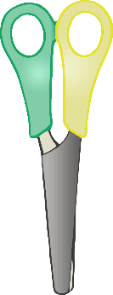

**World Book Day**

**World Book Day**

© 2020 Little Owls Resources

**Design and Cut a** **World Book Day Bookmark!**

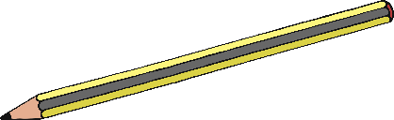



**World Book Day**

**World Book Day**

© 2020 Little Owls Resources

**Design and Cut a** **World Book Day Bookmark!**



**My Favourite Book!**

**My Favourite Book!**

© 2020 Little Owls Resources

**Design and Cut a** **World Book Day Bookmark!**

