Book Review

Name:

Draw your favourite part of the book…

Did you like the book? *(colour one)*

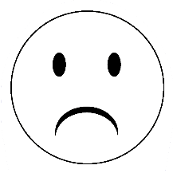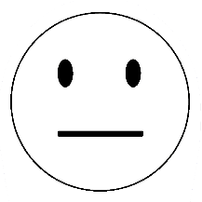

© 2023 Little Owls Resources

Book Review

Name:

Draw your favourite part of the book…

Did you like the book? *(colour one)*



© 2023 Little Owls Resources

____________________________

Write the name of a character.

Book Review

Name:

© 2023 Little Owls Resources

____________________________________________________________________________________

Write about your favourite part of the book.

Draw the main character…

Book title: ____________________________________

How good was the book? *(colour the stars)*