Book Review

____________________________

Write the name of a character…

Draw your favourite part of the book…

Name:

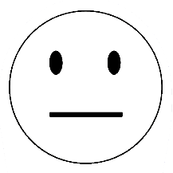

Did you like the book?

Book Title: _________________________________________

Name:

Book Review

Write about your favourite part of the book …

____________________________________________________________________________________

Draw the main character…

How good was the book?

What happened in the book?

Book Title: _________________________________________

Main Character: ___________________________________

Story Setting: ______________________________________

Book Review

Name:

______________________________________________________________________________________________________________________________

How good was the book?

How good was the book?

What do think will happen next?

____________________________________________________________________________________________________________________

What happened in the book?

____________________________________________________________________________________________________________________

Book Title: _________________________________________

Main Character: ___________________________________

Story Setting: ______________________________________

Book Review

Name: