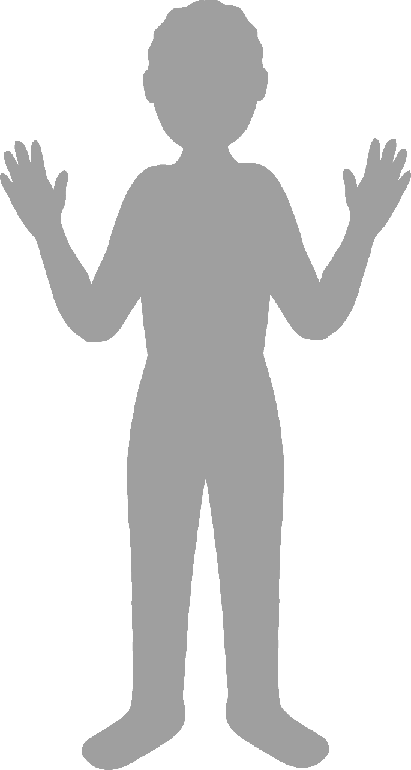

**Body parts**

Name:



**Body parts**

Name:

f

e

h

l

f

h

foot

elbow

hand

leg

finger

head



**Body parts**

Name: