**Blue Tit body parts**

© 2021 Little Owls Resources

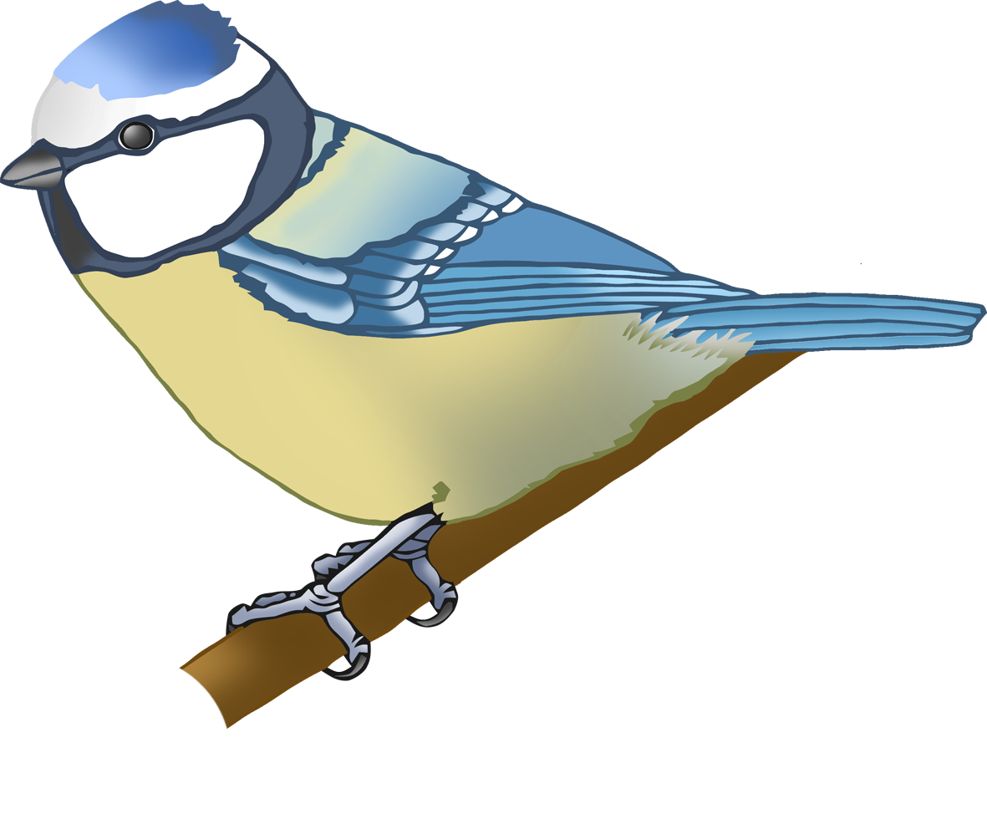

h

t

b

**w**

f

**Blue Tit body parts**

© 2021 Little Owls Resources



foot

head

tail

beak

**w**ing

**Blue Tit body parts**

© 2021 Little Owls Resources

