**Blackbird body parts**

© 2021 Little Owls Resources

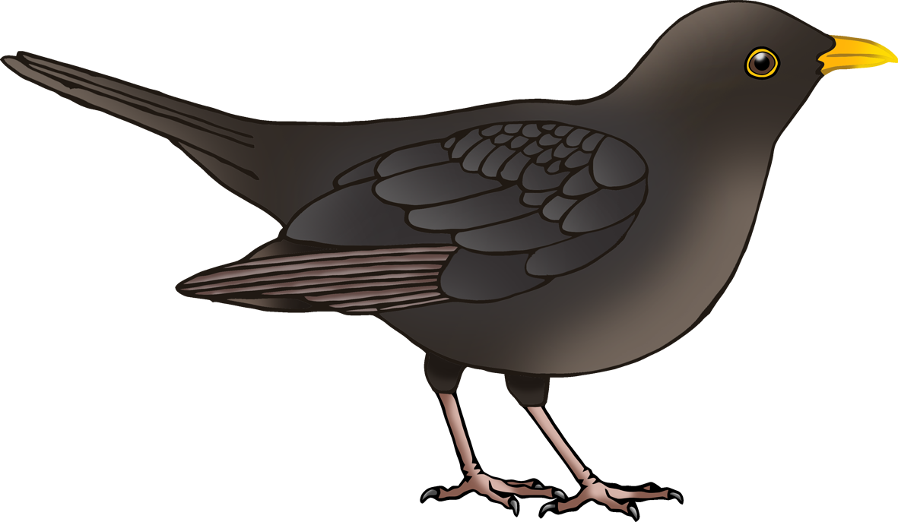

f

**w**

t

h

b

**Blackbird body parts**

© 2021 Little Owls Resources



**w**ing

foot

beak

tail

**Blackbird body parts**

© 2021 Little Owls Resources



head