**Black Rhino**

The pages of this pack give some general information about black rhinos and some fun and engaging activities to foster and develop children’s interest in them.

**This pack includes:**

* Fact posters x3 (Could be used as stimuli for a lesson input)
* Number slice activity (1-10) (Can be pre-cut for a pure number ordering activity or left to be cut by child to add scissor practice)
* Number slice activity - colouring version (1-10) (As above but to be coloured before cutting)
* Description sheet (Can be used as an independent writing activity or with an adult scribing the ideas of a younger child)
* A4 poster
* A4 poster - colouring version
* ‘Body Parts’ x3 (fully labelled, initial sounds only, blank)
* Draw and write sheets x3 (blank sheet, wide lines and narrow lines)
* 1x 4-piece puzzle
* Multimats x4 (for Colouring/Art & Craft/Loose Parts/Playdough)

© 2021 Little Owls Resources

This pack includes:

The pages of this pack give some general information about the role of a paramedic and some fun and engaging activities to foster and develop children’s interest in this role in society.

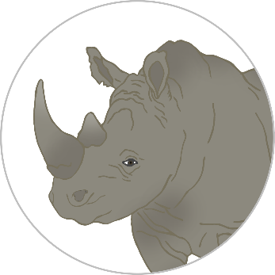

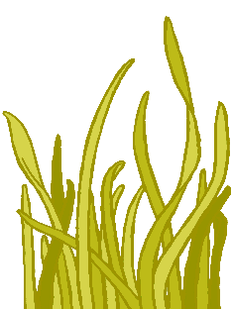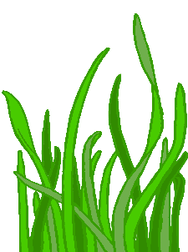

© 2021 Little Owls Resources

**Black Rhino Facts**

Wild black rhinos can live for

years.

**40**

Black rhinos eat **grasses** and **leaves**.

Rhinos have been on Earth for 50 million years!

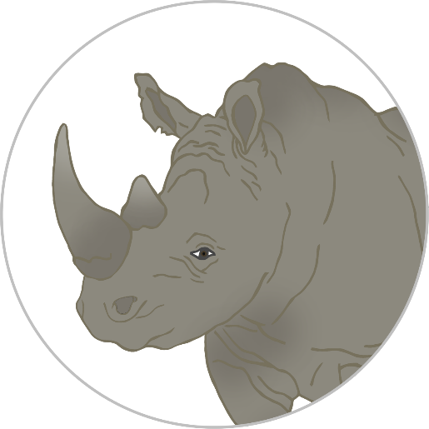

Humans have hunted and killed many black rhinos.

**Black Rhinos are** Endangered.

This means there is a very high risk that they may become extinct.

© 2021 Little Owls Resources

**How big is a Black Rhino?**



170cm / 1.7m

© 2021 Little Owls Resources

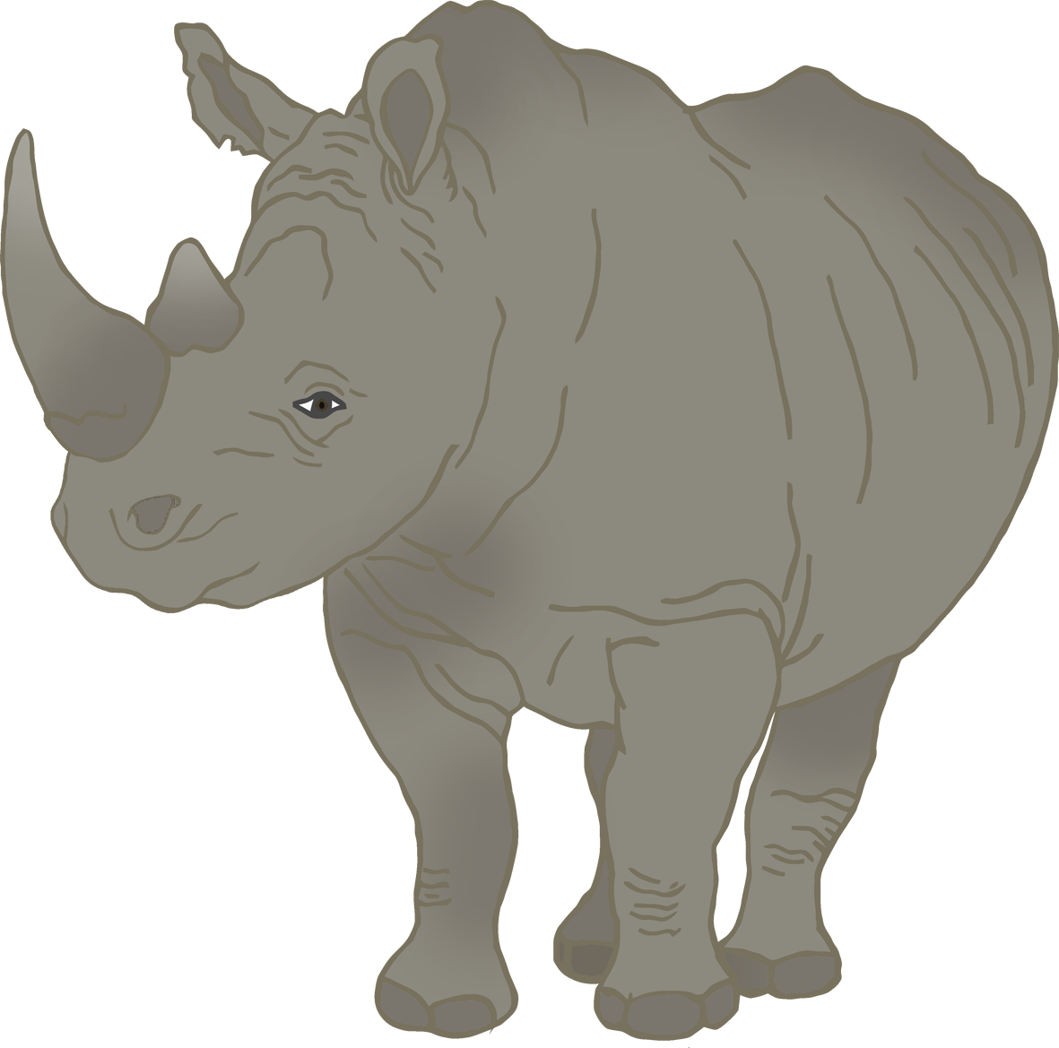



1

2

3

4

5

6

7

8

9

10

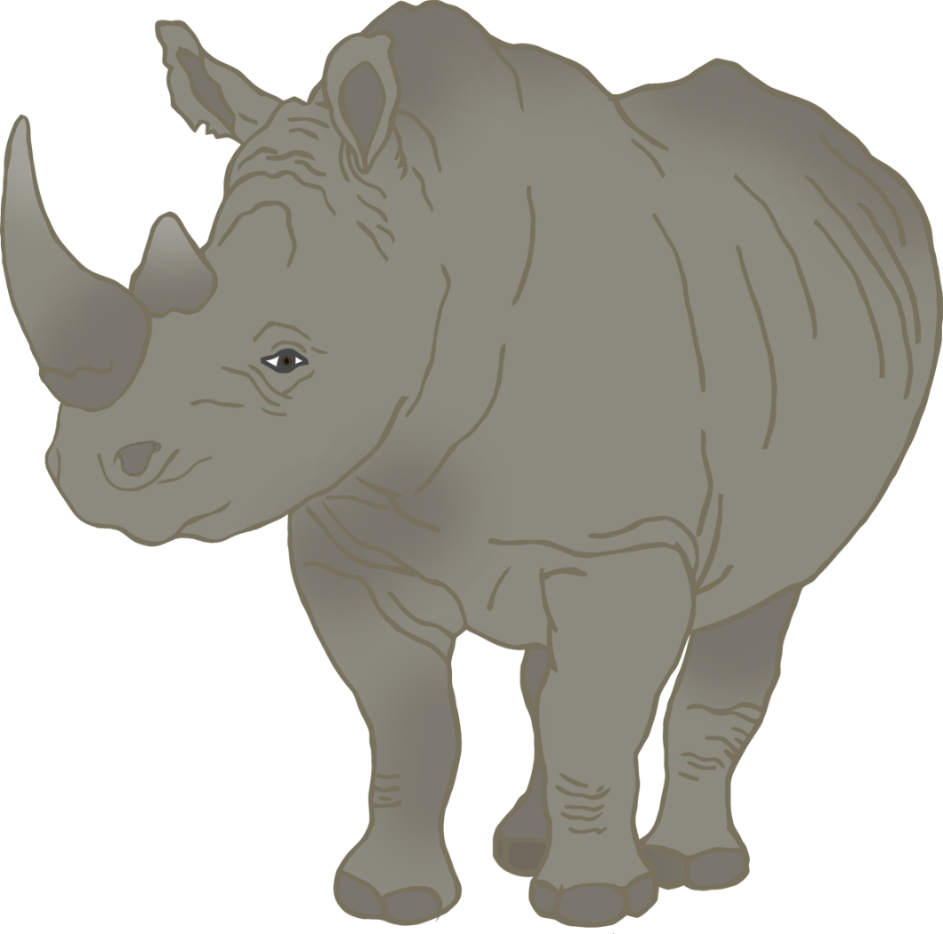

© 2021 Little Owls Resources

© 2021 Little Owls Resources

1

2

3

4

5

6

7

8

9

10

© 2021 Little Owls Resources

**What words would you use to describe a black rhino?**

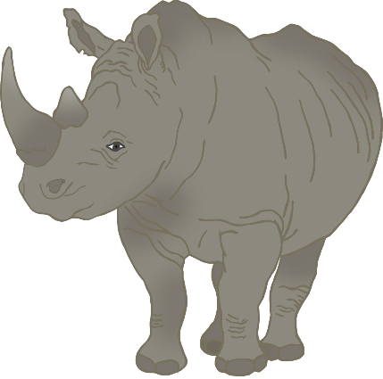

**Black Rhino**



© 2021 Little Owls Resources

**Black Rhino**

© 2021 Little Owls Resources

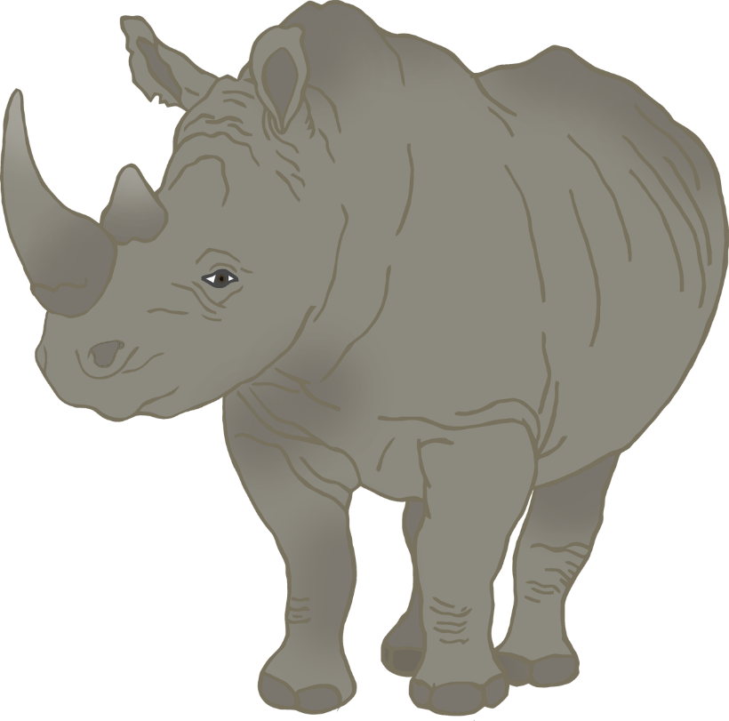

**Black Rhino body parts**

© 2021 Little Owls Resources

back

horn

foot

mouth

leg

ear



**Black Rhino body parts**

© 2021 Little Owls Resources

b

h

f

m

l

e



**Black Rhino body parts**

© 2021 Little Owls Resources

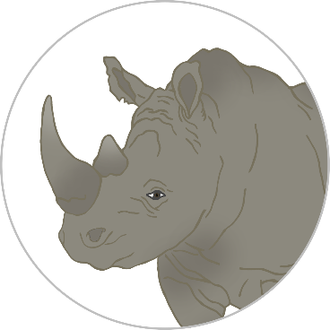

© 2021 Little Owls Resources

**Draw a Black Rhino!**



© 2021 Little Owls Resources

**Draw and write about a Black Rhino!**

____________________________________________________



© 2021 Little Owls Resources

**Draw and write about a Black Rhino!**

______________________________________________________________________________________________________

**Black Rhino**



© 2021 Little Owls Resources



© 2021 Little Owls Resources

**Black Rhino Multimat – Rhino (1)**



© 2021 Little Owls Resources

**Black Rhino Multimat – Rhino (2)**



© 2021 Little Owls Resources

**Black Rhino Multimat – Footprint**

© 2021 Little Owls Resources

**Black Rhino Multimat – Footprints**