Greeting Cards Activity – Birthday

The activity is intended to encourage the children to really think about someone else’s likes.

Each of these cards has the same message across the front but is accompanied by a different image. The children must think about which card they think their friend/family member will like best before colouring it for them.

*N.B. The final page has a card with no image for the children to draw their own.*

©2022 Little Owls Resources

Happy Birthday!

©2022 Little Owls Resources

Happy

Birthday!

©2022 Little Owls Resources

Happy Birthday!

©2022 Little Owls Resources

Happy Birthday!

©2022 Little Owls Resources

**Happy Birthday!**

©2022 Little Owls Resources

Happy Birthday!

©2022 Little Owls Resources

**Happy Birthday!**

©2022 Little Owls Resources

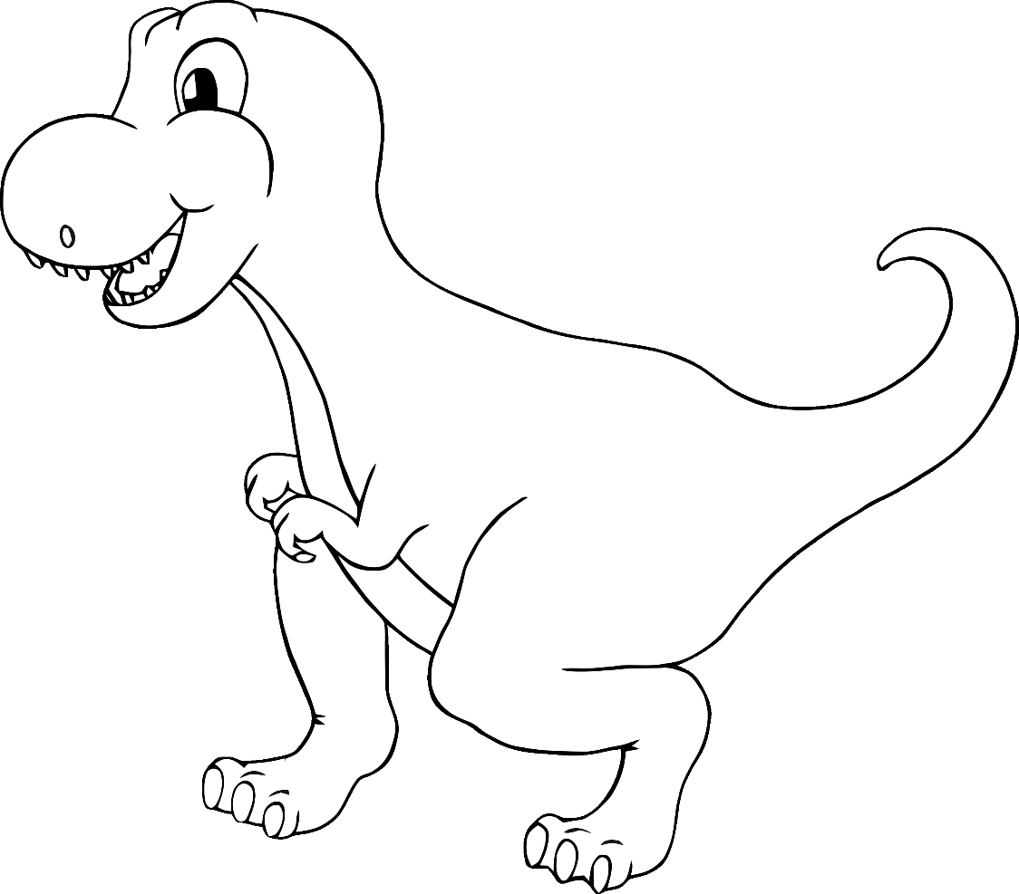

Happy Birthday!

©2022 Little Owls Resources

©2022 Little Owls Resources

**Happy Birthday!**

©2022 Little Owls Resources

**Happy**

**Birthday!**

©2022 Little Owls Resources

**Happy Birthday!**

©2022 Little Owls Resources

**Happy Birthday!**

©2022 Little Owls Resources

**Happy**

**Birthday!**

©2022 Little Owls Resources

**Happy Birthday!**

Happy Birthday!

©2022 Little Owls Resources