Birds Silhouette Match Puzzle

This matching puzzle has a different connection for each set to allow the children to self-correct.

© 2023 Little Owls Resources

pigeon

vulture

© 2023 Little Owls Resources

© 2023 Little Owls Resources

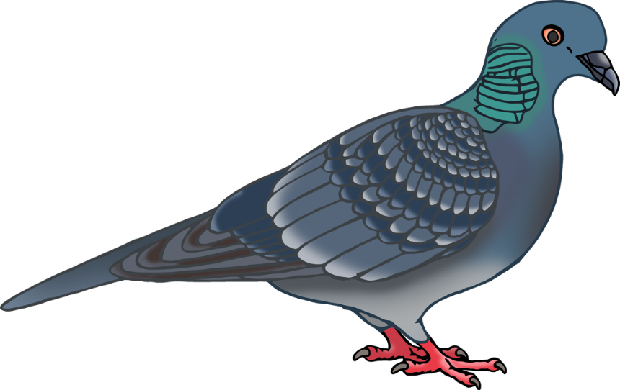

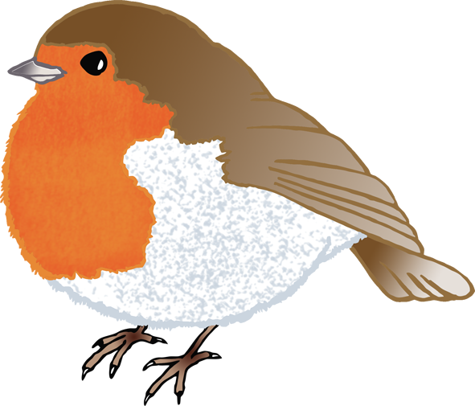

robin

seagull

© 2023 Little Owls Resources

© 2023 Little Owls Resources

magpie

buzzard

© 2023 Little Owls Resources

© 2023 Little Owls Resources

© 2023 Little Owls Resources

© 2023 Little Owls Resources

blackbird

duck

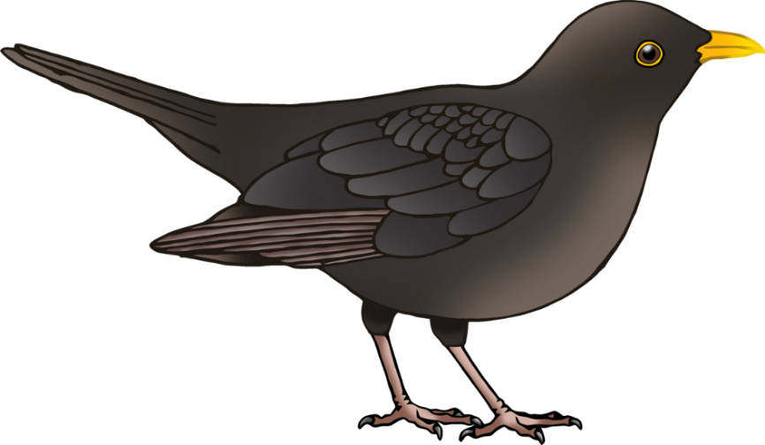

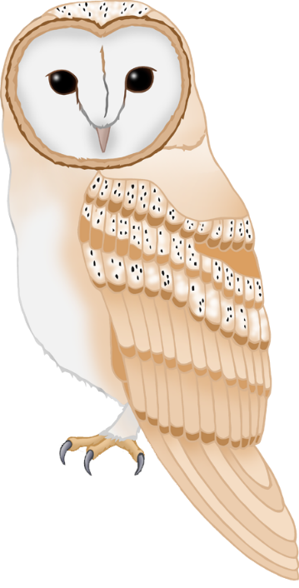

© 2023 Little Owls Resources

© 2023 Little Owls Resources

barn owl

swallow

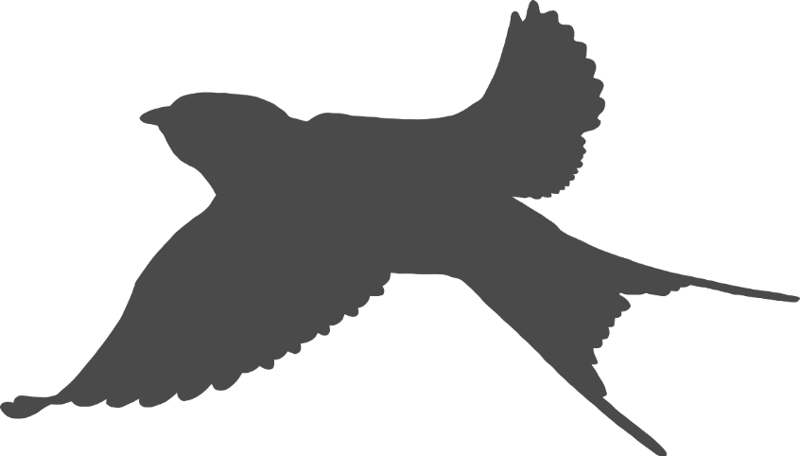

chicken

flamingo

© 2023 Little Owls Resources

© 2023 Little Owls Resources

goose

penguin

© 2023 Little Owls Resources

© 2023 Little Owls Resources

