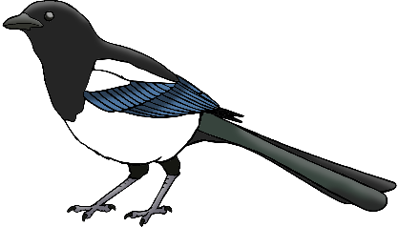

**Sh!**

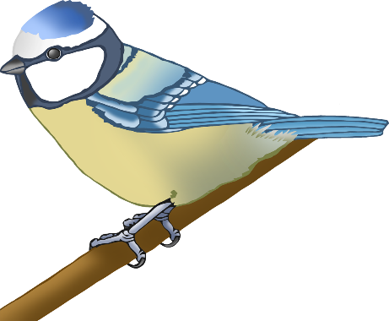

Draw what you can see!

A bird is in the garden!

© 2020 Little Owls Resources