**B-I-N-G-O**

© 2020 Little Owls Resources

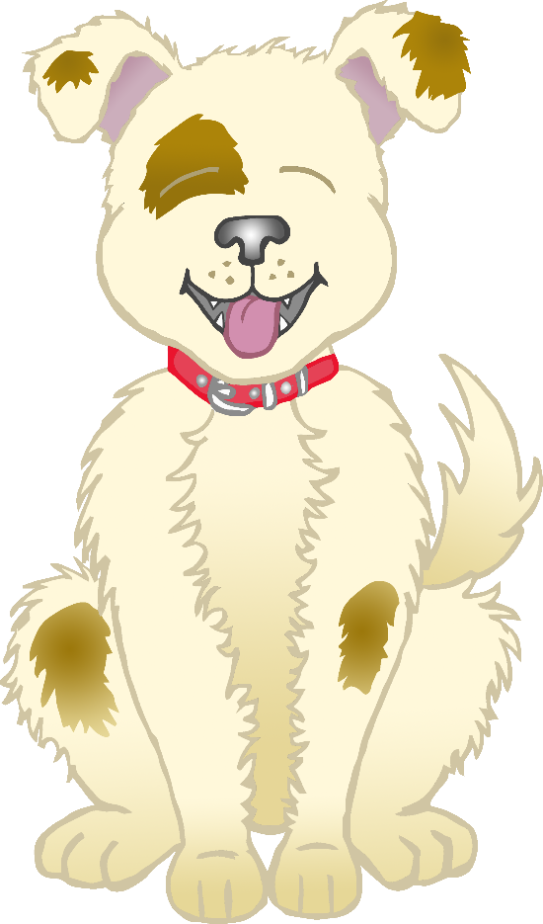

There was a farmer who had a dog,

And Bingo was his name-o.

B-I-N-G-O

B-I-N-G-O

B-I-N-G-O

And Bingo was his name-o.

**B-I-N-G-O**

© 2020 Little Owls Resources

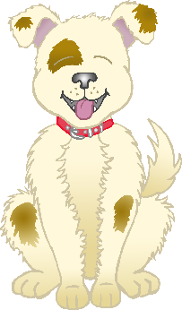

There was a farmer who had a dog,

And Bingo was his name-oh.

(Clap)-I-N-G-O

(Clap)-I-N-G-O

(Clap)-I-N-G-O

And Bingo was his name-oh.

**2.**

There was a farmer who had a dog,

And Bingo was his name-oh.

(Clap)-(Clap)-(Clap)-(Clap)-(Clap)

(Clap)-(Clap)-(Clap)-(Clap)-(Clap)

(Clap)-(Clap)-(Clap)-(Clap)-(Clap)

And Bingo was his name-oh.

**5.**

**6.**

There was a farmer who had a dog,

And Bingo was his name-oh.

(Clap)-(Clap)-(Clap)-(Clap)-O

(Clap)-(Clap)-(Clap)-(Clap)-O

(Clap)-(Clap)-(Clap)-(Clap)-O

And Bingo was his name-oh.

There was a farmer who had a dog,

And Bingo was his name-oh.

(Clap)-(Clap)-(Clap)-G-O

(Clap)-(Clap)-(Clap)-G-O

(Clap)-(Clap)-(Clap)-G-O

And Bingo was his name-oh.

**3.**

**4.**

There was a farmer who had a dog,

And Bingo was his name-oh.

(Clap)-(Clap)-N-G-O

(Clap)-(Clap)-N-G-O

(Clap)-(Clap)-N-G-O

And Bingo was his name-oh.

**1.**

There was a farmer who had a dog,

And Bingo was his name-oh.

B-I-N-G-O

B-I-N-G-O

B-I-N-G-O

And Bingo was his name-oh.