Big Ship Sails

© 2022 Little Owls Resources

**The big ship sails on the ally ally oh,**

**the ally ally oh, the ally ally oh.**

**The big ship sails on the ally ally oh,**

**on the last day of September.**

Big Ship Sails

© 2022 Little Owls Resources

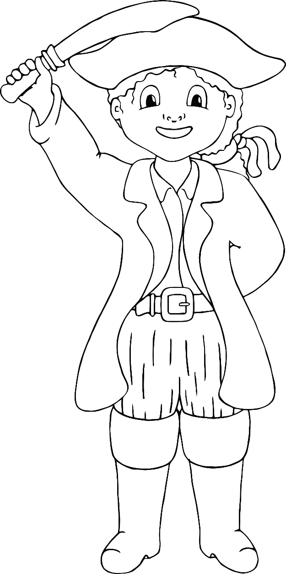

**We all dip our heads in the deep blue sea,**

**the deep blue sea, the deep blue sea.**

**We all dip our heads in the deep blue sea,**

**on the last day of September.**

**The big ship sank to the bottom of the sea,**

**The bottom of the sea, the bottom of the sea.**

**The big ship sank to the bottom of the sea,**

**on the last day of September.**

**The captain said, 'It will never, never do,**

**Never, never do, never, never do.'**

**The captain said, 'It will never, never do,'**

**on the last day of September.**

**The big ship sails on the ally ally oh,**

**the ally ally oh, the ally ally oh.**

**The big ship sails on the ally ally oh,**

**on the last day of September.**