© 2022 Little Owls Resources

The big ship sails on the ally ally oh.

Big Ship Sails

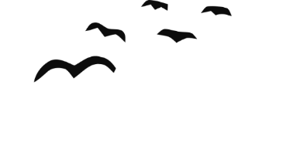

Illustration Activity

© 2022 Little Owls Resources

The captain said, 'It will never, never do.’

Big Ship Sails



Illustration Activity

© 2022 Little Owls Resources

The big ship sank to the bottom of the sea.

Big Ship Sails



Illustration Activity

© 2022 Little Owls Resources

We all dip our heads in the deep blue sea.

Big Ship Sails



Illustration Activity