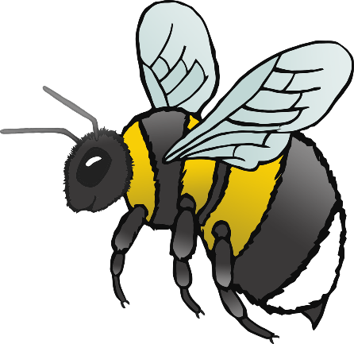

**1**

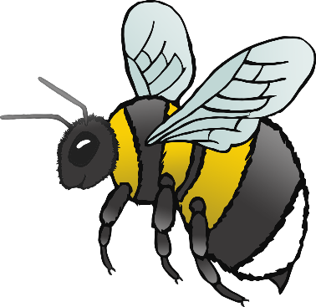

**2**

© 2021 Little Owls Resources

© 2021 Little Owls Resources

two

one

**3**

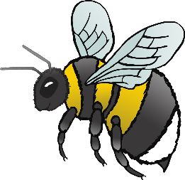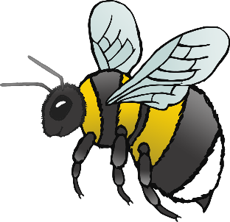

three

**4**

© 2021 Little Owls Resources

© 2021 Little Owls Resources

four

**5**

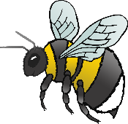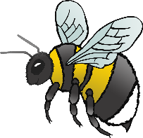

six

**6**

five

© 2021 Little Owls Resources

© 2021 Little Owls Resources

**7**



eight

**8**

seven

© 2021 Little Owls Resources

© 2021 Little Owls Resources

**9**



nine

**10**

ten

© 2021 Little Owls Resources

© 2021 Little Owls Resources