**Bee body parts**

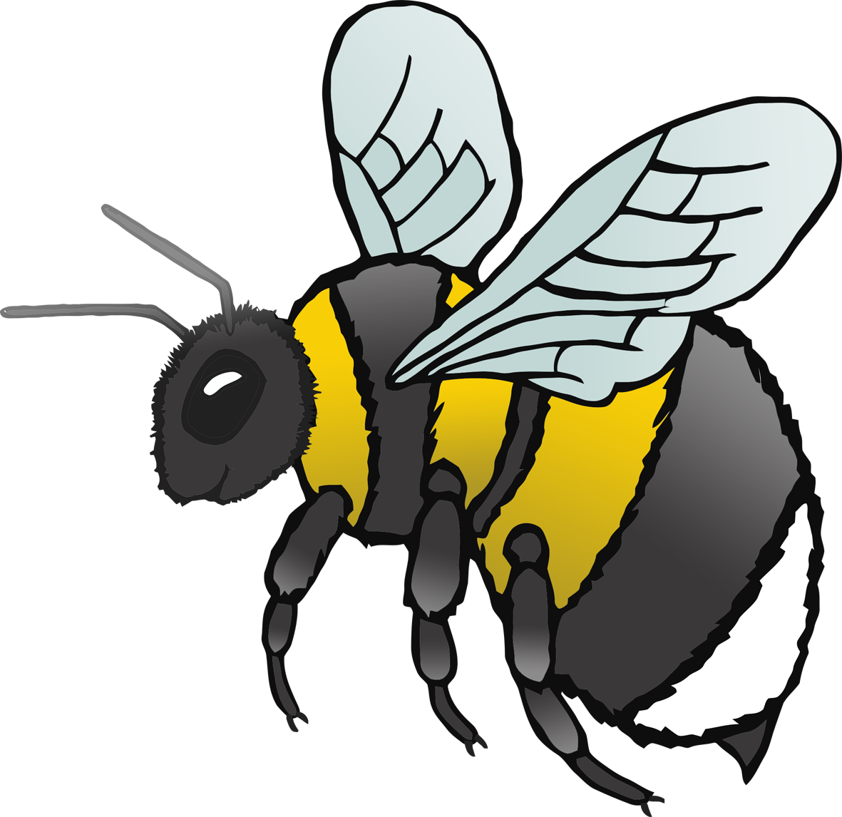

© 2021 Little Owls Resources



e

l

a

**w**

s

**Bee body parts**

© 2021 Little Owls Resources



leg

eye

antenna

**w**ing

stinger

**Bee body parts**

© 2021 Little Owls Resources